Chicago Community
Mennonite Church
425 S. Central Park Blvd., Chicago, IL 60624
(773) 343-4251 | pastor@ccmcil.org
www.ccmcil.org | facebook.com/ccmcil

Jan Lugibihl, Council Chair Tim Peebles, Transitional Pastor

January 3, 2016 ✢ Epiphany
Gathering
Prelude
Call to Worship
One: Let us gather together in thanksgiving to God!
All: For God has made us and this earth, our home.
One: Let us gather together in gratitude to one another.
All: For we are the bearers of God’s blessing and love
for all the earth.
One: Let us praise God. Let us join hearts.
All: Let us reach out in care and courage.
One: so that the goodness of life may be for all God’s creation -
All: today and for generations to come! Amen.
STS 1 Praise the one who breaks the darkness
Welcome
Lighting the Peace Lamp
Prayer for Peace
Praising
STS 122 Let all creation dance
Psalm 24
Children’s Time
Let the children come to me; let the children come.
Never hinder them; never stop them. O let the children come.
Matthew 2:16-23

Receiving God’s Word
HWB 640 This is a day of new beginnings
John 1:1-18
One: For the word of God in scripture,
for the word of God among us,
for the word of God within us,
All: thanks be to God.
Meditation
Responding
STJ 62 Christ’s is the world
Sharing
Prayer: HWB 348 O Lord hear my prayer
Offering
Sending
Announcements
STS 57 Go, my friends, in grace
Benediction
One: On our heads and our houses,
All: The blessing of God.
One: In our coming and going,
All: The peace of God.
One: In our life and believing,
All: The love of God.
One: At our end and new beginning.
All: The arms of God to welcome us and bring us home. Amen.
Extinguishing the Peace Lamp
One: Now the light of Christ is in you.
All: Thanks be to God.

Worship Participants
Worship Leader: Beth Peachey
Meditation: Brian Sauder
Song Leader: Glenn Martin-Klaassen
Instrumentalists: Glenn Martin-Klaassen, Rich Brode
Altar: Brooke Hutchison
Announcements

India Mission Fund: Contributions are still being accepted toward Samita Pal’s nursing school tuition for 2015-16. Please consider helping to make advanced education and a future career of service attainable for this young Indian woman. Checks can be made out to Chicago Community Mennonite Church with “India Mission Fund” on the memo line.

Pastoral Care Needs: In this time of transition, you can share prayer and care concerns with any member of the Prayer and Care Team (Nancy, Rochelle, Derek, Ross, Jan, Tim). If you believe that a particular prayer and care concern requires direct pastoral care, please indicate that when you speak with one of the team members, or contact Pastor Tim directly (pastor@ccmcil.org).

Schedule
 | Today | Next Sunday
Greeter: | Derek Becker | Jason Gerig
Nursery: | Liz Dyrst  Ross Bay | Rochelle Martin Klaassen  Russell Johnson
Fellowship: | Jan Lugibihl, Spencer Foon, Martin Dyrst
------------------------------------------ tear here -----------------------------------------
CCMC Connect Card
We are glad you have joined us for worship! The best way to plug into our congregation is to sign up for our listserv. Bring this card to the Welcome Table in the fellowship hall following worship to receive a welcome gift.
You may also drop it in the offering plate or the basket on the greeter table.

Name______________________________ Phone ______________________

Address_________________________________________________________

Email___________________________________________________________

Add to CCMC listserv to get connected via email? □ Yes □ No, not yet.

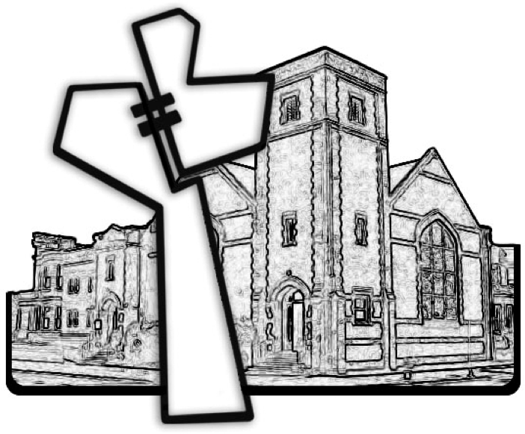
Chicago Community Mennonite Church
January 3, 2016

