Chicago Community
Mennonite Church
425 S. Central Park Blvd., Chicago, IL 60624
(773) 343-4251 | pastor@ccmcil.org
www.ccmcil.org | facebook.com/ccmcil

Jan Lugibihl, Council Chair Tim Peebles, Transitional Pastor

January 10, 2016 ✢ Baptism of Our Lord
Gathering
Prelude
Call to Worship
HWB 17 We gather together
Welcome
Lighting the Peace Lamp
Prayer for Peace
Praising
HWB 124 O worship the Lord
Isaiah 43:1-7
STS 49 I will come to you in the silence
Children’s Time
Let the children come to me; let the children come.
Never hinder them; never stop them. O let the children come.
Receiving God’s Word
Acts 8:14-17
Luke 3:15-22
One: For the word of God in scripture,
for the word of God among us,
for the word of God within us,
All: thanks be to God.
Meditation

Responding
HWB 46 I sing the mighty power of God
Sending of Peters-Fransen Family
Sharing
Prayer
Offering
Sending
Archaeology of Our Faith
Announcements
HWB 435 May the Lord, mighty God
Benediction
Extinguishing the Peace Lamp
One: Now the light of Christ is in you.
All: Thanks be to God.

Worship Participants
Worship Leader: Erin and Justin Beeker
Meditation: Tim Peebles
Song Leader: Glenn Martin-Klaassen
Instrumentalists: Mark Vanderhoff, Philip Kendall
Altar: Antonia Kam
Announcements

Adult Education - Institutional Life Cycles: Having recently explored CCMC's timeline, we will next explore what "stage of life" CCMC is currently experiencing. Everyone, regardless of how long you have attended, is welcome to participate. Your presence has played a role in shaping our community. Facilitator: Tim Peebles.

CDC West Regional Gathering: You are warmly invited to CDC Regional Gatherings on Feb 13 at Community Mennonite Church (Markham, IL), Feb 20 at Faith Mennonite Church (Goshen, IN), or Mar 5 at Emmaus Road Mennonite Fellowship (Berne, IN). The day includes prayer, scripture and song, congregational sharing, a choice of sessions on the recent MCC-sponsored tour to Palestine/Israel or a discussion using the Human Sexuality study guide developed by Gerald and Carrie Mast.
Save the Date: Annual Church Retreat, Feb 13-14: Mark your calendars and plan to join the fun at Camp Menno Haven in Tiskilwa, IL. Church will not meet in Chicago that weekend. All are welcome!

Pastoral Care Needs: In this time of transition, you can share prayer and care concerns with any member of the Prayer and Care Team (Nancy, Rochelle, Justin R., Ross, Kate, Tim). If you believe that a particular prayer and care concern requires direct pastoral care, please indicate that when you speak with one of the team members, or contact Pastor Tim directly (pastor@ccmcil.org).

Schedule
 | Today | Next Sunday
Greeter: | Jason Gerig | Mariell Waltner
Nursery: | Rochelle Martin Klaassen  Russell Johnson | Sherry Jost  Chris Bohlander
Fellowship: | Kurt Frymire | Paul Myers  Rochelle Martin Klaassen
------------------------------------------ tear here -----------------------------------------
CCMC Connect Card
We are glad you have joined us for worship! The best way to plug into our congregation is to sign up for our listserv. Bring this card to the Welcome Table in the fellowship hall following worship to receive a welcome gift.
You may also drop it in the offering plate or the basket on the greeter table.

Name______________________________ Phone ______________________

Address_________________________________________________________

Email___________________________________________________________

Add to CCMC listserv to get connected via email? □ Yes □ No, not yet.

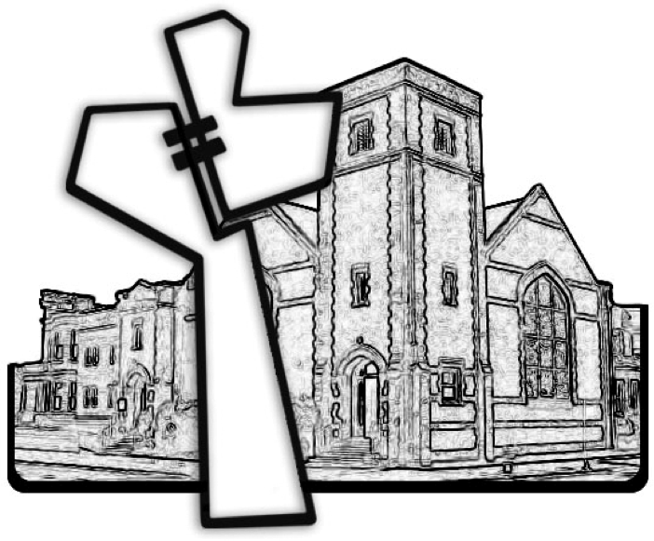
Chicago Community Mennonite Church
January 10, 2016

