Chicago Community
Mennonite Church
425 S. Central Park Blvd., Chicago, IL 60624
(773) 343-4251 | info@ccmcil.org
www.ccmcil.org | facebook.com/ccmcil

September 6, 2015
Gathering
Prelude
Call to Worship
One: God of all goodness, when we really look,
we see you in the everyday
All: In the density of the city,
we find signs of your wonder
One: Tenacious trees that take root and
flourish in abandoned lots
All: May we be like those trees
One: Give us roots going down to water
All: Leaves growing up to sunshine
One: A nest of refuge for the birds of heaven
All: May our fruit be a sign of your life in us.
May we become what you mean us to be.
STS 116 I saw a tree by the riverside
Welcome
Lighting the Peace Lamp
Prayer for Peace
Transitions
One: As we empty this pitcher, we are reminded of the sense of loss we are feeling during this transition.
Our former pastor, Megan Ramer, has now been sent to a new ministry in Seattle. In a similar manner,
the water dwells in a new space. So we bless this congregation as we explore new life for ourselves and our presence in the greater community.
All: May the water of eternal life sustain us with hope and joy.
Praising
HWB 37 Praise to the Lord, the Almighty
Psalm 146
Children’s Time
Let the children come to me; let the children come.
Never hinder them; never stop them. O let the children come.
Receiving God’s Word
Mark 7:24-37
STJ 13 My soul is filled with joy
James 2:1-17
One: For the word of God in scripture,
for the word of God among us,
for the word of God within us,
All: thanks be to God.
Meditation
Responding
STS 39 Will you come and follow me
Sharing
HWB 392 Heart and mind, possessions, Lord
Prayer
STS 121 Nothing is lost on the breath of God
Offering
Sending
Announcements
STS 124 My soul cries out
Benediction
Extinguishing the Peace Lamp
One: Now the light of Christ is in you.
All: Thanks be to God.

Worship Participants
Worship Leader: Mark Frey
Meditation: Russell Johnson
Song Leader: Philip Kendall
Pianist: Kiva Nice-Webb
Altar: Janet Friesen
Announcements
Apply for a PJS Grant: Are you involved in a cause for justice, want to attend nonviolence training, or have an idea for a service project? Apply for funds from the Peace, Justice, and Service Committee. The link to our simple application is available in the Weekend Update. Proposal are due by October 1st. For more information, ask the PJS Committee (Rachael Weasley, Brooke Hutchison, Katie VanderHeide, Ryan Schnurr, Geoff Martin).

Circle of Trust: Beginning Sept. 17, A Healing Circle will meet approximately every other Thursday evening for ten sessions. To learn more, please see Laura Hostetler or Merle Baker.

Basic Quilt Making: Ruby Campos will offer basic training for those that are interested in the process of quilt making. Contact Ruby to set a time to meet: rycampos304@gmail.com or 708-383-3775.

Schedule
 | Today | Next Sunday
Greeter: | Jason Gerig | Mariell Waltner
Nursery: | Brian Paff  Martin Dyrst | Janet Friesen  Josiah Groff
Fellowship: | Antonia Kam  Jan Lugibihl | Rosalynn Gingerich
------------------------------------------ tear here -----------------------------------------
CCMC Connect Card
We are glad you have joined us for worship! The best way to plug into our congregation is to sign up for our listserv. Bring this card to the Welcome Table in the fellowship hall following worship to receive a welcome gift.
You may also drop it in the offering plate or the basket on the greeter table.

Name______________________________ Phone ______________________

Address_________________________________________________________

Email___________________________________________________________

Add to CCMC listserv to get connected via email? □ Yes □ No, not yet.
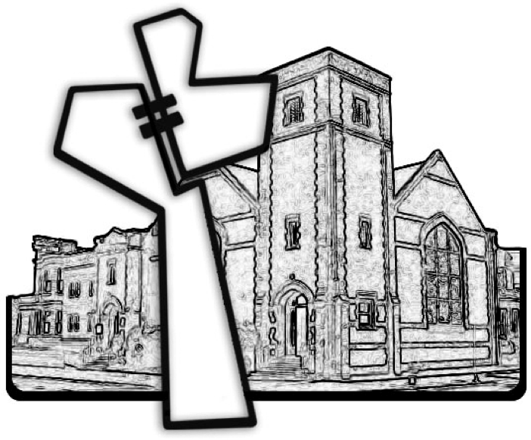
Chicago Community Mennonite Church
September 6, 2015

