Chicago Community
Mennonite Church
425 S. Central Park Blvd., Chicago, IL 60624
(773) 343-4251 | info@ccmcil.org
www.ccmcil.org | facebook.com/ccmcil

September 27, 2015
Gathering
Prelude
Call to Worship
One: We come to this place:
All: to be together and to claim
that we are God’s people.
One: We look to ourselves and to each other:
All: to express the love of God
as a sign of hope for the world.
One: We abandon ourselves:
All: to the working of the Holy Spirit,
trusting in God’s mercy.
HWB 8 Brethren, we have met to worship
Welcome
Lighting the Peace Lamp
Prayer for Peace
Transitions
One: As we empty this pitcher, we are reminded of the sense of loss we are feeling during this transition.
Our former pastor, Megan Ramer, has now been sent to a new ministry in Seattle. In a similar manner,
the water dwells in a new space. So we bless this congregation as we explore new life for ourselves and our presence in the greater community.
All: May the water of eternal life sustain us with hope and joy.

Praising
HWB 403 The church of Christ, in every age
Children’s Time
Let the children come to me; let the children come.
Never hinder them; never stop them. O let the children come.
Receiving God’s Word
STJ 65 Let justice flow like streams
Esther 4
One: For the word of God in scripture,
for the word of God among us,
for the word of God within us,
All: thanks be to God.
Meditation
Responding
STJ 30 Jesus Christ is waiting
Sharing
Welcoming New Members: Brianne & Evan Cline, Monica Kniss
Prayer
Offering
Sending
Announcements
HWB 411 I bind my heart this tide
Benediction
Extinguishing the Peace Lamp
One: Now the light of Christ is in you.
All: Thanks be to God.

Worship Participants
Worship Leader: Jan Lugibihl
Meditation: Brian Sauder
Song Leader: Mariell Waltner
Pianist: Kiva Nice-Webb
Altar: Janet Friesen

Announcements
Education Sessions Today: Contemplative Series: Lectio Devina (Spencer Foon; Second Floor) and From Anabaptists to Mennonites: The Dutch Assimilation (Lauren Friesen; Fellowship Hall)

World Communion Worship & Potluck – Sunday, Oct. 4, 10 am: We will worship at 10 am (sleep in an extra hour!) with our sister congregations, First Church of the Brethren and La Roca de Esperanza. Following worship we will have a joint potluck together.

Michigan Apple Picking – Saturday, Oct. 3: You are invited to CCMC’s annual apple picking party at Twin Maple Orchards north of Galien, MI and a potluck at Vic and Nancy Myers’ home.

Kori’s Kids’ Benefit Concert – Sunday, Oct. 18: At Wellington Ave. UCC. All proceeds benefit the Valdivia-Chupp family. For information and tickets visit waucc.org/chupp-family-fundraiser-2015

Schedule
 | Today | Next Sunday
Greeter: | Rochelle Martin Klaassen | Rosalynn Gingerich
Nursery: | Janet Friesen  Molly Hostetter | Rochelle Martin Klaassen  Russell Johnson
Fellowship: | Paul Myers | Justin Beeker  Leigh Peters Fransen
------------------------------------------ tear here -----------------------------------------
CCMC Connect Card
We are glad you have joined us for worship! The best way to plug into our congregation is to sign up for our listserv. Bring this card to the Welcome Table in the fellowship hall following worship to receive a welcome gift.
You may also drop it in the offering plate or the basket on the greeter table.

Name______________________________ Phone ______________________

Address_________________________________________________________

Email___________________________________________________________

Add to CCMC listserv to get connected via email? □ Yes □ No, not yet.

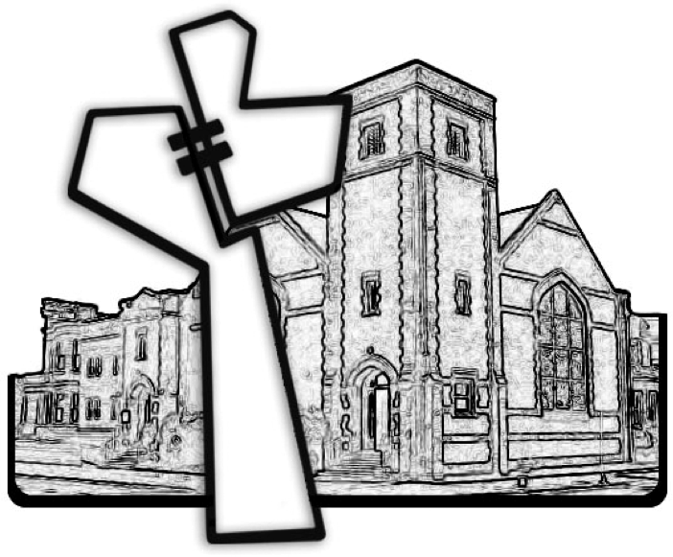
Chicago Community Mennonite Church
September 27, 2015

