Chicago Community
Mennonite Church
425 S. Central Park Blvd., Chicago, IL 60624
(773) 343-4251 | info@ccmcil.org
www.ccmcil.org | facebook.com/ccmcil

September 20, 2015
Gathering
Prelude
Call to Worship
One: We gather to worship together.
All: Different people, different lives, different histories,
One: yet all children of the same Parent,
All: created lovingly by the Source of all life!
One: We gather to reconnect with one another.
All: Different people, different lives, different histories,
One: yet all disciples of one Teacher,
All: Jesus, the Word made flesh, dwelling among us.
One: We gather with different joys and sorrows,
different hopes and fears,
All: different people, different lives, different histories,
One: yet one people with one God, one faith, one baptism.
All: Let us open ourselves to the presence of God
at work in us, among us, and through us.
HWB 407 We are people of God’s peace
Welcome
Lighting the Peace Lamp
Prayer for Peace
Transitions
One: As we empty this pitcher, we are reminded of the sense of loss we are feeling during this transition.
Our former pastor, Megan Ramer, has now been sent to a new ministry in Seattle. In a similar manner,
the water dwells in a new space. So we bless this congregation as we explore new life for ourselves and our presence in the greater community.
All: May the water of eternal life sustain us with hope and joy.
Praising
HWB 226 You are salt for the earth
Psalm 85
Children’s Time
Let the children come to me; let the children come.
Never hinder them; never stop them. O let the children come.
STJ 16 Praise with joy the world’s Creator
Receiving God’s Word
Isaiah 55:6-12
2 Corinthians 5:17-19
STJ 54 Longing for light
Luke 19:1-10
One: For the word of God in scripture,
for the word of God among us,
for the word of God within us,
All: thanks be to God.
Meditation
Responding
HWB 145 There’s a wideness in God’s mercy
Sending of Hannah Klaassen
Sharing
Prayer
Offering
Sending
Announcements
STS 16 Peace before us
Benediction
Extinguishing the Peace Lamp
One: Now the light of Christ is in you.
All: Thanks be to God.

Worship Participants
Worship Leader: Erin and Justin Beeker
Meditation: Bob Hostetter
Song Leader: Beth Peachey
Pianist: Antonia Kam
Altar: Jody Schmidt
Announcements
Adult Education Multi-track Today:
Contemplative Series: Meditation
Facilitator: Julia Robling Griest; Room 2A (Choir Room)
From Anabaptists to Mennonites: The Dutch Assimilation
Speaker: Lauren Friesen; Fellowship Hall

Michigan Apple Picking – Saturday, Oct 3: You are invited to CCMC’s annual apple picking party at Twin Maple Orchards north of Galien, MI and a late afternoon potluck at the home of Vic and Nancy Myers (4450 Curran Rd, Buchanan, MI; 269-695-2101).

Apply for a PJS Grant: Apply for funds from the Peace, Justice, and Service Committee by October 1. More info in the Weekend Update.

Schedule
 | Today | Next Sunday
Greeter: | Merle Baker | Rochelle Martin Klaassen
Nursery: | Nancy Hostetter  Joel Peters Fransen | Ross Bay  Liz Dyrst
Fellowship: | Jason Gerig | Paul Myers
------------------------------------------ tear here -----------------------------------------
CCMC Connect Card
We are glad you have joined us for worship! The best way to plug into our congregation is to sign up for our listserv. Bring this card to the Welcome Table in the fellowship hall following worship to receive a welcome gift.
You may also drop it in the offering plate or the basket on the greeter table.

Name______________________________ Phone ______________________

Address_________________________________________________________

Email___________________________________________________________

Add to CCMC listserv to get connected via email? □ Yes □ No, not yet.

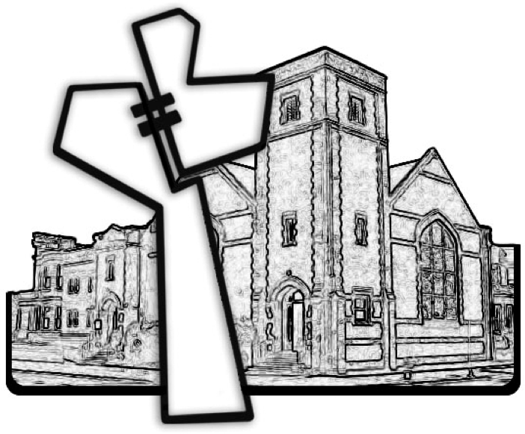
Chicago Community Mennonite Church
September 20, 2015

