Chicago Community
Mennonite Church
425 S. Central Park Blvd., Chicago, IL 60624
(773) 343-4251 | info@ccmcil.org
www.ccmcil.org | facebook.com/ccmcil

September 13, 2015
Gathering
Prelude
Call to Worship
HWB 26 Holy Spirit, come with power
Welcome
Lighting the Peace Lamp
Prayer for Peace
Transitions
One: As we empty this pitcher, we are reminded of the sense of loss we are feeling during this transition.
Our former pastor, Megan Ramer, has now been sent to a new ministry in Seattle. In a similar manner,
the water dwells in a new space. So we bless this congregation as we explore new life for ourselves and our presence in the greater community.
All: May the water of eternal life sustain us with hope and joy.
Praising
STJ 54 Longing for light
Psalm 19
HWB 401 This little light of mine
Children’s Time
Let the children come to me; let the children come.
Never hinder them; never stop them. O let the children come.
STJ 69 Cuando el pobre (When the poor ones)

Receiving God’s Word
Proverbs 1:20-33
James 3:1-17
STJ 96 I’m pressing on the upward way
Mark 8:27-38
One: For the word of God in scripture,
for the word of God among us,
for the word of God within us,
All: thanks be to God.
Meditation
Responding
HWB 372 O healing river
Offering
Blessing of Steve Warkentin
Blessing of Isaiah Dyrst and Derek Becker
Sharing
Prayer
Archaeology of Our Faith
Sending
Announcements
HWB 546 Guide my feet
Benediction
Extinguishing the Peace Lamp
One: Now the light of Christ is in you.
All: Thanks be to God.

Worship Participants
Worship Leader: Paul Myers
Meditation: Will Tanzman
Song Leader: Glenn Klaassen
Instrumentalists: Antonia Kam, Rachael Weasley, Derek Becker
Altar: Antonia Kam

Announcements
Adult Education Today: Will Tanzman will lead a discussion about how large-scale systems like neoliberalism, classism, and racism, intersect with our church’s neighborhood, our home neighborhoods, and our individual lives – and what we can do about it.

Michigan Apple Picking – Saturday, Oct 3: You are invited to CCMC’s annual apple picking party at Twin Maple Orchards north of Galien, MI and a late afternoon potluck at the home of Vic and Nancy Myers (4450 Curran Rd, Buchanan, MI; 269-695-2101).

Apply for a PJS Grant: Apply for funds from the Peace, Justice, and Service Committee by October 1. More info in the Weekend Update.

Basic Quilt Making: Ruby Campos will offer basic training for those that are interested in the process of quilt making. Contact Ruby to set a time to meet: rycampos304@gmail.com or 708-383-3775.

Schedule
 | Today | Next Sunday
Greeter: | Mariell Waltner | Merle Baker
Nursery: | Janet Friesen  Josiah Groff | Nancy Hostetter  Joel Peters Fransen
Fellowship: | Rosalynn Gingerich | Jason Gerig
------------------------------------------ tear here -----------------------------------------
CCMC Connect Card
We are glad you have joined us for worship! The best way to plug into our congregation is to sign up for our listserv. Bring this card to the Welcome Table in the fellowship hall following worship to receive a welcome gift.
You may also drop it in the offering plate or the basket on the greeter table.

Name______________________________ Phone ______________________

Address_________________________________________________________

Email___________________________________________________________

Add to CCMC listserv to get connected via email? □ Yes □ No, not yet.

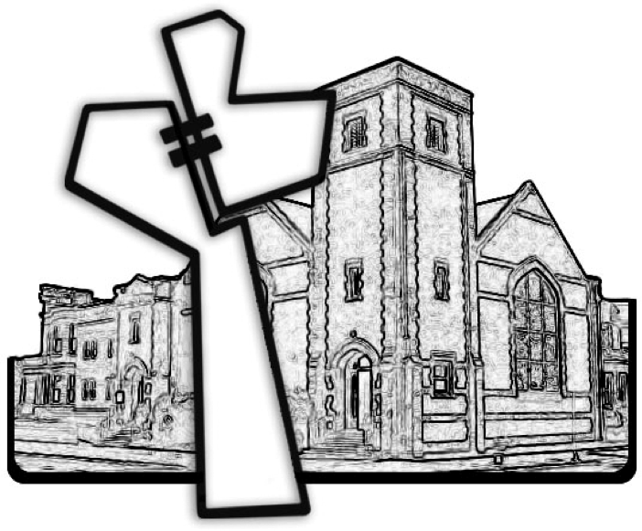
Chicago Community Mennonite Church
September 13, 2015

