Chicago Community Mennonite Church

August 9, 2015

Gathering

Prelude

Call to Worship

One: Oh, open your hearts, friends,

that your pain and loneliness

be turned to love.

**Many: Look to the Beloved, and your**

**emptiness will be filled,**

**your face will radiate love.**

One: Happy are all who dwell in the

Beloved’s heart!

**Many: Abandon yourself into Love’s hands,**

**O you holy ones,**

**For those who give themselves to**

**the Beloved,**

**lack no good thing.**

HWB 383 *God whose giving*

Welcome

Lighting the Peace Lamp

Prayer for Peace

Transitions

One: This pitcher is a symbol of transition and   
self-discovery for our congregation. Our pastor, Megan Ramer, will be taking a new position in Seattle. Just as water takes on many forms and gives life,   
so we renew our dedication to one another and our service to the greater community.

**All: May the water of eternal life sustain us**

**with hope and joy.**

Praising

HWB 486 *God of our life*

Psalm 34:1-8

Children’s Time

*Let the children come to me; let the children come.*

*Never hinder them; never stop them. O let the children come.*

HWB 613 *In heavenly love abiding*

Receiving God’s Word

John 6:35, 41-51

HWB 472 *I am the bread of life*

Ephesians 4:25-5:2

One: For the word of God in scripture,   
for the word of God among us,   
for the word of God within us,

**All: thanks be to God.**

Meditation

Responding

HWB 411 *I bind my heart this tide*

Presentation of Quilt to Suzanna Greist

Sharing

Prayer

Offering

Sending

Announcements

HWB 361 *O Spirit of the living God*

Benediction

Extinguishing the Peace Lamp

One: Now the light of Christ is in you.

**All: Thanks be to God.**

|  |
| --- |
| Worship Participants  Worship Leaders: Laura Hostetler  Meditation: Megan Ramer  Song Leader: Glenn Martin Klaassen  Pianist: Beth Peachey  Altar: Antonia Kam |

Announcements

**Tour the Oriental Institute:** Lauren Friesen is completing the final stages of docent training at the Oriental Institute at University of Chicago. This is where you can help: the two final steps are practice tours with friends (potentially August 11 at 2 p.m. or August 14 at 10 a.m.). The tour will be no longer than an hour. The Oriental Institute is located on the University of Chicago campus, 58th and University in Hyde Park. RSVP with Lauren: friesenjl1970@gmail.com

**Beloved: Megan's Farewell Celebrations.** As we near Megan's farewell and its accompanying celebrations, we invite you to participate in the following ways. **Celebrate** (Saturday, August 15, 5 p.m.):Contribute a poem/performance/song/statement/lip-sync – contact Ross Bay, Brian or Maria Paff (Think: the most epic CCMC talent show ever!). Send photos with Megan to Ross Bay. Contribute Megan's favorite dish or your's to a vegetarian potluck. Can't make it? Record a video of your well wishes and send to Ross Bay. **Send** (Sunday, August 16): Sing in a choir – contact Philip Kendall.

**Small Group Forming:** Merle Baker and Laura Hostetler will be co-facilitating a “Circle of Trust” based on the model put forward by Parker Palmer in *A Hidden Wholeness: The Journey Toward An Undivided Life*. As described by Palmer, the singular purpose of a circle of trust “is to support the inner journey of each person in the group, to make each soul feel safe enough to show up and speak its truth, to help each person listen to his or her inner teacher” (p. 54). Neither a social gathering, nor an intellectual book group, Palmer writes, “In a circle of trust, we practice the paradox of ‘being alone together,’ of being present to one another as a ‘community of solitudes” (p. 54). We envision meeting for a series of ten two-hour sessions over a period of several months (probably on a Wednesday or Thursday evening), and would ask for a high level of commitment from participants for regular attendance. Each meeting will include time for reflection on a quotation or poem, silence, journaling, and sharing. Reading the book is not required, but is recommended. If you would like to learn more about what we are planning or have a look at Parker Palmer’s book, come find Merle and Laura at the table with the bouquet on it during fellowship time.

Schedule

|  |  |  |
| --- | --- | --- |
|  | **Today** | **Next Sunday** |
| **Greeter:** | Antonia Kam | Brooke Hutchison |
| **Nursery:** | Liz Finch  Justin Hochstetler | Bob Hostetter  Zemir Magalhaes |
| **Fellowship:** | Kurt Frymire | Rochelle Martin Klaassen |

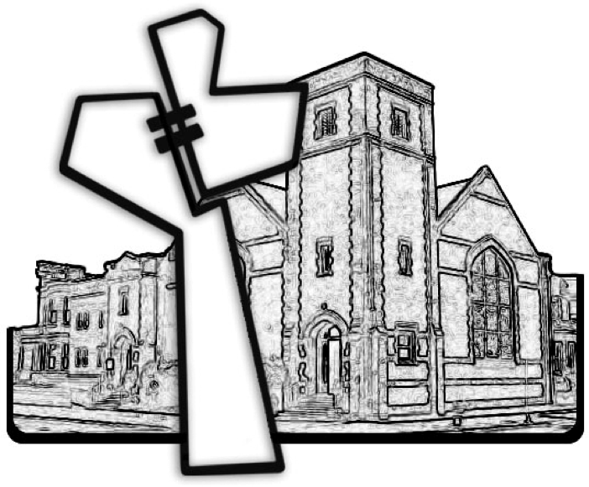

Chicago Community Mennonite Church



Chicago Community Mennonite Church

425 S. Central Park Blvd. (at Congress), Chicago, Illinois 60624-3224

www.ccmcil.org **|** facebook.com/ccmcil

**Church Council Chair:** Jason Gerig, 773-949-4496, jgerig@gmail.com

**Pastor:** Megan Ramer, 773-343-4251, pastor@ccmcil.org

**Minister of Arts & Community Organizing:** Rachael Weasley, 415-314-7156

August 9, 2015