Chicago Community
Mennonite Church
425 S. Central Park Blvd., Chicago, IL 60624
(773) 343-4251 | info@ccmcil.org
www.ccmcil.org | facebook.com/ccmcil

August 30, 2015
Gathering
Prelude
Call to Worship
One: We gather as pilgrims on a journey of faith.
Many: We come seeking the cloud of your presence as we travel the way.
One: We come seeking the cloud of your pillar of fire to light our darkness.
All: Shine in our hearts, O God, with the light of your love. Make your presence known through Jesus, the Christ. Amen
HWB 16 God is here among us
Welcome
Lighting the Peace Lamp
Prayer for Peace
Transitions
One: As we empty this pitcher, we are reminded of the sense of loss we are feeling during this transition.
Our former pastor, Megan Ramer, has now been sent to a new ministry in Seattle. In a similar manner,
the water dwells in a new space. So we bless this congregation as we explore new life for ourselves and our presence in the greater community.
All: May the water of eternal life sustain us with hope and joy.
Praising
HWB 57 Come and give thanks to the Giver
James 1:17-27
Children’s Time
Let the children come to me; let the children come.
Never hinder them; never stop them. O let the children come.
Receiving God’s Word
Psalm 15
HWB 521 Come, thou fount
Mark 7:1-8, 14-15, 21-23
One: For the word of God in scripture,
for the word of God among us,
for the word of God within us,
All: thanks be to God.
Meditation
Responding
HWB 310 How good a thing it is
Offering
HWB 392 Heart and mind, possessions, Lord
Sharing
Prayer
Sending
Announcements
STJ 52 Jesus, help us live in peace
Benediction
Extinguishing the Peace Lamp
One: Now the light of Christ is in you.
All: Thanks be to God.

Worship Participants
Worship Leader: Linda Becker
Meditation: Kevin Key
Song Leader: Philip Kendall
Pianist: Maria Paff
Altar: Amber Kessler-Freer
Announcements
We are glad you have joined us for worship! Please join us for coffee and fellowship downstairs after worship. First Church of the Brethren worships at 11 a.m. Out of courtesy, we try to leave the sanctuary promptly and continue our fellowship in the basement. Most Sundays we have a Welcome Table along the west wall where you can gather with regular attenders to ask questions about our congregation and meet new people. The best way to plug into our congregation is to sign up for our listserv (see back) or watch our online calendar for church news and events.

August Beer Group Meetup, Today, 6:30 p.m.: Let’s savor the last moments of summer tonight at Brian and Maria Paff’s place (531 N Bishop St, Chicago). Next beer group: 9/12 at Jan Lugibihl’s.

Schedule
 | Today | Next Sunday
Greeter: | Derek Becker | Jason Gerig
Nursery: | Jane Baker  Martin Dyrst | Linda Becker  Brian Paff
Fellowship: | Spencer Foon  Geoff Martin | Antonia Kam  Jan Lugibihl

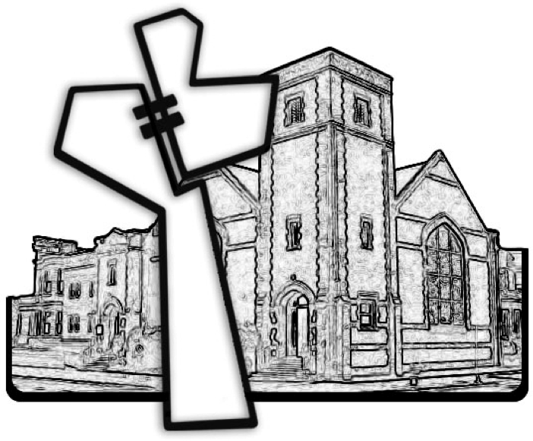

Chicago Community Mennonite Church
------------------------------------------ tear here -----------------------------------------
CCMC Connect Card
We’d love to get connected! Please fill this out and bring it to the Welcome Table in the fellowship hall following worship to receive a welcome gift.
You may also drop it in the offering plate or the basket on the greeter table.

Name______________________________ Phone ______________________

Address_________________________________________________________

Email___________________________________________________________

Add to CCMC listserv to get connected via email? □ Yes □ No, not yet.
August 30, 2015

