Chicago Community Mennonite Church

August 2, 2015

Gathering

Prelude

Call to Worship

One: We invite the forests to worship with us:

**Many: mountain ash and vibrant maples,**

**quivering ferns and glistening moss!**

One: We invite tall trees to celebrate life:

**Many: to lift green leaves in the breeze**

**and sing oxygen into the air.**

One: We call to the forest to sing in the night:

**Many: green tree frogs and timid moths,**

**butterflies and swirling bats!**

One: We join with the fauna of the forest in praising God:

**Many: redwinged blackbirds and hummingbirds,  
creeping things and butterflies.**

One: We celebrate the song of the forest!

**Many: Sing, forest, sing!**

Welcome

Lighting the Peace Lamp

Prayer for Peace

Transitions

One: This pitcher is a symbol of transition and   
self-discovery for our congregation. Our pastor, Megan Ramer, will be taking a new position in Seattle. Just as water takes on many forms and gives life,   
so we renew our dedication to one another and our service to the greater community.

**All: May the water of eternal life sustain us**

**with hope and joy.**

Praising

HWB 648 *Morning has broken*

Children’s Time

*Let the children come to me; let the children come.*

*Never hinder them; never stop them. O let the children come.*

Nursery Graduation for Theo Riegsecker

Blessing of Backpacks and Calendars

Receiving God’s Word

Psalm 139

HWB 46 *I sing the mighty power of God*

Genesis 2:4b-22

One: For the word of God in scripture,   
for the word of God among us,   
for the word of God within us,

**All: thanks be to God.**

Meditation

Responding

STS 116 *I saw a tree by the riverside*

Offering

Sharing

Prayer

Commissioning Kiva Nice-Webb

Sending

Announcements

HWB 427 *You shall go out with joy*

Benediction

Extinguishing the Peace Lamp

One: Now the light of Christ is in you.

**All: Thanks be to God.**

|  |
| --- |
| Worship Participants  Worship Leaders: Jan Lugibihl  Meditation: Celeste Groff  Song Leader: Philip Kendall  Pianist: Antonia Kam  Altar: Brooke Hutchison |

Announcements

**Magazines!** I’ve placed some magazines in the church library: [Adbusters](https://www.adbusters.org/), [geez](http://www.geezmagazine.org/), and [Chicago Wilderness](http://173.254.34.128/CW_Archives/). Claim by today, Aug 2. ~Megan

**Tour the Oriental Institute:** Lauren Friesen is completing the final stages of docent training at the Oriental Institute at University of Chicago. This is where you can help: the two final steps are practice tours with friends (potentially August 11 at 2 p.m. or August 14 at 10 a.m.). The tour will be no longer than an hour. The Oriental Institute is located on the University of Chicago campus, 58th and University in Hyde Park. RSVP with Lauren: friesenjl1970@gmail.com

**Group Exploration: The Undivided Life:** “I yearn to be whole, but dividedness often seems the easier choice. A ‘still, small voice’ speaks the truth about me, my work, or the world. I hear it and yet act as if I did not. I withhold a personal gift that might serve a good end or commit myself to a project that I do not really believe in. I keep silent on an issue I should address or actively break faith with one of my own convictions. I deny my inner darkness, giving it more power over me, or I project it onto other people, creating 'enemies' where none exist.” From *A Hidden Wholeness: The Journey Toward an Undivided Life,* Parker Palmer. If you would like to learn more about joining a group exploration of this book, possibly starting the second week of August, contact Laura Hostetler or Merle Baker.

**Christian Peacemaker Teams Prayers for Peacemakers:** Pray for participants and speakers at the Peacemaker Congress 2015 this weekend. Ask God to undergird the proceedings, so that the people present may find creative new ways to address the Powers who shut off water to the poor in Detroit and abuse the marginalized in all the locations CPT works.

Schedule

|  |  |  |
| --- | --- | --- |
|  | **Today** | **Next Sunday** |
| **Greeter:** | Kate Myers | Antonia Kam |
| **Nursery:** | Anna Schnurr  Steve Jost | Liz Finch  Justin Hochstetler |
| **Fellowship:** | Kate Myers | Kurt Frymire |

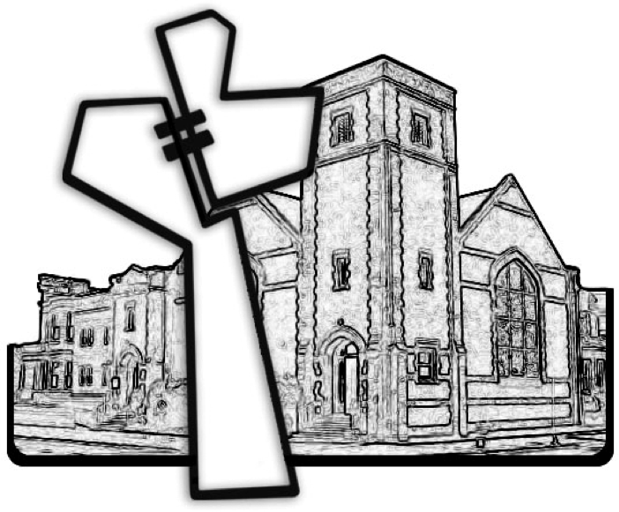

Chicago Community Mennonite Church



Chicago Community Mennonite Church

425 S. Central Park Blvd. (at Congress), Chicago, Illinois 60624-3224

www.ccmcil.org **|** facebook.com/ccmcil

**Church Council Chair:** Jason Gerig, 773-949-4496, jgerig@gmail.com

**Pastor:** Megan Ramer, 773-343-4251, pastor@ccmcil.org

**Minister of Arts & Community Organizing:** Rachael Weasley, 415-314-7156

August 2, 2015