Chicago Community Mennonite Church

August 23, 2015

Gathering

Prelude

Call to Worship

HWB 26 *Holy Spirit, come with power*

Welcome

Lighting the Peace Lamp

Prayer for Peace

Transitions

One: As we empty this pitcher, we are reminded of the sense of loss we are feeling during this transition. Our former pastor, Megan Ramer, has now been sent to a new ministry in Seattle. In a similar manner, the water dwells in a new space. So we bless this congregation as we explore new life for ourselves and our presence in the greater community.

**All: May the water of eternal life sustain us with hope and joy.**

Praising

1 Kings 8:(1,6,10-11), 22-30, 41-43

HWB 466 *Jesus, sun and shield art thou*

Psalm 84

Children’s Time

*Let the children come to me; let the children come.*

*Never hinder them; never stop them. O let the children come.*

STJ 16 *Praise with joy the world’s Creator*

Receiving God’s Word

Ephesians 6:10-20

HWB 510 *O Christ, in thee my soul*

John 6:56-69

One: For the word of God in scripture,   
for the word of God among us,   
for the word of God within us,

**All: thanks be to God.**

Meditation

Responding

HWB 571 *‘Tis not with eyes of flesh we see*

Sharing

Prayer

Offering

Sending

Announcements

STJ 77 *The peace of the earth be with you*

Benediction

One: Go in love,

**All: for love alone endures.**

One: Go in peace,

**All: for it is the gift of God.**

One: Go in safety,

**All: for we cannot go where God is not.**

Extinguishing the Peace Lamp

One: Now the light of Christ is in you.

**All: Thanks be to God.**

|  |
| --- |
| Worship Participants  Worship Leaders: Jason Gerig  Meditation: Kiva Nice-Webb  Song Leader: Glenn Martin Klaassen  Pianist: Steve Warkentin  Altar: Janet Friesen |

Announcements

**Opportunity to Learn Reiki:** Wendy Lehman is teaching Reiki at Equilibrium in Chicago about once a month as a Reiki Master Teacher. Level One (introduction) classes are August 29 and November 21. If you'd like to learn this simple, hands-on technique to help with relaxation and to reduce stress, pain, and insomnia. sign up for the course at Equilibrium's website: www.equilibrium-e3.com.

**Christian Peacemaker Teams Prayers for Peacemakers:** Pray for those whom armed groups have driven off their land in Colombia. The government says its goal is to return six million hectares of land to people who were violently displaced; but at the current rate that the government is returning land to these people, it will take 500 years to reach its goal.

Schedule

|  |  |  |
| --- | --- | --- |
|  | **Today** | **Next Sunday** |
| **Greeter:** | Anna Hershey | Kate Myers |
| **Nursery:** | Mark Frey  Jan Lugibihl | Jane Baker  Martin Dyrst |
| **Fellowship:** | Russell Johnson | Spencer Foon  Geoff Martin |

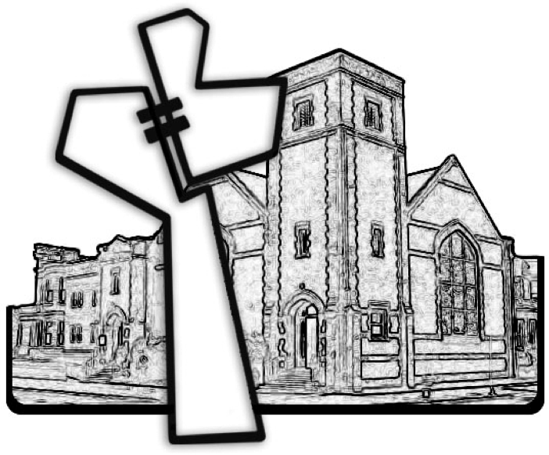

Chicago Community Mennonite Church



Chicago Community Mennonite Church

425 S. Central Park Blvd. (at Congress), Chicago, Illinois 60624-3224

www.ccmcil.org **|** facebook.com/ccmcil **|** info@ccmcil.org

**Church Council Chair:** Jason Gerig, 773-949-4496, jgerig@gmail.com

**Minister of Arts & Community Organizing:** Rachael Weasley, 415-314-7156

August 23, 2015