Chicago Community Mennonite Church

July 5, 2015

Gathering

Prelude

Call to Worship

One: The prophets of old spoke of God’s justice,

Even when it was unwelcome.

Who will hear their message?

**All: We will listen and we will hear!**

One: Responding to God’s call, Jesus traveled,

preaching and teaching all who would listen.

Who will hear their message?

**All: We will listen and we will hear!**

One: Christ sent out disciples two by two,

to spread the good news

in any place that would welcome them.

Who will hear their message?

**All: We will listen and we will hear!**

One: God’s prophets are among us still,

Around the world in these pews.

Who will hear their message?

**All: We will listen and we will hear!**

HWB 26 *Holy Spirit, come with power*

Welcome

Lighting the Peace Lamp

Prayer for Peace

Transitions

One: This pitcher is a symbol of transition and   
self-discovery for our congregation. Our pastor,   
Megan Ramer, will be taking a new position in Seattle.  
Just as water takes on many forms and gives life,   
so we renew our dedication to one another and   
our service to the greater community.

**All: May the water of eternal life sustain us**

**with hope and joy.**

Praising

HWB 111 *O praise the gracious power*

Psalm 30

Children’s Time

*Let the children come to me; let the children come.*

*Never hinder them; never stop them. O let the children come.*

Receiving God’s Word

Ezekiel 2:1-5

2 Corinthians 12:2-10

STS 81 *When we are tempted*

Mark 6:1-13

One: For the word of God in scripture,   
for the word of God among us,   
for the word of God within us,

**All: thanks be to God.**

Meditation

Responding

STS 39 *Will you come and follow me*

Sharing

Prayer

HWB 347 *Through our fragmentary prayers*

Offering

Sending

Announcements

HWB 434 *Thuma mina*

Benediction

**All: We know you, Holy One, as the One who lives and moves in communities of all kinds.**

One: Whether we find ourselves in the center,

on the margins, or somewhere in between,

may we nurture those qualities

in our churches and congregations that are life-giving,

even as we challenge those that are death-dealing.

**All: Be with us as we move with integrity and grace. Amen.**

Extinguishing the Peace Lamp

One: Now the light of Christ is in you.

**All: Thanks be to God.**

|  |
| --- |
| Worship Participants  Worship Leader: Rachael Weasley  Meditation: Beth Peachey  Song Leader: Philip Kendall  Pianist: Antiona Kam  Altar: Brooke Hutchison |

Announcements

**Pledges Update:** Every December, CCMC’s treasurer asks households in the congregation to offer a pledge of what they will give to CCMC for the upcoming year. CCMC makes its budget based on these pledges. Thank you to everyone who has pledged to CCMC for 2015. As of May 31, which is about 41% of the way through the year, we have received about 35% of pledged gifts. While many households check in and catch up on their pledges toward the end of the year, CCMC’s cash reserves are not vast, so it is important for the financial stability of the church that households remit their pledges fairly constantly through the year. If you are a pledging household, please take a moment and see if you are current on your pledged giving. If not, please consider catching up on your pledge. Thank you so much.

Schedule

|  |  |  |
| --- | --- | --- |
|  | **Today** | **Next Sunday** |
| **Greeter:** | Justin Riegsecker | Jan Lugibihl |
| **Nursery:** | Justin Riegsecker  Sara Reschly | Brooke Hutchison  Laura Hostetter |
| **Fellowship:** | Paul Myers | Justin Riegsecker |

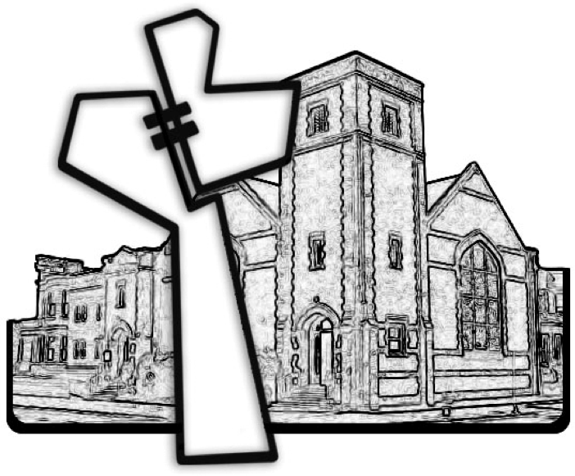

Chicago Community Mennonite Church



Chicago Community Mennonite Church

425 S. Central Park Blvd. (at Congress), Chicago, Illinois 60624-3224

www.ccmcil.org **|** facebook.com/ccmcil

**Church Council Chair:** Jason Gerig, 773-949-4496, jgerig@gmail.com

**Pastor:** Megan Ramer, 773-343-4251, pastor@ccmcil.org

**Minister of Arts & Community Organizing:** Rachael Weasley, 415-314-7156

July 5, 2015