Chicago Community Mennonite Church

July 19, 2015

Gathering

Prelude

Call to Worship

One: Oh God, oh Love that burns in our flesh and bone,

**Many: gather us in, the rich and the haughty,**

**the lost and forsaken,**

One: gather us in and make us your own.

**Many: Not in the dark of buildings confining, not in some heaven, light years away,**

One: but here in this place new light is shining.

Now is the kin-dom, and now is the day.

**Many: See in this space our fears and our dreamings,**

One: our questions and doubts between right and wrong,

**Many: gather us in, all peoples together,**

***All*: *give us the courage to enter the song.***

HWB 6 *Here in this place*

Welcome

Lighting the Peace Lamp

Prayer for Peace

*It goes on one at a time,*

*it starts when you care*

*to act, it starts when you do*

*it again after they said no,*

*it starts when you say We*

*and know who you mean, and each*

*day you mean one more.*

- Marge Piercy

Transitions

One: This pitcher is a symbol of transition and self-discovery for our congregation.  Our pastor, Megan Ramer, will be taking a new position in Seattle.  Just as water takes on many forms and gives life, so we renew our dedication to one another and our service to the greater community.

**All: May the water of eternal life sustain us**

**with hope and joy.**

Praising

HWB 170 *The king of love my shepherd is*

Psalm 23

Children’s Time

*Let the children come to me; let the children come.*

*Never hinder them; never stop them. O let the children come.*

HWB 418 *Move in our midst*

Receiving God’s Word

Jeremiah 22:1-6

Ephesians 2:11-22

STS 44 *When Jesus the healer*

Mark 6:30-34, 53-56

One: For the word of God in scripture,   
for the word of God among us,   
for the word of God within us,

**All: thanks be to God.**

Meditation

Responding

HWB 410 *Lord of Light, your name outshining*

Sharing

Prayer

Offering

Sending

Announcements

STS 89 *Christ is alive*

Benediction

Extinguishing the Peace Lamp

One: Now the light of Christ is in you.

**All: Thanks be to God.**

|  |
| --- |
| Worship Participants  Worship Leaders: Rachael Weasley  Meditation: Megan Ramer  Song Leader: Beth Peachey  Pianist: Antonia Kam  Altar: Jody Schmidt |

Announcements

**Dunes Sunday, July 26:** Plan to join us at Indiana Dunes State Park, North Orchard Shelter, for outdoor worship at 10:30 Central, a potluck picnic, and then fun at the beach. There will be no CCMC worship in Chicago this day. Info: www.ccmcil.org/dunes-sunday

**Group Exploration: The Undivided Life:** "I yearn to be whole, but dividedness often seems the easier choice. A 'still, small voice' speaks the truth about me, my work, or the world. I hear it and yet act as if I did not. I withhold a personal gift that might serve a good end or commit myself to a project that I do not really believe in. I keep silent on an issue I should address or actively break faith with one of my own convictions. I deny my inner darkness, giving it more power over me, or I project it onto other people, creating 'enemies' where none exist." From *A Hidden Wholeness: The Journey Toward an Undivided Life,* Parker Palmer. If you would like to learn more about joining a group exploration of this book, possibly starting the second week of August, contact Laura Hostetler or Merle Baker.

**Magazines!** I've placed some magazines in the church library: [Adbusters](https://www.adbusters.org/), [geez](http://www.geezmagazine.org/), and [Chicago Wilderness](http://173.254.34.128/CW_Archives/). Claim by Aug 2. ~Megan

**Christian Peacemaker Teams Prayers for Peacemakers:** Pray for participants and speakers at the Peacemaker Congress 2015 this weekend. Ask God to undergird the proceedings, so that the people present may find creative new ways to address the Powers who shut off water to the poor in Detroit and abuse the marginalized in all the locations CPT works.

Schedule

|  |  |  |
| --- | --- | --- |
|  | **Today** | **Next Sunday** |
| **Greeter:** | Justin Beeker | Dunes Sunday |
| **Nursery:** | Celcilia Goertzen  Joanne Zimmerly | Dunes Sunday |
| **Fellowship:** | Ross Bay | Dunes Sunday |

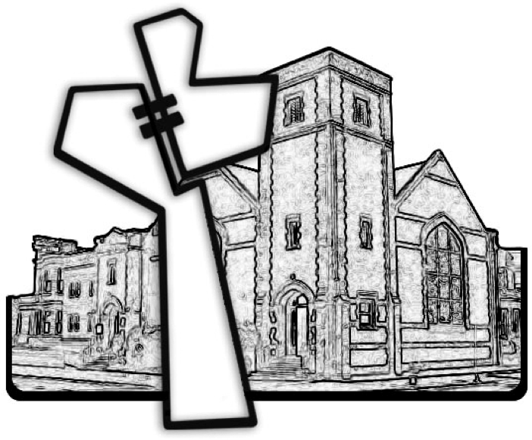

Chicago Community Mennonite Church



Chicago Community Mennonite Church

425 S. Central Park Blvd. (at Congress), Chicago, Illinois 60624-3224

www.ccmcil.org **|** facebook.com/ccmcil

**Church Council Chair:** Jason Gerig, 773-949-4496, jgerig@gmail.com

**Pastor:** Megan Ramer, 773-343-4251, pastor@ccmcil.org

**Minister of Arts & Community Organizing:** Rachael Weasley, 415-314-7156

July 19, 2015