Chicago Community Mennonite Church

July 12, 2015

Gathering

Prelude

Call to Worship

**All: We are bound together.**

**Together we are free. Amen.**

HWB 1 *What is this place*

Welcome

Lighting the Peace Lamp

Prayer for Peace

Transitions

One: This pitcher is a symbol of transition and self-discovery for our congregation.  Our pastor, Megan Ramer, will be taking a new position in Seattle.  Just as water takes on many forms and gives life, so we renew our dedication to one another and our service to the greater community.

**All: May the water of eternal life sustain us**

**with hope and joy.**

Praising

HWB 89 *For the beauty of the earth*

Psalm 85:8-13

Dedication of Children’s Quilt

Children’s Time

*Let the children come to me; let the children come.*

*Never hinder them; never stop them. O let the children come.*

Receiving God’s Word

Ezekiel 1:3-14

HWB 377 *Healer of our every ill*

Mark 6:14-29

One: For the word of God in scripture,   
for the word of God among us,   
for the word of God within us,

**All: thanks be to God.**

Meditation

Responding

Silence

*That is not the church*  Jan Lugibihl

HWB 421 *Bless’d be the tie that binds*

Sharing

Prayer

Offering

Sending

Announcements

HWB 323 *Beyond a dying sun*

Benediction

Extinguishing the Peace Lamp

One: Now the light of Christ is in you.

**All: Thanks be to God.**

|  |
| --- |
| Worship Participants  Worship Leaders: Jody Schmidt and Maria Paff  Meditation: Megan Ramer  Song Leader: Nancy Hostetter  Guitarists: Mark Vanderhoff, Derek Becker, Rachael Weasley  Altar: Antonia Kam |

Announcements

**Dunes Sunday, July 26:** Plan to join us at Indiana Dunes State Park, North Orchard Shelter, for outdoor worship at 10:30 Central, a potluck picnic, and then fun at the beach. There will be no CCMC worship in Chicago this day. Info: www.ccmcil.org/dunes-sunday

**CCMC Canoeing & Camping weekend, July 18-19:** We will enjoy another weekend at Mark, Laura, and Naomi's place on Lake Emma, near Onekama MI. Even if you don't canoe or camp, there's plenty to do (and time to just be!) and indoor places to sleep. More details or to RSVP: Mark Liechty, liechty@uic.edu.

**Magazines!** I've placed some magazines in the church library: [Adbusters](https://www.adbusters.org/), [geez](http://www.geezmagazine.org/), and [Chicago Wilderness](http://173.254.34.128/CW_Archives/). First come, first served. If they're not gone or claimed by August 2, I'll recycle them. ~Megan

**Pledges Update:** Every December, CCMC's treasurer asks households in the congregation to offer a pledge of what they will give to CCMC for the upcoming year. CCMC makes its budget based on these pledges. Thank you to everyone who has pledged to CCMC for 2015. As of May 31, which is about 41% of the way through the year, we have received about 35% of pledged gifts. While many households check in and catch up on their pledges toward the end of the year, CCMC's cash reserves are not vast, so it is important for the financial stability of the church that households remit their pledges fairly constantly through the year. If you are a pledging household, please take a moment and see if you are current on your pledged giving. If not, please consider catching up on your pledge. Thank you so much.

**Christian Peacemaker Teams Prayer for Peacemakers:** Please pray for the Christian Peace Pilgrims arrested for disrupting the ‘Talisman Sabre’ US-Australian war rehearsals this morning. The activists entered the training area in objection to the Australian-US military alliance, and to the human, economic and environmental costs of those wars for Australian soldiers and the Australian taxpaying public. Participants in the action included two members of CPT-Oceania.

Schedule

|  |  |  |
| --- | --- | --- |
|  | **Today** | **Next Sunday** |
| **Greeter:** | Jan Lugibihl | Justin Beeker |
| **Nursery:** | Brooke Hutchison  Laura Hostetter | Celcilia Goertzen  Joanne Zimmerly |
| **Fellowship:** | Justin Riegsecker | Ross Bay |

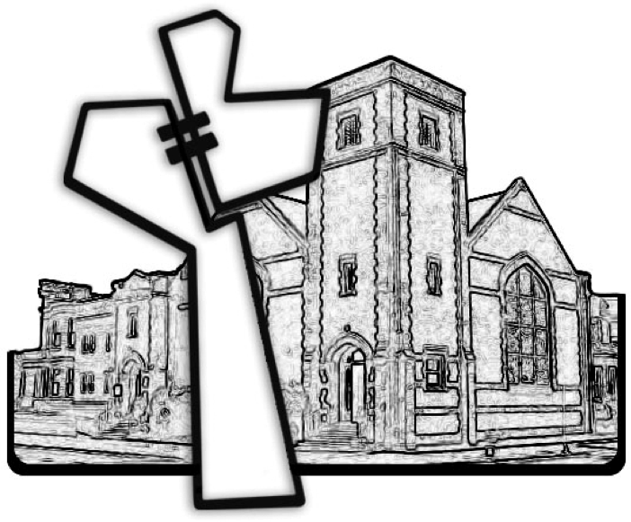

Chicago Community Mennonite Church



Chicago Community Mennonite Church

425 S. Central Park Blvd. (at Congress), Chicago, Illinois 60624-3224

www.ccmcil.org **|** facebook.com/ccmcil

**Church Council Chair:** Jason Gerig, 773-949-4496, jgerig@gmail.com

**Pastor:** Megan Ramer, 773-343-4251, pastor@ccmcil.org

**Minister of Arts & Community Organizing:** Rachael Weasley, 415-314-7156

July 12, 2015