Chicago Community Mennonite Church

June 7, 2015

Gathering

Prelude

Call to Worship

STJ 42 *Listen, God is calling*

Welcome

Lighting the Peace Lamp

Prayer for Peace

Praising

STJ 113 *For mornings bright*

Dedication of Archer Wyatt Vanderhoff

**Community: Archer Wyatt, as representatives of the community of believers and followers of Jesus, we dedicate ourselves to living lives of love, peace, justice, and compassion. We commit ourselves to love you as a child of God, and to prayerfully support you and your parents. May God grant us the grace to be faithful to our task.**

Psalm 130 Antiphonally

Children’s Time

*Let the children come to me; let the children come.*

*Never hinder them; never stop them. O let the children come.*

Receiving God’s Word

Mark 30:20-35

STJ 69 *Cuando el pobre (When the poor ones)*

2 Corinthians 4:13-5:1

One: For the word of God in scripture,   
for the word of God among us,   
for the word of God within us,

**All: thanks be to God.**

Meditation

Responding

HWB 607 *Today I live*

Recognition of Sunday School teachers

Sharing

Prayer

Sending

Announcements

Benediction: STJ 94 *Blest are they*

Extinguishing the Peace Candle

One: Now the light of Christ is in you.

**All: Thanks be to God.**

|  |
| --- |
| Worship Participants  Worship Leader: Nancy McCann Hostetter  Meditation: Megan Ramer  Song Leader: Philip Kendall  Pianist: Spencer Foon  Altar: Brooke Hutchison |

Announcements

**Annual Church Picnic Today:** Come join the fun in Garfield Park (just north of the church). This is an opportunity to recognize and thank the teachers and Education Committee for a job well done.

**Anabaptism 101, Sunday June 14:** Attendees of the recent membership exploration class have scheduled a Part II to cover some basic Mennonite history, theology and practice. Is the Mennonite faith tradition new to you? Interested in dipping your toes into Menno history and theology? Even if you missed Part I of the membership class, you are invited to a conversation after church. We'll wrap up no later than 2:00 p.m. Bring your own brown bag lunch. If the weather is nice, we may picnic in the garden! RSVP with Pastor Megan.

**Small Group on "The Upside-Down Kingdom":** The Small Group that meets at the Sacco's (6813 W. Shakespeare Ave, Chicago) will begin a six-part study of Donald B Kraybill's compelling "The Upside-Down Kingdom," where "Jesus wins by serving and triumphs by losing." The group will discuss the Introduction and the first two chapters on Sunday June 28 at 3pm. If you have any questions, call Michael Sacco at 630-222-9115.

Schedule

|  |  |  |
| --- | --- | --- |
|  | **Today** | **Next Sunday** |
| **Greeter:** | Derek Becker | Anna Hershey |
| **Nursery:** | Bob Hostetter  Jane Baker | Josiah Groff  Kate Myers |
| **Fellowship:** | Church Picnic | Joanne Zimmerly |

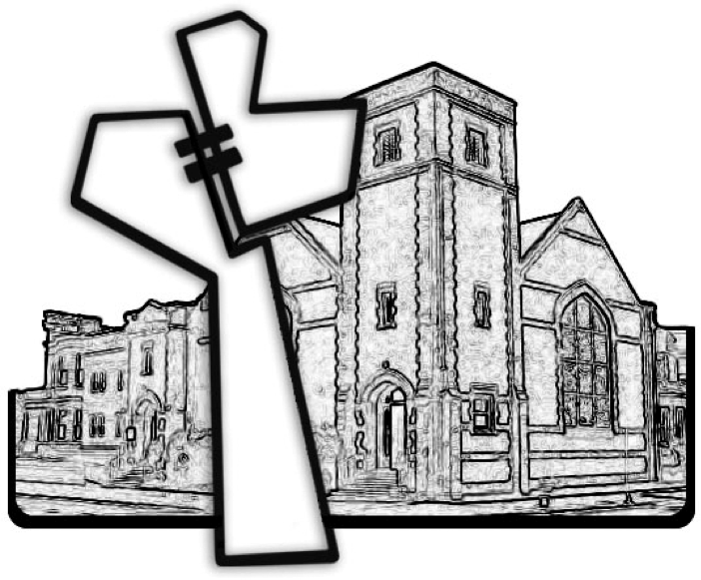

Chicago Community Mennonite Church



Chicago Community Mennonite Church

425 S. Central Park Blvd. (at Congress), Chicago, Illinois 60624-3224

www.ccmcil.org **|** facebook.com/ccmcil

**Church Council Chair:** Jason Gerig, 773-949-4496, jgerig@gmail.com

**Pastor:** Megan Ramer, 773-343-4251, pastor@ccmcil.org

**Minister of Arts & Community Organizing:** Rachael Weasley, 415-314-7156

June 7, 2015