Chicago Community Mennonite Church

June 28, 2015

Gathering

Prelude

Call to Worship: Lamentations 3:22-25

One: The steadfast love of the Lord never ceases;

God’s mercies never come to an end;

they are new every morning;

great is your faithfulness.

“The Lord is my portion,” says my soul,

“therefore I will hope in the Lord.”

The Lord is good to those who wait for God,

to the soul who seeks God.

**All: The steadfast love of the Lord never ceases.**

**We will seek the Lord. Amen**

HWB 327 *Great is thy faithfulness*

Welcome

Lighting the Peace Lamp

Prayer for Peace

Transitions

One: This pitcher is a symbol of transition and self-discovery for our congregation.  Our pastor, Megan Ramer, will be taking a new position in Seattle.  Just as water takes on many forms and gives life, so we renew our dedication to one another and our service to the greater community.

**All: May the water of eternal life sustain us**

**with hope and joy.**

Praising

STJ 16 *Praise with joy the world’s creator*

Psalm 30

Children’s Time

*Let the children come to me; let the children come.*

*Never hinder them; never stop them. O let the children come.*

Receiving God’s Word

HWB 405 *Where the cross the crowded ways*

Mark 5:21-43

One: For the word of God in scripture,   
for the word of God among us,   
for the word of God within us,

**All: thanks be to God.**

Meditation

Responding

HWB 377 *Healer of our every ill*

Sharing

Prayer

Communion

STJ 94 *Blest are they*

Sending

Announcements

Benediction

Extinguishing the Peace Lamp

One: Now the light of Christ is in you.

**All: Thanks be to God.**

|  |
| --- |
| Worship Participants  Worship Leader: Linda Becker  Meditation: Megan Ramer  Song Leader: Nancy Hostetter  Pianist: Steve Warkentin  Altar: Janet Friesen |

Announcements

**CCMC Taize Service, Fri July 3, 7:30pm:** CCMC's next Taize experience will be in Oak Park, where we will join the large monthly Taize gathering at Ascension Church (808 S. East Avenue Oak Park)!  Spencer Foon and Rachael Weasley are committed to go and welcome others to join them.  Let Rachael know if you'd like to attend so that we can meet up and sit together.  Taize is a worship style developed to promote peace and prevent world war by encouraging many nationalities to sing and sit in silence together.

**Mark your July calendars!**

* Rehoboth Blueberry Festival, Sat July 11. More details: Justin Riegsecker, justin.riegsecker@me.com.
* CCMC Canoeing & Camping weekend near Onekama MI, July 18-19. More details or to RSVP: Mark Liechty, liechty@uic.edu.
* Dunes Sunday, Sun July 26. No CCMC worship here in Chicago. More details: Pastor Megan, pastor@ccmcil.org.

**Christian Peacemaker Teams Prayer for Peacemakers:** Give thanks for the steadfast determination of the people of Susiya, who have are facing the obliteration of their village at the hands of Israel.  Give thanks for their Israeli and international supporters who recognize their right to remain where their families have lived for generations, and who will help them rebuild.

Schedule

|  |  |  |
| --- | --- | --- |
|  | **Today** | **Next Sunday** |
| **Greeter:** | Brooke Hutchison | Justin Riegsecker |
| **Nursery:** | Luciano Lima  Sherry Jost | Justin Riegsecker  Sara Reschly |
| **Fellowship:** | Antonia Kam | Paul Myers |

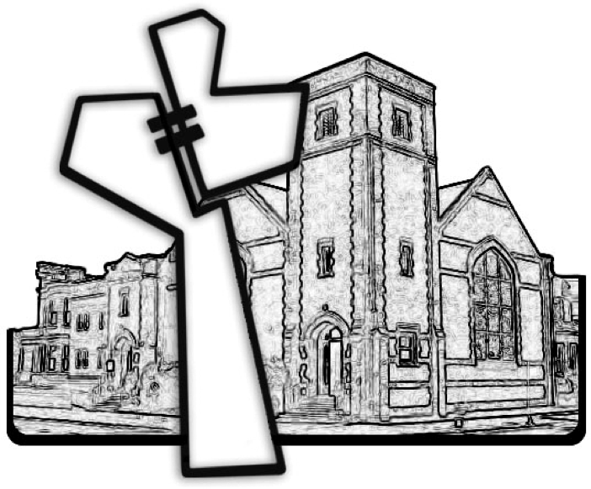

Chicago Community Mennonite Church



Chicago Community Mennonite Church

425 S. Central Park Blvd. (at Congress), Chicago, Illinois 60624-3224

www.ccmcil.org **|** facebook.com/ccmcil

**Church Council Chair:** Jason Gerig, 773-949-4496, jgerig@gmail.com

**Pastor:** Megan Ramer, 773-343-4251, pastor@ccmcil.org

**Minister of Arts & Community Organizing:** Rachael Weasley, 415-314-7156

June 28, 2015