Chicago Community Mennonite Church

June 21, 2015

Gathering

Prelude

Call to Worship

One: The worst storms, Jesus,

are the ones caused by our fear,

**All: when we grow afraid of losing our power,**

One: or we grow suspicious of the power of others,

**All: when we refuse to acknowledge**

**your mysterious authority**

One: Yet, it’s in the storm that we find our capacity to love.

**All: In releasing our weak claim to power**

One: and opening to your reign,

**All: we discover a new way of seeing ourselves –**

One: as called and useful and beloved –

and the other whoever they may be –

**All: as dignified and precious and beloved.**

One: Here in the storm, Jesus, we need you,

and we need each other,

**All: and the love you give us to share, leads us through sacrifice and self-giving to peace and calm,**

One: if only we will loose our hold on fear.

**All: Amen.**

HWB 558 *When the storms of life are raging*

Welcome

Lighting the Peace Lamp

Prayer for Peace

Praising

Psalm 107:1-3, 23-32

**All: Give thanks for Yahweh’s goodness,**

**God’s love endures forever.**

Children’s Time

*Let the children come to me; let the children come.*

*Never hinder them; never stop them. O let the children come.*

STS 72 *We are often tossed and driv’n*

Receiving God’s Word

2 Corinthians 6:1-13

Mark 4:35-41

One: For the word of God in scripture,   
for the word of God among us,   
for the word of God within us,

**All: thanks be to God.**

TMH 148 *Fierce raged the tempest* (insert)

STS 45 *Calm me, Lord*

Meditation

Responding

STS 45 *Calm me, Lord*

Sharing

Prayer: STS 45 *Calm me, Lord*

Offering

Archaeology of our Faith

Sending

Announcements

STJ 71 *Alleluia, the great storm is over*

Benediction

Extinguishing the Peace Lamp

One: Now the light of Christ is in you.

**All: Thanks be to God.**

|  |
| --- |
| Worship Participants  Worship Leader: Benjamin Anderson  Meditation: Megan Ramer  Song Leader: Rachael Weasley  Pianist: Spencer Foon  Altar: Jody Schmidt |

Announcements

**CCMC Taize Service, Fri July 3, 7:30pm:** CCMC's next Taize experience will be in Oak Park, where we will join the large monthly Taize gathering at Ascension Church (808 S. East Avenue Oak Park)!  Spencer Foon and Rachael Weasley are committed to go and welcome others to join them.  Let Rachael know if you'd like to attend so that we can meet up and sit together.  Taize is a worship style developed to promote peace and prevent world war by encouraging many nationalities to sing and sit in silence together.

**Mark your July calendars!**

* Rehoboth Blueberry Festival, Sat July 11. More details: Justin Riegsecker, justin.riegsecker@me.com.
* CCMC Canoeing & Camping weekend near Onekama MI, July 18-19. More details or to RSVP: Mark Liechty, liechty@uic.edu.
* Dunes Sunday, Sun July 26. No CCMC worship here in Chicago. More details: Pastor Megan, pastor@ccmcil.org.

**Small Group on "The Upside-Down Kingdom":** The Small Group that meets at the Sacco's (6813 W. Shakespeare Ave, Chicago) will begin a six-part study of Donald B Kraybill's compelling "The Upside-Down Kingdom," where "Jesus wins by serving and triumphs by losing." The group will discuss the Introduction and the first two chapters on Sunday June 28 at 3pm. If you have any questions, call Michael Sacco at 630-222-9115.

Schedule

|  |  |  |
| --- | --- | --- |
|  | **Today** | **Next Sunday** |
| **Greeter:** | Antonia Kam | Brooke Hutchison |
| **Nursery:** | Cecilia Goertzen  Chris Bohlander | Luciano Lima  Sherry Jost |
| **Fellowship:** | Anna Hershey | Antonia Kam |

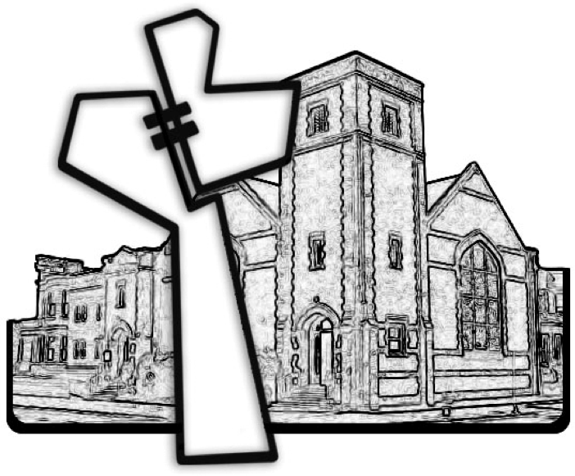

Chicago Community Mennonite Church



Chicago Community Mennonite Church

425 S. Central Park Blvd. (at Congress), Chicago, Illinois 60624-3224

www.ccmcil.org **|** facebook.com/ccmcil

**Church Council Chair:** Jason Gerig, 773-949-4496, jgerig@gmail.com

**Pastor:** Megan Ramer, 773-343-4251, pastor@ccmcil.org

**Minister of Arts & Community Organizing:** Rachael Weasley, 415-314-7156

June 21, 2015