Chicago Community Mennonite Church

June 14, 2015

Gathering

Prelude

Call to Worship

One: Called to be branches in Christ’s body,

**All: we yearn to be connected to the vine.**

One: Called to be mustard bushes offering shade

to God’s creatures,

**All: we search for places to plant the seeds of faith.**

One: Called to be growing with God

in the midst of this world’s painful questions,

**All: we seek God’s nurturing presence.**

HWB 6 *Here in this place*

Welcome

Lighting the Peace Lamp

Prayer for Peace

Praising

HWB 110 *Oh, for a thousand tongues to sing*

Psalm 92:1-4, 12-15

It is good to give thanks to God,

   to sing praises to your name, O Most High;

to declare your steadfast love in the morning,

   and your faithfulness by night,

to the music of the lute and the harp,

   to the melody of the lyre.

For you, O God, have made me glad by your work;

   at the works of your hands I sing for joy.

The righteous flourish like the palm tree,

   and grow like a cedar in Lebanon.

They are planted in the house of God;

   they flourish in the courts of our God.

In old age they still produce fruit;

    they are always green and full of sap,

     showing that God is upright;

God is my rock, and has no unrighteousness.

Children’s Time

*Let the children come to me; let the children come.*

*Never hinder them; never stop them. O let the children come.*

HWB 226 *You are salt for the earth*

Receiving God’s Word

Ezekiel 17:22-24

HWB 224 *The kingdom of God*

Mark 4:26-34

One: For the word of God in scripture,   
for the word of God among us,   
for the word of God within us,

**All: thanks be to God.**

Meditation

Responding

STS 116 *I saw a tree by the riverside*

Sharing

Prayer: HWB 348 *O Lord, hear my prayer*

Offering

Archaeology of our Faith

Sending

Announcements

STS 124 *My soul cries out*

Benediction

Extinguishing the Peace Lamp

One: Now the light of Christ is in you.

**All: Thanks be to God.**

|  |
| --- |
| Worship Participants  Worship Leader: Alita Yoder  Meditation: David Weasley  Song Leader: Glenn Martin Klaassen  Pianist: Beth Peachey  Altar: Antonia Kam |

Announcements

**Action Against Budget Cuts Tomorrow Morning:** Join people of faith and conscience downtown for the 4th consecutive Monday action against Gov. Rauner's threatened budget cuts. Bonus: you will see people wearing a two-person camel costume sewn by Rachael Weasley! There will also be a giant needle made out of swim noodles. June 15, 10:30am – Noon at Thompson Center (Meet at Thompson Center and Process to an Undisclosed Location).

**Small Group on "The Upside-Down Kingdom":** The Small Group that meets at the Sacco's (6813 W. Shakespeare Ave, Chicago) will begin a six-part study of Donald B Kraybill's compelling *The Upside-Down Kingdom*, where "Jesus wins by serving and triumphs by losing." The group will discuss the Introduction and the first two chapters on Sunday June 28 at 3pm. If you have any questions, call Michael Sacco at 630-222-9115.

**Mark your July calendars!**

* Rehoboth Blueberry Festival, Sat July 11. More details: Justin Riegsecker, justin.riegsecker@me.com.
* CCMC Canoeing & Camping weekend near Onekama MI, July 18-19. More details or to RSVP: Mark Liechty, liechty@uic.edu.
* Dunes Sunday, Sun July 26. No CCMC worship here in Chicago. More details: Pastor Megan, pastor@ccmcil.org.

Schedule

|  |  |  |
| --- | --- | --- |
|  | **Today** | **Next Sunday** |
| **Greeter:** | Anna Hershey | Antonia Kam |
| **Nursery:** | Josiah Groff  Kate Myers | Cecillia Goertzen  Chris Bohlander |
| **Fellowship:** | Joanne Zimmerly | Anna Hershey |

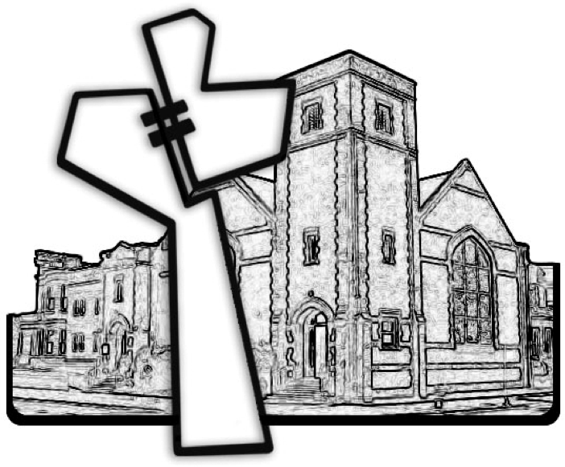

Chicago Community Mennonite Church



Chicago Community Mennonite Church

425 S. Central Park Blvd. (at Congress), Chicago, Illinois 60624-3224

www.ccmcil.org **|** facebook.com/ccmcil

**Church Council Chair:** Jason Gerig, 773-949-4496, jgerig@gmail.com

**Pastor:** Megan Ramer, 773-343-4251, pastor@ccmcil.org

**Minister of Arts & Community Organizing:** Rachael Weasley, 415-314-7156

June 14, 2015