Chicago Community Mennonite Church

May 31, 2015 ✢ Trinity Sunday

Gathering

Prelude

Call to Worship – HWB 670

One: Our God, we gather to worship you,

the One who creates all things.

**Many: For the gift of creation, we give thanks.**

One: We gather to worship you,

the One who brings salvation through Jesus Christ.

**Many: For the gift of redemption, we give thanks.**

One: We gather to worship you,

the One who sustains us by the Spirit.

**Many: For the gift of your presence, we give thanks.**

One: We bring to your our offerings of thanks and praise

for all your gifts.

***All: We worship you –***

***our Creator, Redeemer and Sustainer. Amen***

HWB 13 *Blessed Jesus, at your word*

Welcome

Lighting the Peace Lamp

Prayer for Peace

Praising

HWB 126 *How wondrous great*

Psalm 29:1-11 Antiphonally

Children’s Time

*“Let the children come to me; let the children come. Never hinder them; never stop them. O let the children come.”*

Receiving God’s Word

Isaiah 6:1-8

HWB 334 *Christ is the world’s true light*

Acts 15:1-11

One: For the word of God in scripture,   
for the word of God among us,   
for the word of God within us,

**All: thanks be to God.**

Meditation

Responding

HWB 361 *O Spirit of the living God*

Sharing

Prayer

One: God of all nations,

your love is without limit and without end,

By the example of your Son,

make us ready to serve the needs of the whole world.

**Many: May neither pride of race nor hardness of heart**

**make us despise any for whom Christ died**

**or injure any in whom Christ lives;**

**through the same Jesus Christ our Lord. Amen**

Communion

Sending

Announcements

STJ 429 *Go now in peace*

Benediction

Extinguishing the Peace Candle

One: Now the light of Christ is in you.

**All: Thanks be to God.**

|  |
| --- |
| Worship Participants  Worship Leader: Merle Baker  Meditation: Russell Johnson  Song Leader: Glenn Martin Klaassen  Pianist: Beth Peachey  Altar: Janet Friesen |

Announcements

**Pastor Megan’s Travel Schedule:** Jon and I are in Seattle for a candidating weekend Friday May 29 - Monday June 1. I will be back in the office Tuesday June 2.

**Annual Church Picnic – June 7:** Come join the fun in Garfield Park (just north of the church). This is an opportunity to recognize and thank the teachers and Education Committee for a job well done.

**Community Organizing Training, Saturday June 6 at 11:30am:** The Peace, Justice, & Service Committee hosts a community organizing training from 11:30am to 3:30pm.   Rachael's partner David Weasley will be our guest trainer, and he will focus on the grassroots methodology of community organizing, which is about learning what's important to the people in your community and making connections between people with shared passions to work towards a common goal.  Bring a bagged lunch or something to share.

**Anabaptism 101, Sunday June 14:** Attendees of the recent membership exploration class have scheduled a Part II to cover some basic Mennonite history, theology and practice. Is the Mennonite faith tradition new to you? Interested in dipping your toes into Menno history and theology? Even if you missed Part I of the membership class, you are invited to a conversation after church. We'll wrap up no later than 2:00 p.m. If the weather is nice, we may brown bag lunch a picnic in the garden! RSVP with Pastor Megan.

**Small Group on "The Upside-Down Kingdom":** The Small Group that meets at the Sacco's (6813 W. Shakespeare Ave,  Chicago) will begin a six-part study of Donald B Kraybill's compelling "The Upside-Down Kingdom," where "Jesus wins by serving and triumphs by losing." The group will discuss the Introduction and the first two chapters on Sunday June 28 at 3pm. If you have any questions, call Michael Sacco at 630-222-9115.

Schedule

|  |  |  |
| --- | --- | --- |
|  | **Today** | **Next Sunday** |
| **Greeter:** | Rosalynn Gingerich | Derek Becker |
| **Nursery:** | Ross Bay  Janet Friesen | Bob Hostetter  Jane Baker |
| **Fellowship:** | Leigh Peters-Fransen | Church Picnic |
| **Welcome Table:** | Amber Kessler Freer  Josiah Groff | Church Picnic |

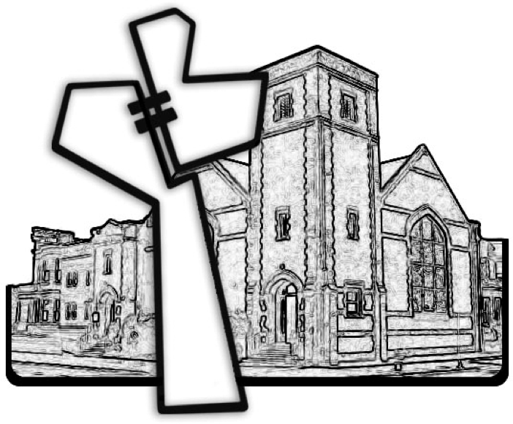

Chicago Community Mennonite Church



Chicago Community Mennonite Church

425 S. Central Park Blvd. (at Congress), Chicago, Illinois 60624-3224

www.ccmcil.org **|** facebook.com/ccmcil

**Church Council Chair:** Jason Gerig, 773-949-4496, jgerig@gmail.com

**Pastor:** Megan Ramer, 773-343-4251, pastor@ccmcil.org

May 31, 2015