Chicago Community
Mennonite Church
425 S. Central Park Blvd., Chicago, IL 60624
(773) 343-4251 | pastor@ccmcil.org
www.ccmcil.org | facebook.com/ccmcil

Jason Gerig, Council Chair Tim Peebles, Transitional Pastor

December 27, 2015 ✢ Christmas
Gathering
Prelude
Call to Worship
One: Today the light has come:
All: We have seen the star in the east.
One: Today the shepherds have come:
All: We have them bow in adoration.
One: Today the Angels appeared:
All: We have heard their hosannas sung on high.
One: Today the sheep and camels stood calmly by his side:
All: We have seen them on the hillsides.
One: We have seen the Christ child:
All: Born in a stable and alive in all human hearts.
STS 30 Arise your light is come
HWB 189 To us a child of hope it’s born
Welcome
Lighting the Peace Lamp
Prayer for Peace
Matthew 2:1-15
Praising
HWB 212 O come all ye faithful
Advent Candle Lighting
Children’s Time
Let the children come to me; let the children come.
Never hinder them; never stop them. O let the children come.
Matthew 2:16-23
HWB 215 What child is this?
STS 26 Helpless and hungry
Receiving God’s Word
Psalm 8
Isaiah 55:1-5
One: For the word of God in scripture,
for the word of God among us,
for the word of God within us,
All: thanks be to God.
Meditation
Responding
HWB 211 Lo how a rose
Sharing
Communion
Sending
Announcements
HWB 318 Joy to the world
Benediction
Extinguishing the Peace Lamp
One: Now the light of Christ is in you.
All: Thanks be to God.

Worship Participants
Worship Leader: Lauren Friesen
Meditation: Tim Peebles
Song Leader: Beth Peachey
Altar: Janet Friesen
Announcements

India Mission Fund: Contributions are still being accepted toward Samita Pal’s nursing school tuition for 2015-16. Please consider helping to make advanced education and a future career of service attainable for this young Indian woman. Checks can be made out to Chicago Community Mennonite Church with “India Mission Fund” on the memo line.
Pastoral Care Needs: In this time of transition, you can share prayer and care concerns with any member of the Prayer and Care Team (Nancy, Rochelle, Derek, Ross, Jan, Tim). If you believe that a particular prayer and care concern requires direct pastoral care, please indicate that when you speak with one of the team members, or contact Pastor Tim directly (pastor@ccmcil.org).

Schedule
 | Today | Next Sunday
Greeter: | Antonia Kam | Derek Becker
Nursery: | Brian Paff  Joel Peters-Fransen | Liz Dyrst  Ross Bay
Fellowship: | Ross Bay | Jan Lugibihl, Spencer Foon, Martin Dyrst
------------------------------------------ tear here -----------------------------------------
CCMC Connect Card
We are glad you have joined us for worship! The best way to plug into our congregation is to sign up for our listserv. Bring this card to the Welcome Table in the fellowship hall following worship to receive a welcome gift.
You may also drop it in the offering plate or the basket on the greeter table.

Name______________________________ Phone ______________________

Address_________________________________________________________

Email___________________________________________________________

Add to CCMC listserv to get connected via email? □ Yes □ No, not yet.

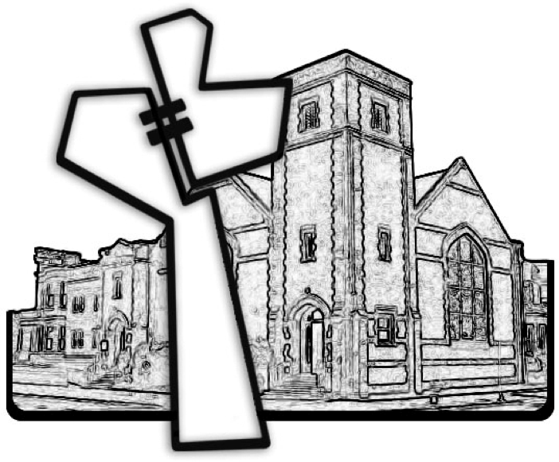
Chicago Community Mennonite Church
December 27, 2015

