Chicago Community
Mennonite Church
425 S. Central Park Blvd., Chicago, IL 60624
(773) 343-4251 | pastor@ccmcil.org
www.ccmcil.org | facebook.com/ccmcil

Jason Gerig, Council Chair Tim Peebles, Transitional Pastor

December 20, 2015 ✢ Fourth Sunday of Advent
Gathering
Prelude
Call to Worship
One: We come seeking Jesus, the Light of the world!
All: Shine in our hearts, Lord Jesus!
One: We believe in the strength of God
to illuminate dark places.
All: The light shines in the darkness,
and the darkness shall not overcome it.
One: Lord, in this hour of worship, kindle in us
the light of your love.
All: Let your light shine through us, now and forever.
STS 1 Praise the One who breaks the darkness
Welcome
Lighting the Peace Lamp
Prayer for Peace
Praising
STS 7 Come, Come Emmanuel
Children’s Time
Let the children come to me; let the children come.
Never hinder them; never stop them. O let the children come.
Advent Candle Lighting
STS 4 Rejoice, rejoice the Savior comes

Receiving God’s Word
Genesis 1:1-2
John 1:1-20
Colossians 1:15-23
Ephesians 1:1-14
One: For the word of God in scripture,
for the word of God among us,
for the word of God within us,
All: thanks be to God.
STS 15 Hope is a candle
Meditation
Responding
HWB 188 Sleepers, wake
Sharing
Prayer
Offering
Sending
Announcements
STS 10 Come, walk in the light
Benediction
Extinguishing the Peace Lamp
One: Now the light of Christ is in you.
All: Thanks be to God.

Worship Participants
Worship Leader: Benjamin Anderson
Meditation: Tim Peebles
Song Leader: Mariell Waltner
Pianist: Kiva Nice-Webb
Altar: Brooke Hutchison
Announcements
Adult Education: CCMC History Part 2: We will reconvene to reflect more on our past has shaped our present. Everyone, regardless of how long you have attended, is welcome to participate. Your presence has played a role in shaping our community.

Longest Night Service, Monday, Dec. 21, 6:30 p.m.: Come for a contemplative worship service marking the coming of winter and honoring some of the loss associated with the Christmas season.

India Mission Fund: Contributions are still being accepted toward Samita Pal’s nursing school tuition for 2015-16. Please consider helping to make advanced education and a future career of service attainable for this young Indian woman. Checks can be made out to Chicago Community Mennonite Church with “India Mission Fund” on the memo line.

Pastoral Care Needs: In this time of transition, you can share prayer and care concerns with any member of the Prayer and Care Team (Nancy, Rochelle, Derek, Ross, Jan, Tim). If you believe that a particular prayer and care concern requires direct pastoral care, please indicate that when you speak with one of the team members, or contact Pastor Tim directly (pastor@ccmcil.org).

Schedule
 | Today | Next Sunday
Greeter: | Justin Hochstetler | Antonia Kam
Nursery: | Linda Becker  Janet Friesen | Brian Paff  Joel Peters-Fransen
Fellowship: | Justin Riegsecker | Jan Lugibihl
------------------------------------------ tear here -----------------------------------------
CCMC Connect Card
We are glad you have joined us for worship! The best way to plug into our congregation is to sign up for our listserv. Bring this card to the Welcome Table in the fellowship hall following worship to receive a welcome gift.
You may also drop it in the offering plate or the basket on the greeter table.

Name______________________________ Phone ______________________

Address_________________________________________________________

Email___________________________________________________________

Add to CCMC listserv to get connected via email? □ Yes □ No, not yet.

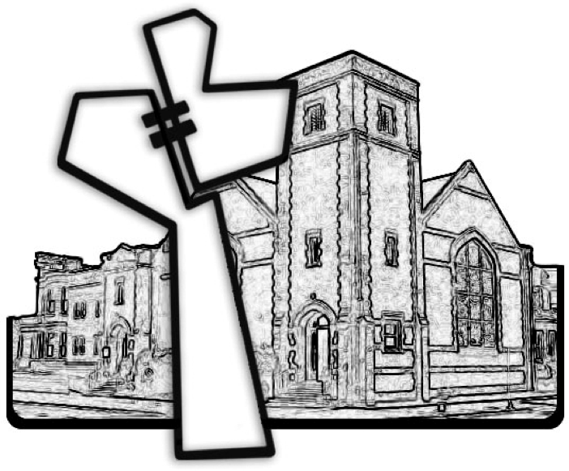
Chicago Community Mennonite Church
December 20, 2015

