Chicago Community
Mennonite Church
425 S. Central Park Blvd., Chicago, IL 60624
(773) 343-4251 | pastor@ccmcil.org
www.ccmcil.org | facebook.com/ccmcil

Jason Gerig, Council Chair Tim Peebles, Transitional Pastor

December 13, 2015 ✢ Third Sunday of Advent
Gathering
Prelude
Call to Worship
One: Holy One, we gather in your name to worship you.
All: We give thanks for the small spark of God within us.
One: Holy One, we gather in your name waiting
and seeking Christ's coming among us.
All: We wait expectantly for that spark
to be kindled into a flame.
One: Holy One, we gather from far and near to bear witness
to the year of the Lord's favor.
All: Come Lord Jesus, Come.
STS 7 Come, come Emmanuel
Welcome
Lighting the Peace Lamp
Prayer for Peace
Praising
Isaiah 61:1-2
Micah 6:8
Children’s Time
Let the children come to me; let the children come.
Never hinder them; never stop them. O let the children come.
Advent Candle Lighting
Archaeology of our Faith

Receiving God’s Word
Luke 1:1-2:20, 4:18-19
HWB 180 The angel Gabriel
HWB 181 My soul proclaims with wonder
HWB 174 Bless’d be the God of Israel
HWB 196 While shepherds watched
HWB 201 Hark! the herald angels sing
One: For the word of God in scripture,
for the word of God among us,
for the word of God within us,
All: thanks be to God.
Meditation
Responding
Sharing
Prayer
Offering
Sending
Announcements
Benediction
STS 7 Come, come Emmanuel
Extinguishing the Peace Lamp
One: Now the light of Christ is in you.
All: Thanks be to God.

Worship Participants
Worship Leader: Kiva Nice-Webb
Meditation: Tim Peebles
Song Leader: Nancy Hostetter
Instrumentalists: Beth Peachey, Benjamin Anderson
Altar: Jody Schmidt
Announcements
Adult Education: Sharing Our Spiritual Journeys: Please join us for a time of sharing with Philip Kendall, as he reflects on the pathways of his life journey. Whenever we listen to one another's life stories, we find ourselves on holy ground.

Longest Night Service, Monday, Dec. 21, 6:30 p.m.: Come for a contemplative worship service marking the coming of winter and honoring some of the loss associated with the Christmas season.

India Mission Fund: Contributions are still being accepted toward Samita Pal’s nursing school tuition for 2015-16. Please consider helping to make advanced education and a future career of service attainable for this young Indian woman. Checks can be made out to Chicago Community Mennonite Church with “India Mission Fund” on the memo line.

Pastoral Care Needs: In this time of transition, you can share prayer and care concerns with any member of the Prayer and Care Team (Nancy, Rochelle, Derek, Ross, Jan, Tim). If you believe that a particular prayer and care concern requires direct pastoral care, please indicate that when you speak with one of the team members, or contact Pastor Tim directly (pastor@ccmcil.org).

Schedule
 | Today | Next Sunday
Greeter: | Justin Beeker | Justin Hochstetler
Nursery: | Jan Lugibihl  Martin Dyrst | Linda Becker  Janet Friesen
Fellowship: | Justin Beeker | Justin Riegsecker
------------------------------------------ tear here -----------------------------------------
CCMC Connect Card
We are glad you have joined us for worship! The best way to plug into our congregation is to sign up for our listserv. Bring this card to the Welcome Table in the fellowship hall following worship to receive a welcome gift.
You may also drop it in the offering plate or the basket on the greeter table.

Name______________________________ Phone ______________________

Address_________________________________________________________

Email___________________________________________________________

Add to CCMC listserv to get connected via email? □ Yes □ No, not yet.

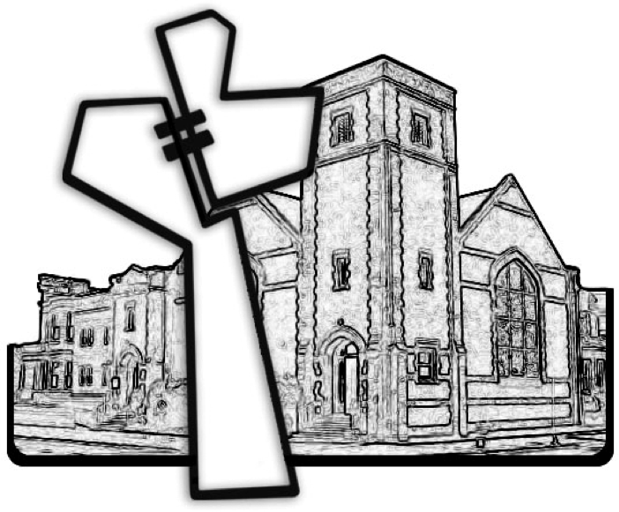
Chicago Community Mennonite Church
December 13, 2015

