Chicago Community
Mennonite Church
425 S. Central Park Blvd., Chicago, IL 60624
(773) 343-4251 | pastor@ccmcil.org
www.ccmcil.org | facebook.com/ccmcil

Jason Gerig, Council Chair Tim Peebles, Transitional Pastor

November 8, 2015
Gathering
Prelude
Call to Worship
HWB 1 What is this place
Welcome
Lighting the Peace Lamp
Prayer for Peace
Praising
HWB 343 My hope is built on nothing less
Psalm 127
Children’s Time
Let the children come to me; let the children come.
Never hinder them; never stop them. O let the children come.
HWB 397 God loves all his many people
Receiving God’s Word
Ecclesiastes 3:1-8; Phillipians 1:6
HWB 545 Be thou my vision
Matthew 16:19, 18:18
One: For the word of God in scripture,
for the word of God among us,
for the word of God within us,
All: thanks be to God.
Meditation
Responding
HWB 328 O God, our help in ages past
Sharing
Offering
Archeology of our Faith
Sending
Announcements
HWB 433 Go, my children
Benediction
Extinguishing the Peace Lamp
One: Now the light of Christ is in you.
All: Thanks be to God.

Worship Participants
Worship Leader: Alita Yoder
Meditation: Tim Peebles
Song Leader: Philip Kendall
Instrumentalists: Derek Becker, Mark Vanderhoff
Altar: Antonia Kam
Announcements

Special Matching Fund to Benefit Kori's Kids: Donations are invited to be made to a special fund to benefit the children of Korissa Chupp whose life was lost in a July 10 house fire that also severely burned her children – Jerry Junior (7) and Kiara (2) – and their father Jerry Senior who suffered minor burns. Donations to the fund will be matched by Everence (as funds allow). Church council has already allocated $500 to the fund. Can you help us reach a $2,000 goal? To make a contribution, write a check to CCMC with “Kori’s Kids Fund” in the memo line. Donations should be made by December 10 in order to qualify for the Everence matching.

Adult Education – LGBTQ Task Force: Here and Now (Part 1): Join us for a presentation of developmental highlights, regarding LGBTQ inclusion within MSUSA. Starting with the KC convention and leading to present time, topics include first hand accounts from the convention, a review of the responses since the conference by several MSUSA conferences and educational institutions, and a high-level exploration of the new Human Sexuality paper from the Central District Conference.

Pastoral Care Needs: In this time of transition, you can share prayer and care concerns with any member of the Prayer and Care Team (Nancy, Rochelle, Derek, Ross, Jan, Tim). We will share those needs within the team, consider how to best attend to them, and assign members of the team to respond accordingly. If you believe that a particular prayer and care concern requires direct pastoral care, please indicate that when you speak with one of the team members, or contact Pastor Tim directly (pastor@ccmcil.org).

Schedule
 | Today | Next Sunday
Greeter: | Amber Kessler Freer | Geoff Martin
Nursery: | Brooke Hutchison  Justin Hochstetler | Laura Hostetter  Joanne Zimmerly
Fellowship: | Jan Lugibihl | Jason Gerig
------------------------------------------ tear here -----------------------------------------
CCMC Connect Card
We are glad you have joined us for worship! The best way to plug into our congregation is to sign up for our listserv. Bring this card to the Welcome Table in the fellowship hall following worship to receive a welcome gift.
You may also drop it in the offering plate or the basket on the greeter table.

Name______________________________ Phone ______________________

Address_________________________________________________________

Email___________________________________________________________

Add to CCMC listserv to get connected via email? □ Yes □ No, not yet.

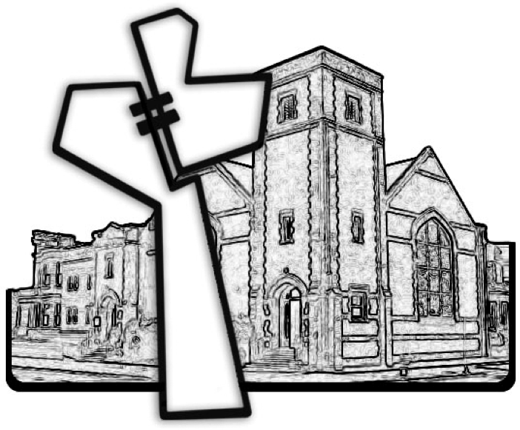
Chicago Community Mennonite Church
November 8, 2015

