Chicago Community
Mennonite Church
425 S. Central Park Blvd., Chicago, IL 60624
(773) 343-4251 | pastor@ccmcil.org
www.ccmcil.org | facebook.com/ccmcil

Jason Gerig, Council Chair Tim Peebles, Transitional Pastor

November 29, 2015 ✢ First Sunday of Advent
Gathering
Prelude
Call to Worship
One: Now is the time of watching and waiting.
All: The time of pregnant expectation of new life.
One: Now is the season of hope unfolding.
All: The dark winter season
when hope is waiting to be born.
One: Let us come before God with receptive and willing spirits.
All: Rejoice! God comes to bring
the birthday of life and hope.
STS 1 Praise the One who breaks the darkness
Welcome
Lighting the Peace Lamp
Prayer for Peace
Praising
Children’s Time
Let the children come to me; let the children come.
Never hinder them; never stop them. O let the children come.
STJ 7 Come, come Immanuel
Receiving God’s Word
Psalm 68:5-6
Romans 8:14-16
Galatians 4:4-6
HWB 178 Come, thou long expected Jesus
Matthew 1:1 - 2:23
One: For the word of God in scripture,
for the word of God among us,
for the word of God within us,
All: thanks be to God.
Meditation/Sharing
Responding
HWB 182 Oh, how shall I receive thee
Prayer
Offering
Sending
Announcements
STS 16 Peace before us
Benediction
Extinguishing the Peace Lamp
One: Now the light of Christ is in you.
All: Thanks be to God.

Worship Participants
Worship Leader: Jan Lugibihl
Meditation: Tim Peebles
Song Leader: Philip Kendall
Altar: Brooke Hutchison
Announcements
Advent Cookie Party, Saturday, Dec. 5, 4 p.m.: The Peters-Fransens will host the annual CCMC cookie party at 115 Elgin Ave in Forest Park. The cookie ceremonies will be followed by a pizza dinner at 6 p.m. and then the classic Grinch and a second holiday movie. RSVP to Joel and Leigh, petersfransen@gmail.com.

Annual Meeting, Sunday, Dec. 6: Hear from each of our committees, our financial team, Pastor Tim, and your council chair. We’ll be approving a slate and a budget for 2016. Wear your most Christmas-y holiday sweater. Whether “ugly” or beautiful, all holiday sweaters are welcome. There will be baked good prizes.

Donations & Tour of Breakthrough Urban Ministries: You are invited to join several of us as we attend Breakthrough’s “Behind the Scenes Tour” on Monday, Dec. 7 at 6:15 pm. Contact Geoff Martin gmartin9@gmail.com to coordinate details. Please also consider donating items from the Breakthrough “Wish List” (at breakthrough.org) for their Christmas Store program. PJS will deliver CCMC’s “Wish List” donations to Breakthrough on the Dec. 7th tour.

Special Matching Fund to Benefit Kori’s Kids: Donations are invited to be made to a special fund to benefit the children of Korissa Chupp whose life was lost in a July 10 house fire. Donations made by December 10 will be matched by Everence (as funds allow). Can you help us reach a $2,000 goal? To make a contribution, write a check to CCMC with “Kori’s Kids Fund” in the memo line.

Schedule
 | Today | Next Sunday
Greeter: | Josiah Groff | Jan Lugibihl
Nursery: | Steve Jost  Zemir Magalhaes | Bob Hostetter  Mark Frey
Fellowship: | Antonia Kam | Russell Johnson
------------------------------------------ tear here -----------------------------------------
CCMC Connect Card
We are glad you have joined us for worship! The best way to plug into our congregation is to sign up for our listserv. Bring this card to the Welcome Table in the fellowship hall following worship to receive a welcome gift.
You may also drop it in the offering plate or the basket on the greeter table.

Name______________________________ Phone ______________________

Address_________________________________________________________

Email___________________________________________________________

Add to CCMC listserv to get connected via email? □ Yes □ No, not yet.

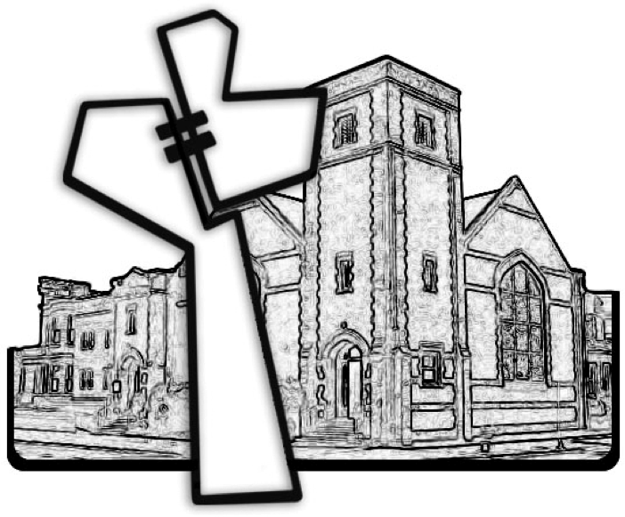
Chicago Community Mennonite Church
November 29, 2015

