Chicago Community
Mennonite Church
425 S. Central Park Blvd., Chicago, IL 60624
(773) 343-4251 | pastor@ccmcil.org
www.ccmcil.org | facebook.com/ccmcil

Jason Gerig, Council Chair Tim Peebles, Transitional Pastor

November 1, 2015
Gathering
Prelude
Call to Worship
HWB 16 God is here among us
Lighting the Peace Lamp
Prayer for Peace
Welcome
Praising
Isaiah 25:6-9
Psalm 24
HWB 186 Fling wide the door, unbar the gate
Children’s Time
Let the children come to me; let the children come.
Never hinder them; never stop them. O let the children come.
Receiving God’s Word
HWB 299 New earth, heavens new
Revelation 21:1-6a
HWB 234 When Jesus wept, the falling tear
John 11:32-44
One: For the word of God in scripture,
for the word of God among us,
for the word of God within us,
All: thanks be to God.
Meditation
Responding
Special Music: “Poor Wayfaring Stranger”
HWB 497 Come, ye disconsolate
Sharing
Offering
Sending
Announcements
HWB 580 My life flows on
Benediction
Extinguishing the Peace Lamp
One: Now the light of Christ is in you.
All: Thanks be to God.

Worship Participants
Worship Leader: Kiva Nice-Webb
Meditation: Thais Carter
Song Leader: Glenn Martin Klaassen
Pianist: Antonia Kam
Altar: Brooke Hutchison
Announcements

Pastoral Care Needs: In this time of transition, you can share prayer and care concerns with any member of the Prayer and Care Team (Nancy, Rochelle, Derek, Ross, Jan, Tim). We will share those needs within the team, consider how to best attend to them, and assign members of the team to respond accordingly. If you believe that a particular prayer and care concern requires direct pastoral care, please indicate that when you speak with one of the team members, or contact Pastor Tim directly (pastor@ccmcil.org).

Schedule
 | Today | Next Sunday
Greeter: | Katie VanderHeide | Josiah Groff
Nursery: | Cecilia Goertzen  Jane Baker | Brooke Hutchison  Derek Becker
Fellowship: | Rochelle Martin Klaassen  Paul Myers | Jan Lugibihl
------------------------------------------ tear here -----------------------------------------
CCMC Connect Card
We are glad you have joined us for worship! The best way to plug into our congregation is to sign up for our listserv. Bring this card to the Welcome Table in the fellowship hall following worship to receive a welcome gift.
You may also drop it in the offering plate or the basket on the greeter table.

Name______________________________ Phone ______________________

Address_________________________________________________________

Email___________________________________________________________

Add to CCMC listserv to get connected via email? □ Yes □ No, not yet.

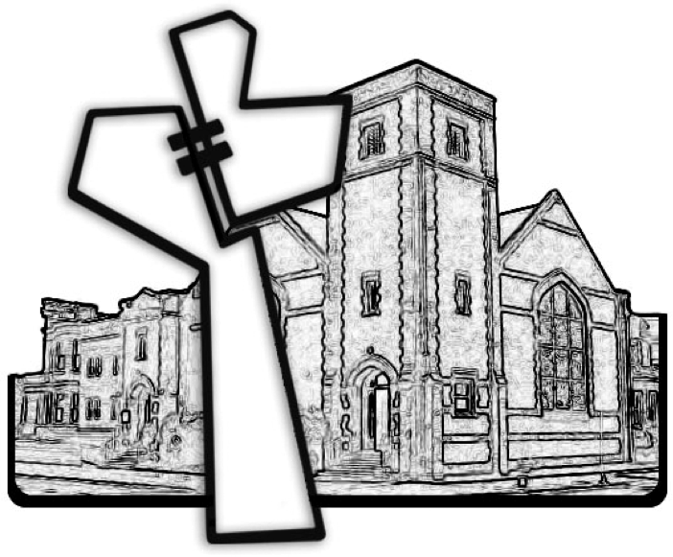
Chicago Community Mennonite Church
November 1, 2015

