Chicago Community
Mennonite Church
425 S. Central Park Blvd., Chicago, IL 60624
(773) 343-4251 | pastor@ccmcil.org
www.ccmcil.org | facebook.com/ccmcil

Jason Gerig, Council Chair Tim Peebles, Transitional Pastor

November 15, 2015
Gathering
Prelude
Call to Worship
One: Jesus taught us to speak of hope as the coming of God’s kingdom.
All: We believe that God is at work in our world
turning hopeless and evil situations into good.
We believe that goodness and justice and love
will triumph in the end and that tyranny and oppression cannot last forever.
One day all tears will be wiped away;
the lamb will lie down with the lion,
and justice will roll down like a mighty stream.
One: True peace and true reconciliation are not only desired,
they are assured and guaranteed in Christ.
All: This is our faith. This is our hope.
HWB 21 All praise to our redeeming Lord
Welcome
Lighting the Peace Lamp
Prayer for Peace
Praising
STJ 1 We sing to you, O God
Psalm 67
Children’s Time
Let the children come to me; let the children come.
Never hinder them; never stop them. O let the children come.
STJ 15 Santo (Holy)
Receiving God’s Word
Psalm 119:97-105
1 Corinthians 5:16-21
One: For the word of God in scripture,
for the word of God among us,
for the word of God within us,
All: thanks be to God.
Meditation
Responding
HWB 407 We are people of God’s peace
Blessing of Molly Hostetter and Liz Finch
Sharing
Prayer
Offering
Sending
Announcements
STS 49 I will come to you in the silence
Benediction
Extinguishing the Peace Lamp
One: Now the light of Christ is in you.
All: Thanks be to God.

Worship Participants
Worship Leader: Erin and Justin Beeker
Meditation: Tim Peebles
Song Leader: Beth Peachey
Instrumentalists: Kiva Nice-Webb
Altar: Jody Schmidt
Announcements
Adult Education – LGBTQ Task Force: Here and Now (Part 2): Join us for a second session of developmental highlights, regarding LGBTQ inclusion within MSUSA. Topics include first hand accounts from the convention, a review of the responses since the conference by several MSUSA conferences and educational institutions, and a high level exploration of the new Human Sexuality paper from the Central District Conference.
Special Matching Fund to Benefit Kori’s Kids: Donations are invited to be made to a special fund to benefit the children of Korissa Chupp whose life was lost in a July 10 house fire that also severely burned her children – Jerry Junior (7) and Kiara (2) – and their father Jerry Senior who suffered minor burns. Donations to the fund will be matched by Everence (as funds allow). Can you help us reach a $2,000 goal? To make a contribution, write a check to CCMC with “Kori’s Kids Fund” in the memo line. Donations should be made by December 10 in order to qualify for the Everence matching.

Pastoral Care Needs: In this time of transition, you can share prayer and care concerns with any member of the Prayer and Care Team (Nancy, Rochelle, Derek, Ross, Jan, Tim). We will share those needs within the team, consider how to best attend to them, and assign members of the team to respond accordingly. If you believe that a particular prayer and care concern requires direct pastoral care, please indicate that when you speak with one of the team members, or contact Pastor Tim directly (pastor@ccmcil.org).

Schedule
 | Today | Next Sunday
Greeter: | Geoff Martin | Justin Hochstetler
Nursery: | Laura Hostetler  Joanne Zimmerly | Anna Schnurr  Derek Becker
Fellowship: | Jason Gerig | Ross Bay
------------------------------------------ tear here -----------------------------------------
CCMC Connect Card
We are glad you have joined us for worship! The best way to plug into our congregation is to sign up for our listserv. Bring this card to the Welcome Table in the fellowship hall following worship to receive a welcome gift.
You may also drop it in the offering plate or the basket on the greeter table.

Name______________________________ Phone ______________________

Address_________________________________________________________

Email___________________________________________________________

Add to CCMC listserv to get connected via email? □ Yes □ No, not yet.

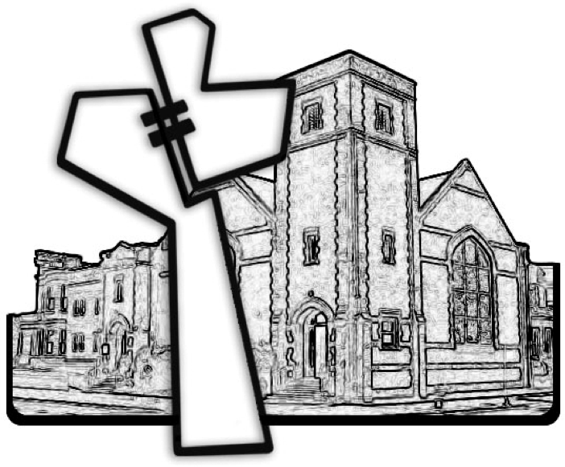
Chicago Community Mennonite Church
November 15, 2015

