Chicago Community
Mennonite Church
425 S. Central Park Blvd., Chicago, IL 60624
(773) 343-4251 | pastor@ccmcil.org
www.ccmcil.org | facebook.com/ccmcil

Jason Gerig, Council Chair Tim Peebles, Transitional Pastor

October 11, 2015
Gathering
Prelude
Call to Worship
HWB 12 Come, let us all unite to sing
Lighting the Peace Lamp
Prayer for Peace
Welcome
Praising
HWB 414 God, who stretched
Psalm 8
HWB 112 O Lord, our Lord, how majestic
Genesis 2:18-24
Archaeology of our Faith
Children’s Time
Let the children come to me; let the children come.
Never hinder them; never stop them. O let the children come.
Receiving God’s Word
Hebrews 1:1-4, 2:5-12
HWB 517 Open my eyes, that I may see
Mark 10:2-16
One: For the word of God in scripture,
for the word of God among us,
for the word of God within us,
All: thanks be to God.
Meditation
Responding
HWB 363 Renew your church
Sharing
Prayer
Offering
HWB 594 Lord, you sometimes speak
Sending
Announcements
Benediction
Extinguishing the Peace Lamp
One: Now the light of Christ is in you.
All: Thanks be to God.

Worship Participants
Worship Leader: Kiva Nice-Webb
Meditation: Maria Jantz
Song Leader: Glenn Martin-Klaassen
Pianist: Beth Peachey
Altar: Antonia Kam
Announcements
Adult Education Multi-track Today:
Contemplative Series: Centering Prayer (Jan Lugibihl; Room 2A)
Oppression, Progress and Catastrophe: The Sojourn in Russia
(Lauren Friesen; Fellowship Hall)

Transitional Team Info Meeting – October 18, 12 p.m.: As we continue our time of transition together, transitional pastor Tim would like to work with a team of people to develop and implement a plan for congregational dreaming, discerning, and developing. We will meet next Sunday after second hour to discuss with Tim the possible interests and gifts which would serve this team well, along with what expectations and obligations might be part of serving on the team. Whether you are compelled or curious, ready to go or vaguely interested, please come with your questions and comments. Can’t make it but still interested? Send an email to pastor@ccmcil.org.

Kori’s Kids’ Benefit Concert – October 18: All proceeds benefit the Valdivia-Chupp family. Wellington Ave. UCC, 615 W. Wellington. For information and tickets visit waucc.org/chupp-family-fundraiser-2015

Schedule
 | Today | Next Sunday
Greeter: | Ross Bay | Russell Johnson
Nursery: | Kate Myers  Chris Bohlander | Mark Liechty  Sherry Jost
Fellowship: | Kurt Frymire | Josiah Groff
------------------------------------------ tear here -----------------------------------------
CCMC Connect Card
We are glad you have joined us for worship! The best way to plug into our congregation is to sign up for our listserv. Bring this card to the Welcome Table in the fellowship hall following worship to receive a welcome gift.
You may also drop it in the offering plate or the basket on the greeter table.

Name______________________________ Phone ______________________

Address_________________________________________________________

Email___________________________________________________________

Add to CCMC listserv to get connected via email? □ Yes □ No, not yet.

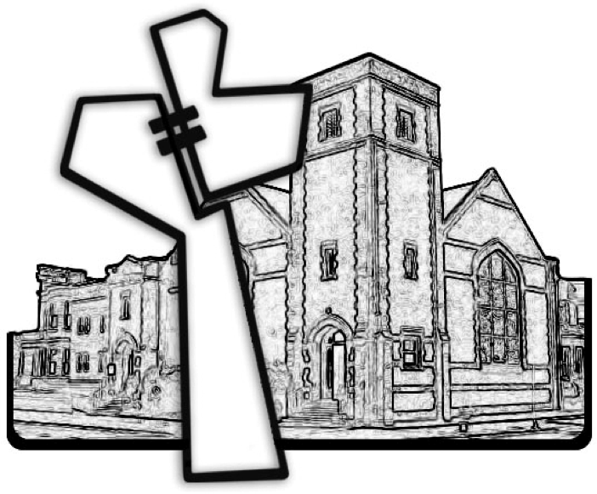
Chicago Community Mennonite Church
October 11, 2015

