World Communion Sunday
October 4, 2015
La Iglesia Christiana Roca de Esperanza
First Church of the Brethren
Chicago Community Mennonite Church

Canto | Singing
Heritage 131 Guide my feet
HWB 6 Here in this place
Llamar a Adorar | Call to Worship
Oración | Prayer
Pasando de la Paz | Passing the Peace
La paz de Dios / La paz de Cristo
Alabando | Praising
Un Momento con los Niños | Children’s Time
Heritage 681 Let us talents and tongues employ
Sagrada Escritura | Scriptures
Hebrews 12:1-3
Psalm 133
Ephesians 4:4-15
Sermon
Responder | Responding
Heritage 164 Siyahamba – We are marching in the light of God
Oraciones de la Gente | Prayers of the People

Comunión | Communion
Prayer of Preparation
One: To God be the glory…yet seeking grace:
All: God, we yearn for the healing you promise.
One: God of Justice…yet seeking forgiveness:
All: God, we yearn for the justice you promise.
One: God of Peace…yet seeking a forgiving heart:
All: God, we yearn for the peace you promise.
One: Knowing that through Christ all things are made new…our faith and commitment.
All: God, we submit ourselves to renewal through you. This we pray through Jesus Christ, our Lord and Savior. Amen
Offering
Heritage 686 Let Us Break Bread Together
HWB 471 Eat this bread
HWB 472 I will raise you up
Heritage 680 Taste and see
Prayer of Thanksgiving
One: Praise God from whom all blessings flow! With thanksgiving, let us celebrate our new life in Christ giving thanks to God our creator and sustainer:
All: Loving and gracious God, thank you for this holy meal. Thank you for Jesus and his all-inclusive love for humanity. Thank you for this day which we worship and serve you. Amen.
Anuncios | Announcements
Bendición | Benediction
HWB 429 Go now in peace

   
¡Todas y todos están cordialmente invitados a una comida a la canasta en el sótano después del servicio!

Everyone is warmly invited to a potluck meal downstairs in our Fellowship Hall following this service of worship!
   
Worship Participants
Sermon: Joel and Sonia Alonso
Musicians: Rich Brode, Kiva Nice-Webb,
Glenn Martin Klaassen
Altar: Janet Friesen

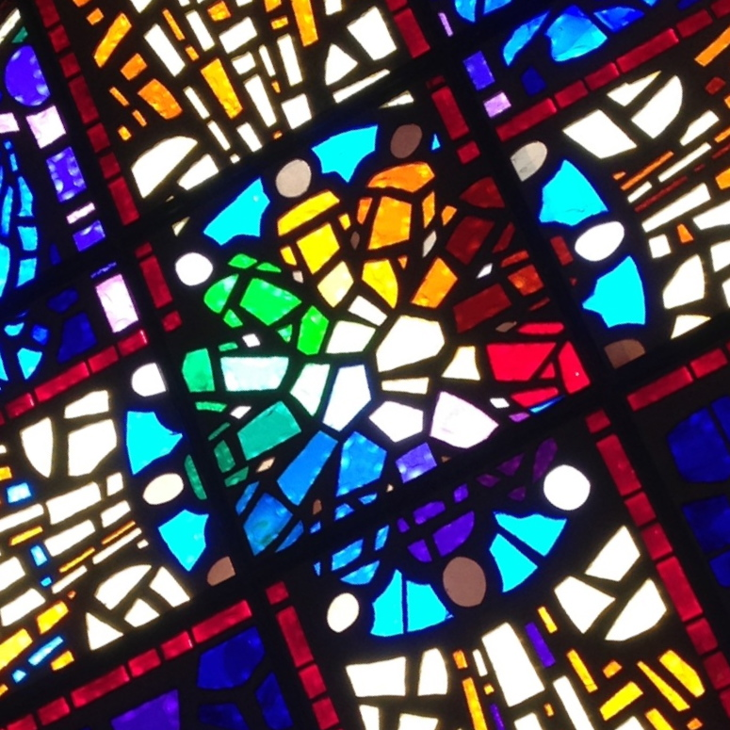

World Communion Sunday

La Iglesia Cristiana Roca de Esperanza
First Church of the Brethren
Chicago Community Mennonite Church
October 4, 2015

