Chicago Community Mennonite Church

January 4, 2015 ✢ Epiphany ✢ Faith on the Move: Pilgrimage

Gathering

Prelude

Call to Worship

One: In the time of King Herod, after Jesus was born in Bethlehem of Judea, wise men from the East came to Jerusalem, asking, “Where is the child who has been born king of the Jews? For we observed his star at its rising, and have come to pay him homage.” When King Herod heard this, he was frightened.

**Many: The kings of empires do well to be frightened by a baby, for that is how all who rise up against them come into the world.**

One: When they had heard the king, they set out; and there, ahead of them, went the star that they had seen at its rising, until it stopped over the place where the child was.

**Many: We, too, are searching for the newly born Christ.  We have been searching for a long time.**

One: When they saw that the star had stopped, they were overwhelmed with joy. On entering the house, they saw the child with Mary his mother; and they knelt down and paid him homage. Then, opening their treasure chests, they offered him gifts of gold, frankincense, and myrrh. And having been warned in a dream not to return to Herod, they left for their own country by another road.

**Many: Neither will we turn Jesus over to those who are greedy for power.  We will go by another way, overwhelmed by joy, blazing our own trail under the light of God’s star.**

Lighting the Peace Lamp

Prayer for Peace

STS 26 *Helpless and hungry*

Welcome

Praising

STS 28 *Holy child within the manger*

Receiving God’s Word

Isaiah 60:1-6

*Arise, Shine*

Matthew 2:1-12

One: For the word of God in scripture,   
for the word of God among us,   
for the word of God within us,

**All: thanks be to God.**

A Word About Children’s Time

Children’s Time

*Let the children come to me; let the children come.   
Never hinder them; never stop them. O let the children come.*

Meditation

Responding

STS 40 *We will follow*

Sharing

Prayer

Offering

Sending

Announcements

STS 27 *Sing a different song*

Benediction

Extinguishing the Peace Candle

**One: Now the light of Christ is in you.**

All: Thanks be to God.

|  |
| --- |
| Worship Participants  Worship Leader: Rachael Weasley  Meditation: Megan Ramer  Song Leader: Philip Kendall  Pianist: Hannah Klaassen  Altar: Brooke Hutchison |

Announcements

**MLK Day Celebration and Public Meeting, Sat Jan 17, 9:30 AM – 2 PM:** Reclaim Chicago and Southsiders Organized for Unity and Liberation (SOUL) will host *It’s Still Time for a Freedom Party!* at The Grand Ballroom (6351 S. Cottage Grove Ave in Chicago). In honor of the legacy of Rev. Dr. Martin Luther King, Jr. the event organizes neighbors to join the fight for racial and economic equality. Reclaim Chicago will showcase its progressive slate of candidates for Chicago City Council and send hundreds of canvassers out to door knock and phone bank to solicit votes.Register at mlkchicago.com and RSVP with Rachael Weasley (rachael.weasley@gmail.com), who will facilitate carpooling as needed.

**Save the Date: Annual Church Retreat, Feb 14-15:** Mark your calendars and plan to join the fun at Camp Menno Haven in Tiskilwa, IL. Church will not meet in Chicago that weekend. All are welcome!

**Pledges for 2014 and 2015:** If you want to know the remaining amount of your 2014 pledge, please check with Treasurer Paul Myers (paulmyerschicago@gmail.com). Because of the deficit budget for 2014, we can use all contributions. We encourage those of you who intend to pledge for 2015 to do so, including those of you who are new to the congregation.

Schedule

|  |  |  |
| --- | --- | --- |
|  | **Today** | **Next Sunday** |
| **Greeter:** | Derek Becker | Justin Riegsecker |
| **Nursery:** | Mark Frey  Brooke Hutchison | Brian Paff  Rochelle Martin Klaassen |
| **Fellowship:** | Rochelle Martin Klaassen  Brennan Martin Klaassen | Russell Johnson |
| **Welcome Table:** | Potluck |  |

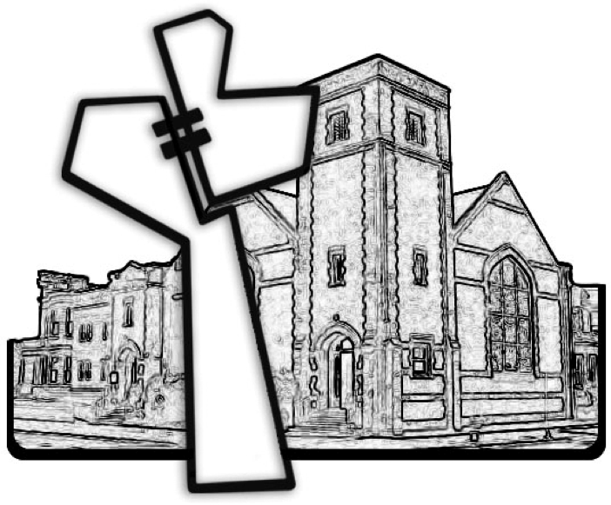

Chicago Community Mennonite Church



Chicago Community Mennonite Church

425 S. Central Park Blvd. (at Congress), Chicago, Illinois 60624-3224

www.ccmcil.org **|** facebook.com/ccmcil

**Church Council Chair:** Jason Gerig, 773-949-4496, jgerig@gmail.com

**Pastor:** Megan Ramer, 773-343-4251, pastor@ccmcil.org

January 4, 2015