Chicago Community Mennonite Church

January 25, 2015 ✢ Faith on the Move: Dancing

Gathering

Prelude

Call to Worship – STJ 153

**All: Blessed be the ones**

**who dance**

**in the corridors of death,**

**who sing**

**in the hallways of terror,**

**who laugh**

**in the prisons of fear,**

**who shout**

**across the silencing walls,**

**who love**

**beyond the borders of hatred,**

**who live**

**to welcome home freedom,**

**who die**

**never turning their heads,**

**who return**

**as the rising of hope.**

STJ 49 *Rain down*

Welcome

Lighting the Peace Lamp

Prayer for Peace

Praising

Instrumental & Prayer

Psalm 30 Antiphonally

Children’s Time

*Let the children come to me; let the children come. Never hinder them; never stop them. O let the children come.*

Nursery Graduation for Eve Becker

HWB 155 *O God, great womb*

Receiving God’s Word

Genesis 1:1-5

HWB 139 *Far, far away from my loving father*

Luke 15:11-32

One: For the word of God in scripture,   
for the word of God among us,   
for the word of God within us,

**All: thanks be to God.**

Meditation

Responding

HWB 84 *Oh, that I had a thousand voices*

Sharing

Prayer

Communion

Hymn: HWB 580 *My Life Flows On*

Sending

Announcements

STJ 73 *The Lord lift you up*

Benediction

Extinguishing the Peace Candle

One: Now the light of Christ is in you.

**All: Thanks be to God.**

|  |
| --- |
| Worship Participants  Worship Leader: Justin Beeker and Rachael Weasley  Meditation: Philip Kendall  Song Leader: Nancy Hostetter  Pianist: Steve Warkentin  Altar: Janet Friesen |

Announcements

**Second Hour Faith in Motion Series: Dance:** Susanna Hostetter will lead a dance workshop during Second Hour today.  This will be a low pressure, fun, and inclusive environment.  If you are less inclined to dancing, there will be a service discussion group in the choir room.

**Selma Discussion Today:** Several of you joined our First Church friends in watching the movie Selma last Sunday afternoon, and others of you have seen it on your own. All are invited to a discussion together with First Church friends this afternoon at 1:00 PM.

**CCMC Game Night:** Where: 1627 W 21st St, Unit 2 (Jason & Hannah's apartment) When: Saturday, January 31st @ 6:00 PM. Please RSVP by 1/30. A veggie chili will be served. Please bring a side (corn bread, fruit, dessert, beer, etc) and your favorite game.

**Save the Date: Annual Church Retreat, Feb 14-15:** Mark your calendars and plan to join the fun at Camp Menno Haven in Tiskilwa, IL. Church will not meet in Chicago that weekend. All are welcome!

**Christian Peacemaker Teams Prayer for Peacemakers:** Pray for the Palestinian people. They are subjected everyday to extensive controls by the Israeli Army, as a consequence they cannot walk with freedom in their own land, and they have to modify their schedules regarding school, work and spare time based on these controls. Let us pray together for our Palestinian sisters and brothers, that they are not subjected anymore to this violation of their basic rights.

Schedule

|  |  |  |
| --- | --- | --- |
|  | **Today** | **Next Sunday** |
| **Greeter:** | Brian & Maria Paff | Hannah Klaassen |
| **Nursery:** | Josiah Groff  Liz Dyrst | Bob Hostetter  Jan Lugibihl |
| **Fellowship:** | Spencer Foon  Geoff Martin | Ross Bay  Josiah Groff |
| **Welcome Table:** | Amber Kessler Freer  Josiah Groff | Potluck |

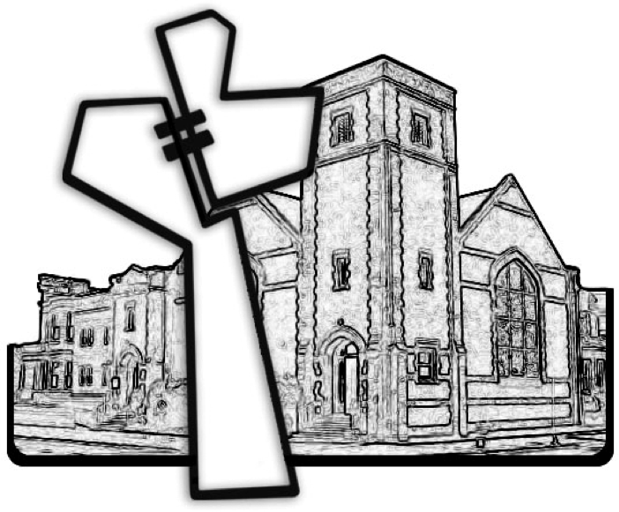

Chicago Community Mennonite Church



Chicago Community Mennonite Church

425 S. Central Park Blvd. (at Congress), Chicago, Illinois 60624-3224

www.ccmcil.org **|** facebook.com/ccmcil

**Church Council Chair:** Jason Gerig, 773-949-4496, jgerig@gmail.com

**Pastor:** Megan Ramer, 773-343-4251, pastor@ccmcil.org

January 25, 2015