Chicago Community Mennonite Church

May 24, 2015 ✢ Pentecost

Gathering

Prelude

HWB 26 *Holy Spirit, come with power*

Call to Worship

|  |  |
| --- | --- |
| One: | Holy Spirit, Creating Presence  as in the beginning you hover over the waters;  you breathe life into all creatures;  without you every living creature dies and  returns to nothing. |
| **All:** | **Come, Holy Spirit.** |
| One: | Holy Spirit, Comforter,  by you we are born again as children of God  you make us living temples of your presence;  you pray within us prayers too deep for words. |
| **All:** | **Come, Holy Spirit.** |
| One: | Holy Spirit, Lord and Giver of life,  you are light; you bring us light;  you are goodness and the source of all goodness. |
| **All:** | **Come, Holy Spirit.** |
| One: | Holy Spirit, Breath of life,  you sanctify and breathe life into  the whole body of the church;  you dwell in each of us  and will one day give new life to our mortal bodies. |
| **All:** | **Come, Holy Spirit.** |

Welcome

Lighting the Peace Lamp

Prayer for Peace

Praising

Psalm 104:24-34, 35b

HWB 580 *My life flows on*

Children’s Time

*Let the children come to me; let the children come.*

*Never hinder them; never stop them. O let the children come.*

Receiving God’s Word

Ezekiel 37:1-14

HWB 418 *Spirit, come, dispel our sadness*

Acts 2

|  |  |
| --- | --- |
| One: | For the word of God in scripture,  for the word of God among us,  for the word of God within us |
| **All:** | **Thanks be to God.** |

Meditation

Responding

HWB 353 *Lord, listen to your children praying*

Sharing

Prayer

Offering

Sending

Announcements

STJ 72 *One is the body*

Benediction

Extinguishing the Peace Lamp

One: Now the light of Christ is in you.

**All: Thanks be to God.**

|  |  |
| --- | --- |
| Worship Participants | |
| Worship Leader: | Celeste Groff |
| Meditation: | Jan Lugibihl |
| Song Leader: | Mariell Waltner |
| Pianist: | Maria Paff |
| Altar: | Rachael Weasley |

Announcements

**Pastor Megan’s Travel Schedule:** Jon and I are vacationing with friends in Montreal and I return to the office May 26–28 and then our candidating weekend in Seattle is May 29–June 1.

**Annual Church Picnic – June 7:** Come join the fun in Garfield Park (just north of the church). This is an opportunity to recognize and thank the teachers and Education Committee for a job well done.

**Community Organizing Training: Help us Pick the Date!** PJS will be hosting a community organizing training on either June 6 or August 22 and would like to pick the date that works best. If you’re interested, contact Rachael Weasley or refer to the weekend update.

**Teach Sunday School:** Curious what it’s like to teach a Sunday School class at CCMC? Find out for yourself by visiting a class. Contact Brooke Hutchison at brooke.hutchison@gmail.com if you’d like to find out more.

**Register for the CDC Annual Conference, June 11–13:** The conference, themed “Transformed Through Text and Table,” will be hosted by the Goshen/Elkhart area congregations at Southside Mennonite Fellowship on the campus of Anabaptist Mennonite Biblical Seminary in Elkhart, IN. Register by June 1 to get the early registration fee.

**Prayers for Peacemakers Indigenous Peoples Solidarity:** Give thanks that a judge in Kenora, ON dissolved the injunction calling for the arrest of Grassy Narrows member Judy Da Silva, if she tried to block the CN rail line. Nevertheless, CN railway is still threatening to sue her.

|  |  |  |
| --- | --- | --- |
| Schedules | | |
|  | ***Today*** | ***Next Sunday*** |
| **Greeter** | Josiah Groff | Rosalynn Gingerich |
| **Nursery** | Russell Johnson  Joel Peters-Fransen | Ross Bay  Janet Friesen |
| **Fellowship** | Justin Beeker | Leigh Peters-Fransen |
| **Welcome Table** | Derek Becker | Amber Kessler Freer  Josiah Groff |



Chicago Community Mennonite Church

425 S. Central Park Blvd. (at Congress), Chicago, Illinois 60624-3224

www.ccmcil.org **|** facebook.com/ccmcil

**Church Council Chair:** Jason Gerig, 773-949-4496, jgerig@gmail.com

**Pastor:** Megan Ramer, 773-343-4251, pastor@ccmcil.org

**Minister of Arts & Community Organizing:** Rachael Weasley, 415-314-7156

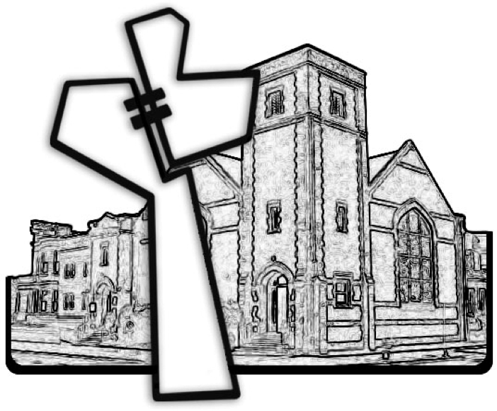

Chicago Community Mennonite Church

May 24, 2015