Chicago Community Mennonite Church

May 17, 2015 ✢ Seventh Sunday of Eastertide

Gathering

Prelude

Call to Worship

|  |  |
| --- | --- |
| One: | Lord, this day is your gracious gift |
| **All:** | **May we walk in the clear light of your grace.** |
| One: | Give us a heart that is pure in your sight, that we may see you. |
| **All:** | **May we love our neighbors as ourselves and truly deal justly with them.** |
| One: | O Lord, may your gracious eyes be upon us day and night. |
| **All:** | **Bless all our undertakings to your honor. Amen.** |

Lighting the Peace Lamp

Prayer for Peace

HWB 17 *We gather together*

Welcome

Announcements

Praising

HWB 420 *Heart with loving heart united*

Psalm 1

Children’s Time

*Let the children come to me; let the children come.*

*Never hinder them; never stop them. O let the children come.*

Nursery Graduation for Eleanor Peters-Fransen

STJ 44 *The love of God*

Praying Together

Offering

Sharing

Prayer

HWB 306 *In Christ there is no East or West*

Receiving God’s Word

John 17:6-19

|  |  |
| --- | --- |
| One: | For the word of God in scripture,  for the word of God among us,  for the word of God within us |
| **All:** | **Thanks be to God.** |

Meditation

Sending

HWB 418 *Move in our midst*

Benediction

Extinguishing the Peace Candle

One: Now the light of Christ is in you.

**All: Thanks be to God.**

|  |  |
| --- | --- |
| Worship Participants | |
| Worship Leader: | Justin & Erin Beeker |
| Meditation: | Megan Ramer |
| Song Leader: | Beth Peachey |
| Pianist: | Antonia Kam |
| Altar: | Jody Schmidt |

Announcements

**Adult Education: Christian Growth and Development**

Join us this morning as we consider together what makes for healthy Christian growth and development at various stages of our lives: young children, older children, youth, young adulthood, etc. What personal, family, small group and corporate practices most support this development? What is working for you? Do you long for something more?

**Action Against State Budget Cuts: May 18, 1pm, Jackson and** **LaSalle** Join Rachael Weasley downtown for an overturning of tables in front of the Mercantile Exchange, part of IIRON's campaign against Rauner's proposed budget cuts called "What Would Jesus Cut?" More info on insert.

**Teach Sunday School 2015-2016**

Curious what it's like to teach a Sunday School class at CCMC? Find out for yourself by visiting a class this month. Curious? Contact our Sunday School Coordinator, Brooke Hutchison at [brooke.hutchison@gmail.com](mailto:brooke.hutchison@gmail.com).

**Spirituality of Peace Group**

We are open for new members to join us next Sunday, 3pm at Michael and Barbara Sacco's home (6813 W Shakespeare Ave in Chicago). This group provides an interesting and fun exploration of Scripture and practice within the context of our Mennonite faith, as well as some tasty vittles! Please reach out to Amber, Justin R, or the Saccos with questions or to RSVP.

|  |  |  |
| --- | --- | --- |
| Schedules | | |
|  | ***Today*** | ***Next Sunday*** |
| **Greeter** | Geoff Martin | Josiah Groff |
| **Nursery** | Tim Schuler  Martin Dyrst | Russell Johnson  Joel Peters-Fransen |
| **Fellowship** | Spencer Foon  Geoff Martin | Spencer Foon  Geoff Martin |
| **Welcome Table** | Brian Paff | Derek Becker  Hannah Klaassen |

**Christian Peacemaker Teams Prayers for Peacemakers:**

Pray for CPT's Iraqi Kurdistan team's partners who work with children, teaching peacebuilding skills and comforting those who had to flee from their homes.

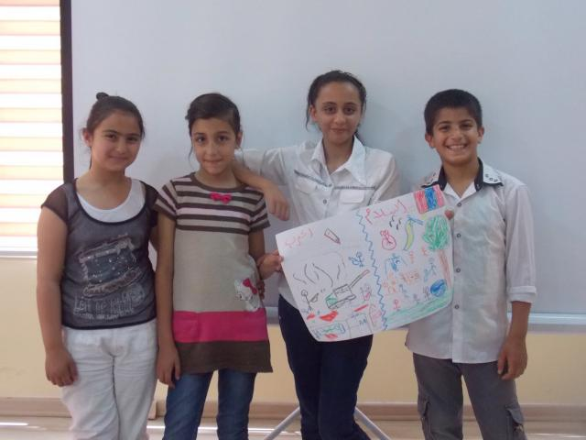



Chicago Community Mennonite Church

425 S. Central Park Blvd. (at Congress), Chicago, Illinois 60624-3224

www.ccmcil.org **|** facebook.com/ccmcil

**Church Council Chair:** Jason Gerig, 773-949-4496, jgerig@gmail.com

**Pastor:** Megan Ramer, 773-343-4251, pastor@ccmcil.org

**Minister of Arts & Community Organizing:** Rachael Weasley, 415-314-7156

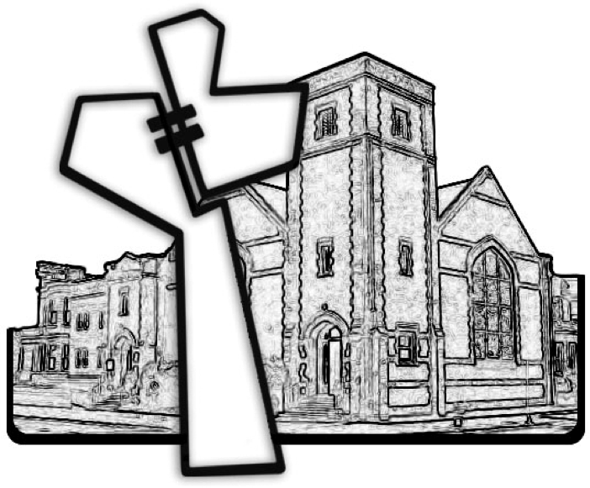

Chicago Community Mennonite Church

May 17, 2015