Chicago Community Mennonite Church

May 10, 2015 ✢ Sixth Sunday of Eastertide

Gathering

Prelude

Call to Worship

|  |  |
| --- | --- |
| One: | All you who love Jesus, |
| **All:** | **Join us in worship!** |
| One: | All you who believe, |
| **All:**  One:  **All:** | **Join us in worship!**  All you who question,  **Join us in worship!** |
| One: | All you who falter, |
| **All:** | **Join us in worship!** |
| One: | And may our worship move us forward together  as we seek to follow Jesus. |

STJ 5 *Come and be light for our eyes*

Welcome

Lighting the Peace Lamp

Prayer for Peace

Praising

STJ 28 *We worship God the rock*

Psalm 98

Children’s Time

*Let the children come to me; let the children come.*

*Never hinder them; never stop them. O let the children come.*

Receiving God’s Word

HWB 522 *My Jesus, I love thee*

John 15:9-17

|  |  |
| --- | --- |
| One: | For the word of God in scripture,  for the word of God among us,  for the word of God within us |
| **All:** | **Thanks be to God.** |

Meditation

Responding

STJ 42 *Listen, God is calling*

Sharing

Sending Tim and Allison Schuler

Prayer

Offering

Archaeology of Our Faith

Sending

Announcements

STJ 74 *Now go in peace*

Benediction

Extinguishing the Peace Candle

One: Now the light of Christ is in you.

**All: Thanks be to God.**

|  |  |
| --- | --- |
| Worship Participants | |
| Worship Leader: | Hannah Klaassen |
| Meditation: | Megan Ramer |
| Song Leader: | Glenn Martin Klaassen |
| Instrumentalists:  Children’s Time: | Tim Schuler, Mark Vanderhoff, Rachael Weasley  Jody Schmidt |
| Altar: | Antonia Kam |

Announcements

**Today’s Adult Second Hour**

A few times each year we have the opportunity to experience being on the holy ground of hearing someone's spiritual journey – this morning Brooke Hutchison will share.

**Taize Service on May 11**

Join us at Hannah and Jason's apartment (1627 W 21st St, Unit 2) at 7pm tomorrow for an hour or so of contemplative singing with a period of silence. Please contact Rachael.Weasley@gmail.com if you have questions, song requests, or if you can help out on guitar/flute/etc. We hope you will leave feeling renewed and restored!

**Spirituality of Peace Group on May 17**

We are open for new members to join us next Sunday, 3pm at Michael and Barbara Sacco's home (6813 W Shakespeare Ave in Chicago). This group provides an interesting and fun exploration of Scripture and practice within the context of our Mennonite faith, as well as some tasty vittles! Please reach out to Amber, Justin R, or the Saccos with questions or to RSVP.

**Christian Peacemaker Teams Prayers for Peacemakers**

Join the churches and individuals who are participating in Days of Prayer and Action for Colombia, May 17-18, 2015 or uplift their efforts in prayer.

|  |  |  |
| --- | --- | --- |
| Schedules | | |
|  | ***Today*** | ***Next Sunday*** |
| **Greeter** | Katie VanderHeide | Josiah Groff |
| **Nursery** | Mark Frey  Jan Lugibihl | Martin Dyrst  (sub needed) |
| **Fellowship** | Sherry Jost | Spencer Foon  Geoff Martin |
| **Welcome Table** | Sara Reschly  Steve Jost | Brian Paff |

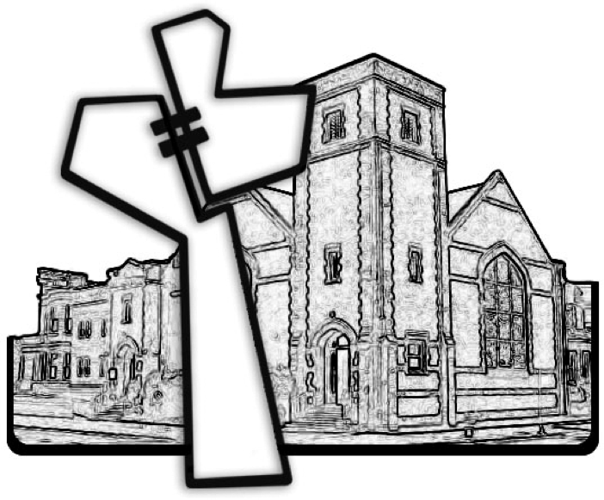

Chicago Community Mennonite Church



Chicago Community Mennonite Church

425 S. Central Park Blvd. (at Congress), Chicago, Illinois 60624-3224

www.ccmcil.org **|** facebook.com/ccmcil

**Church Council Chair:** Jason Gerig, 773-949-4496, jgerig@gmail.com

**Pastor:** Megan Ramer, 773-343-4251, pastor@ccmcil.org

**Minister of Arts & Community Organizing:** Rachael Weasley, 415-314-7156

May 10, 2015