Chicago Community Mennonite Church

May 3, 2015 ✢ CDC Sunday ✢ Transformed Through Text and Table

Gathering

Prelude

Call to Worship

|  |  |
| --- | --- |
| One: | Here we are Lord! |
| **All:** | **We've come today to this worship service for many reasons;** |
| One: | we've come because we need to meet you, |
| **All:** | **we've come because we are hungry for your word,** |
| One | we've come because we need to be with friends, |
| **Many** | **we've come because you are the friend we need most of all.** |
| One | Here we are—touch each person here with your presence, |
| **All** | **transform us into the church that you want us to be.** |

Welcome

STJ 4 *You’ve got a place*

Lighting the Peace Lamp

Prayer for Peace

Praising

STJ 54 *Longing for light*

Children’s Time

*Let the children come to me; let the children come. Never hinder them; never stop them. O let the children come.*

Feasting With God

|  |  |
| --- | --- |
| Step 1: | I Kings 17:10-16 |
| Step 2: | Mark 8:1-8 |
| Step 3: | Matthew 6:7-13 |
| Step 4: | Matthew 7:7-11 |
| Step 5: | I Corinthians 12:12-18 |
| Step 6: | I Corinthians 10:14-17 |

Responding

STJ 72 *One is the body*

Sharing

Prayer

Offering & Special Offering

Sending

Announcements

STJ 73 *The Lord lift you up*

Benediction

Extinguishing the Peace Candle

One: Now the light of Christ is in you.

**All: Thanks be to God.**

|  |  |
| --- | --- |
| Worship Participants | |
| Worship Leader: | Ross Bay |
| Meditation: | Megan Ramer |
| Song Leader: | Nancy Hostetter |
| Pianist: | Hannah Klaassen |
| Altar: | Brooke Hutchison |

Announcements

**CCMC Spring Fling Redux, Sat May 10, 7pm**

Come celebrate the in-between-renters expansiveness of Liz and Martin's empty second floor for the revival of CCMC's Spring Fling dance party. The second floor will feature a sound system, lights, and dancing. The third floor and outdoor patio will provide quieter spaces for hanging out and talking. Potluck food/snacks and BYOB. Dyrst home: 3044 W Logan Blvd. See you there!

**Taize Service on May 11th**

Join us at Hannah and Jason's apartment (1627 W 21st St, Unit 2) at 7 p.m. on Monday, May 11th for an hour or so of contemplative singing with a period of silence.  Please contact Rachael.weasley@gmail.com if you have questions, song requests, or if you can help out on guitar/flute/etc.  We hope you will leave feeling renewed and restored!

**Spirituality of Peace Group**

The Spirituality of Peace Small Group is open for new members to join us on Sunday May 17, 2015 3:00pm at Michael and Barbara Sacco's home (6813 W. Shakespeare Ave in Chicago). This group provides an interesting and fun exploration of Scripture and practice within the context of our Mennonite faith, as well as some tasty vittles! Please reach out to Amber Freer-Kessler, Justin Riegsecker, or Michael and/or Barbara Sacco with questions or to RSVP.

**Christian Peacemaker Teams Prayers for Peacemakers**

Pray for the families of the migrants who have drowned in the Mediterranean in the past week trying to reach Europe. Pray that Europe and the international community will make preserving human life their priority as they formulate immigration policies.



|  |  |  |
| --- | --- | --- |
| Schedules | | |
|  | ***Today*** | ***Next Sunday*** |
| **Greeter** | Sara Reschly | Katie VanderHeide |
| **Nursery** | Brian Paff  Linda Becker | Mark Frey  Jan Lugibihl |
| **Fellowship** | Rosalynn Gingerich  Russell Johnson | Sherry Jost |
| **Welcome Table** | Potluck | Sara Reschly  Steve Jost |

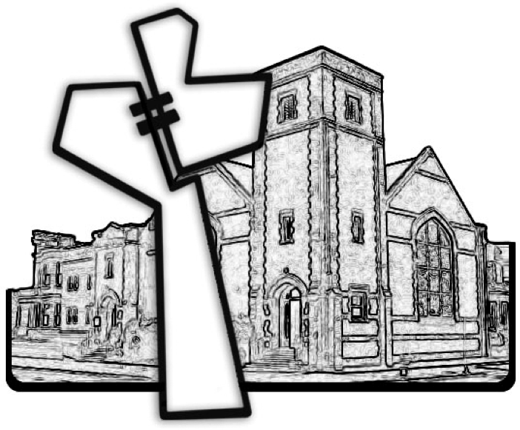

Chicago Community Mennonite Church



Chicago Community Mennonite Church

425 S. Central Park Blvd. (at Congress), Chicago, Illinois 60624-3224

www.ccmcil.org **|** facebook.com/ccmcil

**Church Council Chair:** Jason Gerig, 773-949-4496, jgerig@gmail.com

**Pastor:** Megan Ramer, 773-343-4251, pastor@ccmcil.org

**Minister of Arts & Community Organizing:** Rachael Weasley, 415-314-7156

May 3, 2015