Chicago Community Mennonite Church

April 26, 2015 ✢ Fourth Sunday of Easter ✢ Communion Sunday

Gathering

Prelude

Call to Worship

|  |  |
| --- | --- |
| One: | Watch! Wait! The day of God is at hand! |
| **All:** | **Like the bud on a tree, God's possibilities are about to blossom!** |
| One: | Stay awake! The reign of God is very near. |
| **All:** | **We are here, watching and waiting with hope. May God bring justice to all people on this day. May God's reign come on earth as in heaven.** |

HWB 304 *There are Many Gifts*

Announcements

Welcome

Lighting the Peace Lamp & Prayer for Peace

Praising

Psalm 23

Children’s Time

*Let the children come to me; let the children come. Never hinder them; never stop them. O let the children come.*

Receiving God’s Word

John 10.11-18

HWB 352 *Gentle Shepherd, Come and Lead Us*

Acts 4.5-12

|  |  |
| --- | --- |
| One: | For the word of God in scripture,  for the word of God among us,  for the word of God within us |
| **All:** | **Thanks be to God.** |

Meditation

Responding

HWB 421 *Blest Be the tie that Binds*

Sharing

Prayer

Communion

HWB 420 *Heart with Loving Heart United*

Sending

Benediction

Extinguishing the Peace Lamp

One: Now the light of Christ is in you.

**All: Thanks be to God.**

|  |  |
| --- | --- |
| Worship Participants | |
| Worship Leader: | Lauren Friesen |
| Meditation: | Kevin Key |
| Song Leader: | Philip Kendall |
| Pianist: | Steve Warkentin |
| Altar: | Janet Friesen |

Announcements

**Taize Service on May 11th**

Join us at Hannah and Jason's apartment (1627 W 21st St, Unit 2) at 7 p.m. on Monday, May 11th for an hour or so of contemplative singing with a period of silence.  Please contact Rachael.weasley@gmail.com if you have questions, song requests, or if you can help out on guitar/flute/etc.  We hope you will leave feeling renewed and restored!

**PJS Committee wants to fund peace, justice, and service!**

You are invited to apply for funds from the Peace, Justice, and Service Committee.  Our application is simple: just give us your name, contact info, amount requested, how your project relates to peace, justice, or service, and a description of what you'll use the money for.  Check the Weekend Update for more details.  Turn in your proposal by paper or email to Brooke Hutchinson or Rachael Weasley by May 1st.

**Spirituality of Peace Group**

The Spirituality of Peace Small Group is open for new members to join us on Sunday May 17, 2015 3:00pm at Michael and Barbara Sacco's home (6813 W. Shakespeare Ave in Chicago). This group provides an interesting and fun exploration of Scripture and practice within the context of our Mennonite faith, as well as some tasty vittles! Please reach out to Amber Freer-Kessler, Justin Riegsecker, or Michael and/or Barbara Sacco with questions or to RSVP.

**Feed CCMC’s newest (sleep-deprived) first-time parents!**

Sign up to bring a meal to Mark & Julia at www.bit.ly/babyarchie

**Christian Peacemaker Teams Prayer for Peacemakers**

Pray for the extended Jabari family, which owns land between the Israeli settlements of Kiryat 'Arba and Givat Ha'avot, This week, the Israeli military finally followed through on a long-standing Israeli court order to dismantle a settlement outpost on Jabari family land. When outposts are taken down, settlers often take out their anger on the nearby Palestinian inhabitants in "pricetag" attacks.

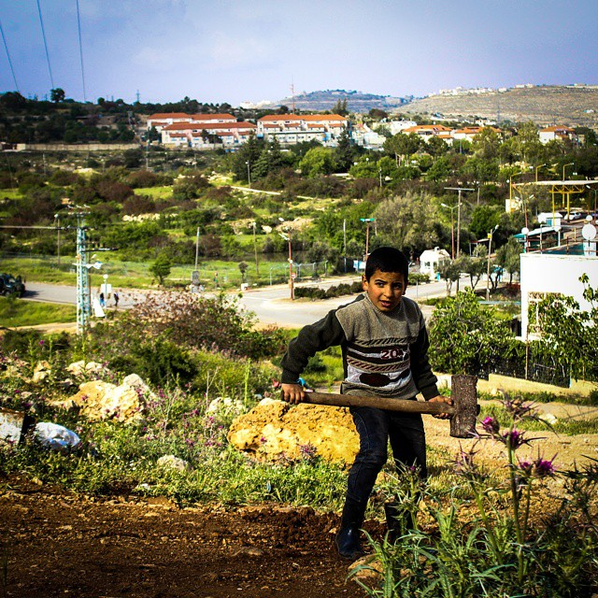

|  |  |  |
| --- | --- | --- |
| Schedules | | |
|  | ***Today*** | ***Next Sunday*** |
| **Greeter** | Russell Johnson | Sara Reschly |
| **Nursery** | Sean Conner  TBD | Brian Paff  Linda Becker |
| **Fellowship** | *Guess Who's Coming to Lunch* | Rosalynn Gingerich  Russell Johnson |
| **Welcome Table** | *Guess Who's Coming to Lunch* | Potluck |



Chicago Community Mennonite Church



Chicago Community Mennonite Church

425 S. Central Park Blvd. (at Congress), Chicago, Illinois 60624-3224

www.ccmcil.org **|** facebook.com/ccmcil

**Church Council Chair:** Jason Gerig, 773-949-4496, jgerig@gmail.com

**Pastor:** Megan Ramer, 773-343-4251, pastor@ccmcil.org

**Minister of Arts & Community Organizing:** Rachael Weasley, 415-314-7156

April 19, 2015