Chicago Community Mennonite Church

April 19, 2015 ✢ Earth Day Worship

Gathering

Prelude

Call to Worship

|  |  |
| --- | --- |
| One: | Awaken! The new day reveals itself in every moment, and by the grace of God all things are made possible. Come, let us give thanks. |
| **All:** | **We give thanks to you, blessed, mysterious Life-giver, for one more day to experience the miracle of creation.** |
| South: | With every breath we remember that life is a gift from you, O God, and we give thanks. |
| North: | With every bite of healthy food, we know the wonder of your diverse and fruitful Earth, and we give thanks. |
| One: | With every word, we affirm your transforming love for each of us, and we give thanks. |
| **All:** | **Holy Beloved, through you all things are made new. Creation is full of your glory. All praise be yours!** |

STJ 33 *Come Holy Spirit Descend*

Welcome

Lighting the Peace Lamp & Prayer for Peace

Praising

HWB 57 *Come and Give Thanks to the Giver*

Psalm 4

Children’s Time

*Let the children come to me; let the children come. Never hinder them; never stop them. O let the children come.*

HWB 614 *In the Bulb there is a Flower*

Receiving God’s Word

Luke 24:36b-48

|  |  |
| --- | --- |
| One: | For the word of God in scripture,  for the word of God among us,  for the word of God within us |
| **All:** | **Thanks be to God.** |

Meditation: “Have you anything here to eat?”

Responding

Hymn: *Body of Christ*

Sharing

Prayer

Offering

Sending

Announcements

Sending and Commissioning Carol Rose

HWB 229 *Lord, you Have Come to the Lakeshore*

Benediction

Extinguishing the Peace Lamp

One: Now the light of Christ is in you.

**All: Thanks be to God.**

|  |  |
| --- | --- |
| Worship Participants | |
| Worship Leader: | Ben Anderson |
| Meditation: | Megan Ramer |
| Song Leader: | Rachael Weasley |
| Pianist: | Antonia Kam |
| Altar: | Jody Schmidt |

Announcements

**Adult Education today:** *What the Asylum Cannot Confine: One family's encounter with the American Mental Health System*. Please join us for a biographical sketch examining the point of connection between family and the 1920's American Mental Health System, presented by Lauren Friesen.

**PJS Committee wants to fund peace, justice, and service!** You are invited to apply for funds from the Peace, Justice, and Service Committee.  Our application is simple: just give us your name, contact info, amount requested, how your project relates to peace, justice, or service, and a description of what you'll use the money for.  Check the Weekend Update for more details.  Turn in your proposal by paper or email to Brooke Hutchinson or Rachael Weasley by May 1st.

**Canoe Trip, July 18-19:** Mark your calendars now for our (mostly) annual CCMC canoe/camping weekend at Laura, Mark, and Naomi's cottage on Lake Emma near Onekama, Michigan. Many more details to come.

**Service Project, Sat Apr 25:** Join us again this year for Rebuilding Together! PJS is looking for 10 volunteers to travel to a home near Oak Park and do some light work: installing a bannister, scraping old paint, painting fresh paint. The time commitment is about 4-5 hours on Saturday morning. Please let Brooke, Rachael, or Allison know if you can make it!

**Spirituality of Peace Group:** The Spirituality of Peace Small Group is open for new members to join us on Sunday May 17, 3:00pm at Michael and Barbara Sacco's home (6813 W Shakespeare Ave, Chicago). This group provides an interesting and fun exploration of Scripture and practice within the context of our Mennonite faith, as well as some tasty vittles! Please reach out to Amber Freer-Kessler, Justin Riegsecker, or Michael and/or Barbara Sacco with questions or to RSVP.

**Christian Peacemaker Teams Prayers for Peacemakers:** Pray for the community of Grassy Narrows and Judy Da Silva. On Friday, April 10, 2015 hosted a traditional Anishinaabe Water Ceremony on the shores of Wild Lake, near the CN railway mainline between Kenora and Grassy Narrows.  Despite the fact the group called off a blockade of the railway—which transports toxic tar sands bitumen over local waterways—CN still served Da Silva with an injunction against impeding trains and/or trespassing on CN property, and/or ‘counselling’ others to do the same. The injunction will be before the court on April 16 at 10 a.m. in Kenora.

|  |  |  |
| --- | --- | --- |
| Schedules | | |
|  | ***Today*** | ***Next Sunday*** |
| **Greeter** | Ross Bay | Russell Johnson |
| **Nursery** | Justin Hochstetter  Brooke Hutchison | Sean Connor  Rochelle Martin Klaassen |
| **Fellowship** | Ross Bay | *Guess Who's Coming to Lunch* |
| **Welcome Table** | Rachael Weasley  Rochelle Martin Klaassen | Rosalynn Gingerich  Ruby Campos |

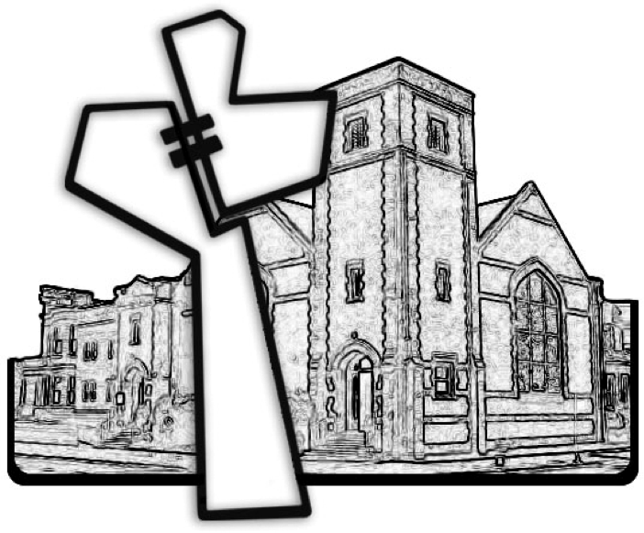

Chicago Community Mennonite Church



Chicago Community Mennonite Church

425 S. Central Park Blvd. (at Congress), Chicago, Illinois 60624-3224

www.ccmcil.org **|** facebook.com/ccmcil

**Church Council Chair:** Jason Gerig, 773-949-4496, jgerig@gmail.com

**Pastor:** Megan Ramer, 773-343-4251, pastor@ccmcil.org

**Minister of Arts & Community Organizing:** Rachael Weasley, 415-314-7156

April 19, 2015