Chicago Community Mennonite Church

April 12, 2015

Gathering

Prelude

Call to Worship

|  |  |
| --- | --- |
| One: | God, we are gathered today as your disciples were so long ago, thinking all hope was lost, believing you were dead. |
| **All:** | **Come among us this morning and let us know that you are still alive.** |
| One: | We are here, waiting, worrying, watching, wishing, wondering. |
| **All:** | **Will we witness you walk in among us?** |
| One: | Come in, even through our locked doors |
| **All:** | **Reveal yourself, alive today**  **within us and among us** |

STJ 33 *Come Holy Spirit Descend*

Welcome

Lighting the Peace Lamp

Prayer for Peace

Praising

STJ 37 Behold, How Pleasant

Psalm 133

Children’s Time

*Let the children come to me; let the children come. Never hinder them; never stop them. O let the children come.*

STJ 27 *God of the Bible*

Receiving God’s Word

Acts 4:32-35

STJ 39 *Ubi caritas*

John 20:19-31

|  |  |
| --- | --- |
| One: | For the word of God in scripture,  for the word of God among us,  for the word of God within us |
| **All:** | **Thanks be to God.** |

Meditation

Responding

STJ 59 *Come and Fill Our Hearts*

Sharing

Prayer

Offering

Sending

Announcements

STJ 69 *When the Poor Ones*

Benediction

Extinguishing the Peace Candle

One: Now the light of Christ is in you.

**All: Thanks be to God.**

|  |  |
| --- | --- |
| Worship Participants | |
| Worship Leader: | Rachael Weasley |
| Meditation: | Megan Ramer |
| Song Leader: | Glenn Martin Klaassen |
| Pianist: | Beth Peachey |
| Altar: | Antonia Kam |

Announcements

**Adult Education Multi-track Series - April 12**

* Enneagram Workshop – Session 3: This final Enneagram session will focus on the Gut Center.  We'll wrap up this look at the Enneagram with a discussion of the place that these patterns hold in the larger picture of life. Presenter: Glenn Martin Klassen; Location: Fellowship Hall
* Discussion of the morning's Meditation / Worship Experience: Facilitator: Michael Sacco; Location: 1A
* Make a Joyful Noise: Come enjoy singing from our hymnals. Bring instruments or just sit back and tap your foot! Facilitator: Maria Paff; Location: 2A, Choir Room

**PJS Committee wants to fund peace, justice, and service!** You are invited to apply for funds from the Peace, Justice, and Service Committee.  Just give us your name, contact info, amount requested, how your project relates to peace, justice, or service, and a description of what you'll use the money for. Please submit your proposal to Brooke Hutchison or Rachael Weasley by Friday, May 1.

**Save the Date: Canoe trip, July 18-19:** Our (mostly) annual CCMC canoe/camping weekend at Laura, Mark, and Naomi's cottage on Lake Emma near Onekama, Michigan. Many more details to come.

**Film Screening, Thur Apr 16, 6:30pm:** As part of the (In)Justice for All Film Festival, we have the great privilege of hosting the film "What World Do You Live In?" about police violence and struggles for justice on the streets of Toronto. Mennonite pastor, Doug Johnson Hatlem, was involved in the making of this film and plans to be present for our screening.

**Service Project, Sat Apr 25:** Join us again this year for Rebuilding Together! PJS is looking for 10 volunteers to travel to a home near Oak Park and do some light work: installing a bannister, scraping old paint, painting fresh paint. The time commitment is about 4-5 hours on Saturday morning. Please let Brooke, Rachael, or Allison know if you can make it!

**Spirituality of Peace Group, Sun May 17, 3pm:** The Spirituality of Peace Small Group is accepting new members. Meet at the Sacco home (6813 W Shakespeare Ave). This group provides an interesting and fun exploration of Scripture and practice within the context of our Mennonite faith, as well as some tasty vittles! Questions or RSVP: Amber, Justin R, Michael, Barbara.

**Christian Peacemaker Teams Prayers for Peacemakers:** Pray for the displaced Yazidi and Arab residents of Arbat Camp in Iraqi Kurdistan—all of whom have fled great violence and upheavals. Yazidi/Ezidi refugees tell CPTers they face discrimination and abuse by some of the displaced Arab inhabitants of the camp.

|  |  |  |
| --- | --- | --- |
| Schedules | | |
|  | ***Today*** | ***Next Sunday*** |
| **Greeter** | Rosalynn Gingerich | Ross Bay |
| **Nursery** | Steve Jost  Liz Finch | Justin Hochstetter  Brooke Hutchison |
| **Fellowship** | Rochelle Martin Klaassen | Ross Bay |
| **Welcome Table** | Michael Sacco  Nancy McCann Hostetter | Rachael Weasley  Rochelle Martin Klaassen |

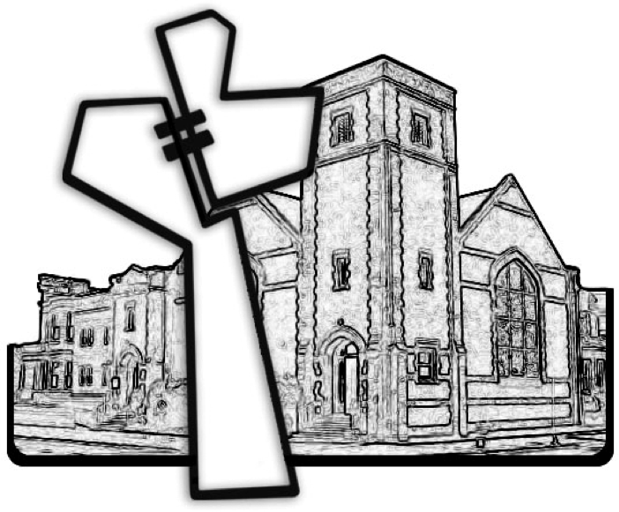

Chicago Community Mennonite Church



Chicago Community Mennonite Church

425 S. Central Park Blvd. (at Congress), Chicago, Illinois 60624-3224

www.ccmcil.org **|** facebook.com/ccmcil

**Church Council Chair:** Jason Gerig, 773-949-4496, jgerig@gmail.com

**Pastor:** Megan Ramer, 773-343-4251, pastor@ccmcil.org

**Minister of Arts & Community Organizing:** Rachael Weasley, 415-314-7156

April 12, 2015