Chicago Community Mennonite Church

April 5, 2015 ✢ Easter Sunday

Gathering

Prelude

Call to Worship

One: The stone has been rolled away.

**All: The grave clothes are lying in a heap.**

One: The body is gone.

**All: Mary’s weeping is halted by the man’s questions:**

One: Why are you crying?

**All: Who is it you are looking for?**

One: Let us proclaim with Mary:

**All: We have seen the risen Lord!**

One: Christ is Risen!

**All: Christ is Risen Indeed!**

**Hallelujah! Amen.**

HWB 280  *Christ the Lord is risen today*

Welcome

Lighting the Peace Lamp

Prayer for Peace

Praising

Isaiah 25:6-9

Psalm 118:1-2, 14-24

Children’s Time

*Let the children come to me; let the children come. Never hinder them; never stop them. O let the children come.*

HWB 275  *Lift your glad voices*

Receiving God’s Word

STS 88 *The Easter morn at the break of day*

Mark 16:1-8

One: For the word of God in scripture,   
for the word of God among us,   
for the word of God within us,

**All: thanks be to God.**

Meditation

Responding

STS 89 *Christ is Alive*

Sharing

Prayer

STS 123  *Let us talents and tongues employ*

Communion

Sending

Announcements

STJ 73 *The Lord lift you up*

Extinguishing the Peace Candle

One: Now the light of Christ is in you.

**All: Thanks be to God.**

The Messiah “Hallelujah” Chorus G.F. Handel

|  |
| --- |
| Worship Participants  Worship Leader: Justin Beeker, Ben Anderson  Meditation: Megan Ramer  Song Leader: Philip Kendall  Pianist: Spencer Foon  Altar: Brooke Hutchison |

Announcements

**Easter Potluck today:** You are welcome to stay and share an Easter feast with the CCMC family.

**Please turn in colorful inserts:** We ask that you return your communion liturgy inserts. We will reuse them in the future.

**Taize Service, Thurs Apr 9, 7pm:** You are invited to the Dyrst home (3044 W Logan Blvd, Apt 3) for a quiet evening of contemplative prayer, song, and silence. Taize songs are short and meant to be sung over and over until we're singing by heart. Bring your voices and other instruments. Light snacks will be provided. Candles will be lit.

**Film Screening, Thur Apr 16, 6:30pm:** As part of the (In)Justice for All Film Festival, we have the great privilege of hosting the film "What World Do You Live In?" about police violence and struggles for justice on the streets of Toronto. Mennonite pastor, Doug Johnson Hatlem, was involved in the making of this film and plans to be present for our screening.

**CDC Regional Gathering, Sat Apr 18:** The leadership of Central District is excited to invite you to the 2015 gathering hosted by North Danvers Mennonite Church, 9:45am – 3:00pm. Please RSVP to Pastor Megan.

**Service Project, Apr 25:** Join us again this year for Rebuilding Together! PJS is looking for 10 volunteers to travel to a home near Oak Park and do some light work: installing a bannister, scraping old paint, painting fresh paint. The time commitment is about 4-5 hours on Saturday morning, April 25. Please let Brooke, Rachael, or Allison know if you can make it!

**Save the Date: Canoe trip, July 18-19:** Our (mostly) annual CCMC canoe/camping weekend at Laura, Mark, and Naomi's cottage on Lake Emma near Onekama, Michigan. Many more details to come.

**Christian Peacemaker Teams Prayers for Peacemakers:** Pray for the farmers of El Guayabo, Colombia who are resisting displacement through the ordinary act of planting food that sustains their community and its families.

Schedules

|  |  |  |
| --- | --- | --- |
|  | **Today** | **Next Sunday** |
| **Greeter:** | Rochelle Martin Klaassen | Rosalynn Gingerich |
| **Nursery:** | Mark Liechty Hannah Klaassen | Steve Jost Liz Finch |
| **Fellowship:** | Justin Riegsecker Kate Myers | Rochelle Martin Klaassen |
| **Welcome Table:** | Potluck | Michael Sacco  Nancy McCann Hostetter |

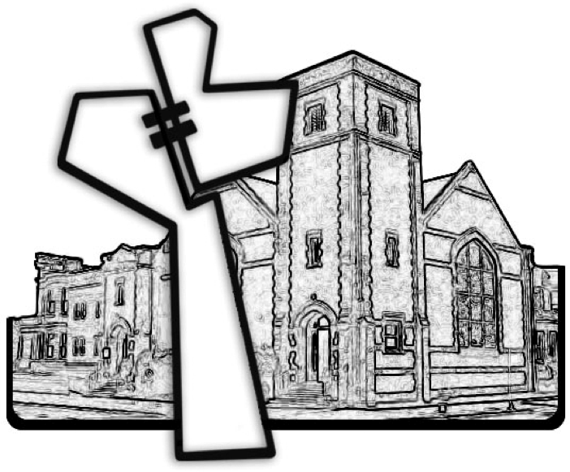

Chicago Community Mennonite Church



Chicago Community Mennonite Church

425 S. Central Park Blvd. (at Congress), Chicago, Illinois 60624-3224

www.ccmcil.org **|** facebook.com/ccmcil

**Church Council Chair:** Jason Gerig, 773-949-4496, jgerig@gmail.com

**Pastor:** Megan Ramer, 773-343-4251, pastor@ccmcil.org

**Minister of Arts & Community Organizing:** Rachael Weasley, 415-314-7156

April 5, 2015