Hymn of Gathering: HWB 285 All Hail the Power of Jesus' Name

Lighting the Peace Lamp and Prayer for Peace
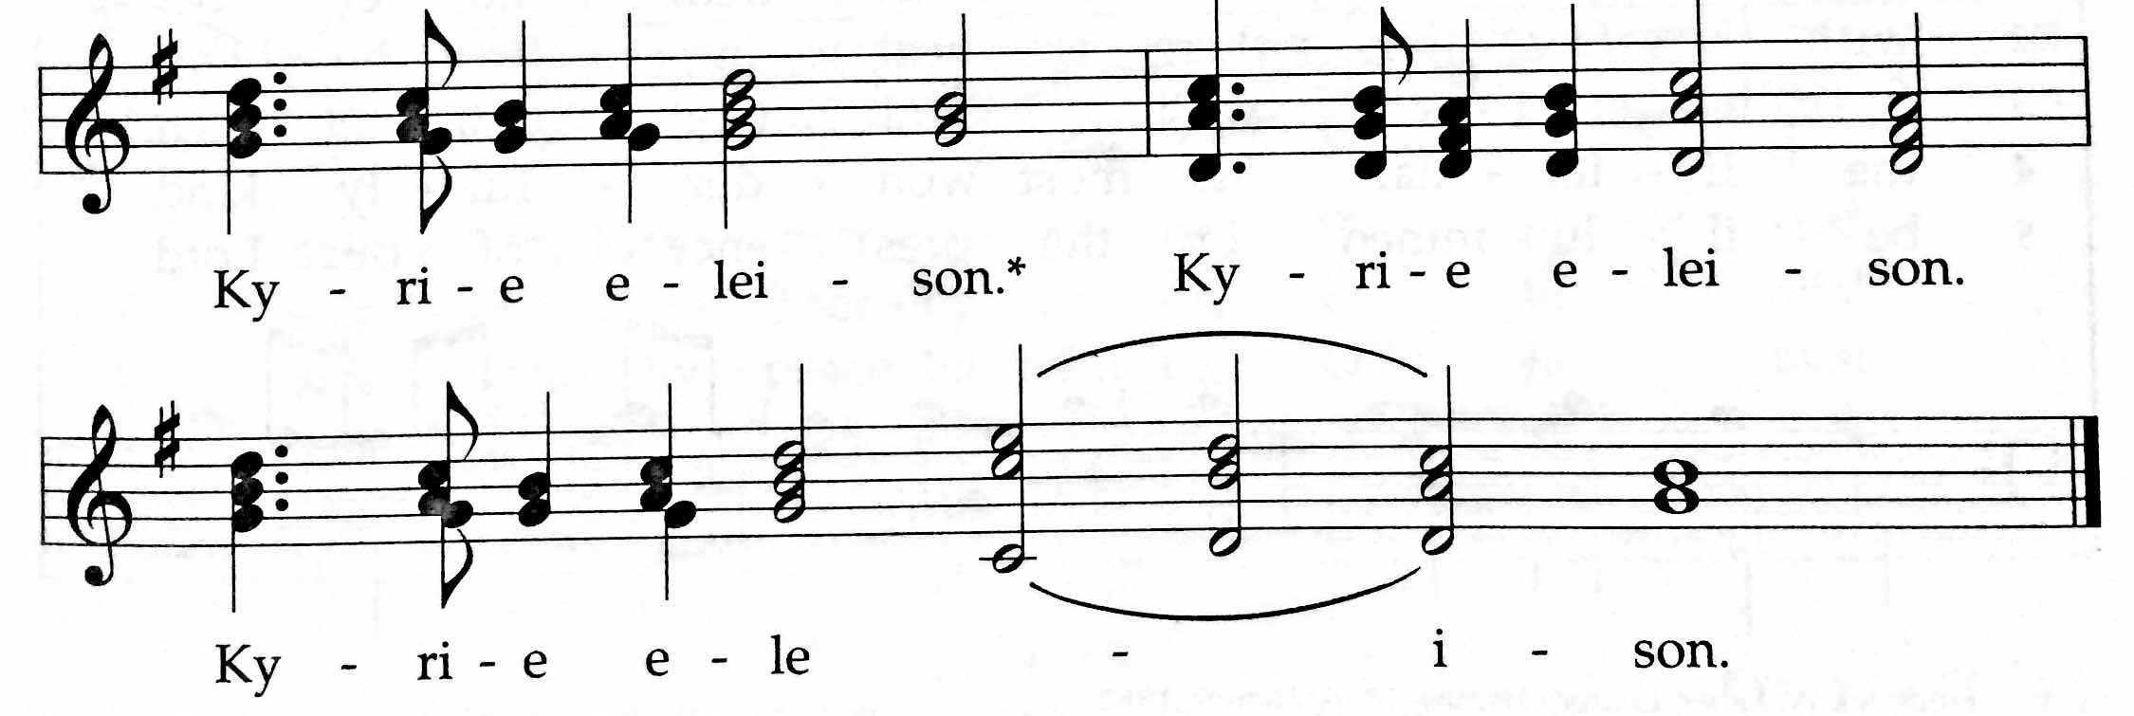
✢ Word ✢
Children’s Time
Let the children come to me; let the children come.
Never hinder them; never stop them. O let the children come.

HWB 238 Hosanna, Loud Hosanna

First Reading: Philippians 2:5-11

Antiphonal Reading of Psalms 31 and 118

Doxology (TUNE: Old Hundredth Doxology, HWB 119)
Praise God, the Source of life and birth.
Praise God, the Word, who came to earth.
Praise God, the Spirit, holy flame.
All glory, honor to God's name! Amen.

Gospel: Mark 11:1-11
For the word of God in scripture, for the word of God among us,
for the word of God within us, Thanks be to God.

Sermon

Silence (use this time to pray, reflect, or simply sit in silence)

Prayers of The People
Psalm 141, Let my prayer rise up like incense before you (insert)
Offering (guests may place Connect Cards from insert in the basket)
Generous God, through your Son, Christ Jesus,
You have shown us what it means to love.
And you’ve called us to follow your example—
to love our neighbors as we love ourselves,
to offer our lives and our resources in your service.
Accept the gifts we bring today.
May they help to spread the love we have received
to the world around us. Amen.
(Whether or not you have something physical to drop in the basket this morning, please take a moment to offer a prayer or blessing for this congregation, or pause to consider how you would like to offer yourself in service to God this week.)
For these offerings of money, of prayers, of intentions,
we give thanks, O God. Amen.

✢ Sending ✢
Closing Hymn: HWB 429 Go Now in Peace

Benediction and Extinguishing the Peace Lamp
Finally, whatever is true, whatever is honorable, whatever is just,
whatever is pure, whatever is lovely, whatever is gracious,
if there is any excellence, if there is anything worthy of praise,
think about these things. The God of peace be with you. Amen.
Now the light of Christ is in you.
Thanks be to God.

Worship Participants
Worship Leader: Jan Lugibihl
Meditation: Megan Ramer
Song Leader: Philip Kendall
Pianist: Maria Paff
Altar: Amber Kessler Freer

Announcements
Please turn in colorful inserts: We ask that you return your Psalm 141 (Let my prayer rise up) inserts. We will reuse them in the future.
Adult Education Multi-track Series:
- Enneagram Workshop – Session 2: The enneagram offers 9 patterns that describe different personality styles and motivations that shape these styles. Presenter: Glenn Martin Klassen; Location: Fellowship Hall
- Discussion of the morning's Meditation / Worship Experience: Facilitator: Michael Sacco
- Make a Joyful Noise: Come enjoy singing from our hymnals. Bring instruments or just sit back and tap your foot! Facilitator: Maria Paff

Taize Service, Thurs Apr 9, 7pm: You are invited to the Dyrst home (3044 W Logan Blvd, Apt 3) for a quiet evening of contemplative prayer, song, and silence. Taize songs are short and meant to be sung over and over until we're singing by heart. Bring your voices and other instruments. Sheet music will be available but you are welcome to pick up the short, simple songs by ear. Light snacks will be provided. Candles will be lit. You are invited!

Film Screening, Thur Apr 16, 6:30pm: As part of the (In)Justice for All Film Festival, we have the great privilege of hosting the film "What World Do You Live In?" about police violence and struggles for justice on the streets of Toronto. Mennonite pastor, Doug Johnson Hatlem, was involved in the making of this film and plans to be present for our screening.

CDC Regional Gathering, Sat Apr 18: The leadership of Central District is excited to invite you to the 2015 gathering hosted by North Danvers Mennonite Church, 9:45am – 3:00pm. Please RSVP to Pastor Megan.

Service Project, Apr 25: Join us again this year for Rebuilding Together! PJS is looking for 10 volunteers to travel to a home near Oak Park and do some light work: installing a bannister, scraping old paint, painting fresh paint. The time commitment is about 4-5 hours on Saturday morning, April 25. Please let Brooke, Rachael, or Allison know if you can make it!

Save the Date: Canoe trip, July 18-19: Our (mostly) annual CCMC canoe/camping weekend at Laura, Mark, and Naomi's cottage on Lake Emma near Onekama, Michigan. Many more details to come.

Schedules
 | Today | Next Sunday
Greeter: | Merle Baker | Rochelle Martin Klaassen
Nursery: | Laura Hostetter  Anna Schnurr | Mark Liechty  Hannah Klaassen
Fellowship: | Paul Myers | Justin Riegsecker  Kate Myers
Welcome Table: | Mariell Waltner  Mark Frey | potluck

Chicago Community
Mennonite Church
425 S. Central Park Blvd., Chicago, IL 60624
773-343-4251 | pastor@ccmcil.org
www.ccmcil.org | facebook.com/ccmcil

Megan Ramer, Pastor 773-343-4251, pastor@ccmcil.org
Jason Gerig, Church Council Chair 773-949-4496, jgerig@gmail.com
Rachael Weasley, Minister of Arts & Community Organizing 415-314-7156

March 29, 2015 ✢ Lent: Let Our Prayers Rise Up

Announcements
✢ Gathering ✢
Hymn of Preparation
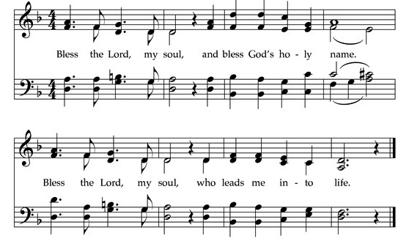
Call to Worship
The grace of our Lord Jesus Christ, the love of God,
and the communion of the Holy Spirit be with you all.
And also with you.
Welcome to our worship. Just as you are. Welcome.

