Hymn of Gathering: HWB 356 Breathe on me, breath of God

Lighting the Peace Lamp and Prayer for Peace
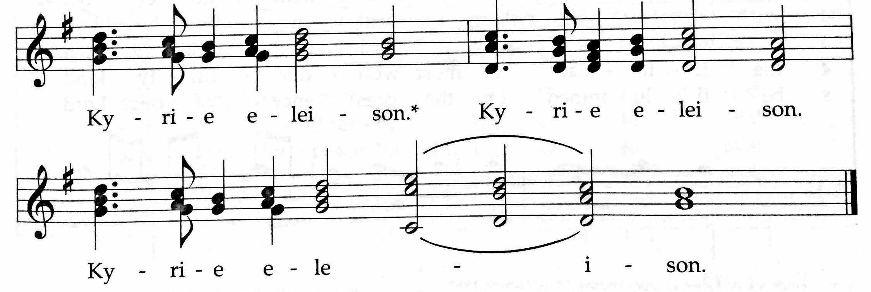
✢ Word ✢
Children’s Time
Let the children come to me; let the children come.
Never hinder them; never stop them. O let the children come.

Special Music by Sheepdog

Scriptures: Psalm 51: 1-12; Hebrews 5:5-10

Doxology (TUNE: Old Hundredth Doxology, HWB 119)
Praise God, the Source of life and birth.
Praise God, the Word, who came to earth.
Praise God, the Spirit, holy flame.
All glory, honor to God's name! Amen.

Gospel: John 12:20-33
For the word of God in scripture, for the word of God among us,
for the word of God within us, Thanks be to God.

Sermon

Silence (use this time to pray, reflect, or simply sit in silence)

Prayers of The People
Psalm 141, Let my prayer rise up like incense before you (insert)

Receiving New Member: Ben Anderson
Offering (guests may place Connect Cards from insert in the basket)
Generous God, through your Son, Christ Jesus,
You have shown us what it means to love.
And you’ve called us to follow your example—
to love our neighbors as we love ourselves,
to offer our lives and our resources in your service.
Accept the gifts we bring today.
May they help to spread the love we have received
to the world around us. Amen.
(Whether or not you have something physical to drop in the basket this morning, please take a moment to offer a prayer or blessing for this congregation, or pause to consider how you would like to offer yourself in service to God this week.)
For these offerings of money, of prayers, of intentions,
we give thanks, O God. Amen.

✢ Sending ✢
Closing Hymn: HWB 435 May the Lord, mighty God (tune: Edelweiss)

Benediction and Extinguishing the Peace Lamp
Finally, whatever is true, whatever is honorable, whatever is just,
whatever is pure, whatever is lovely, whatever is gracious,
if there is any excellence, if there is anything worthy of praise,
think about these things. The God of peace be with you. Amen.
Now the light of Christ is in you.
Thanks be to God.

Worship Participants
Worship Leaders: Justin & Erin Beeker
Meditation: Celeste Grace Groff
Song Leader: Mariell Waltner
Pianist: Hannah Klaassen
Altar: Janet Friesen

Announcements
Please turn in colorful inserts: We ask that you return your Psalm 141 (Let my prayer rise up) inserts. We will reuse them throughout Lent.
Adult Education Multi-track Series, beginning this morning:
- Enneagram Workshop – Session 1: Introduction
The enneagram offers 9 patterns that describe different personality styles. It also offers insights into the variety of motivations that shape these styles. This Sunday we will have a brief intro and look at the patterns comprising the "Heart" center. Appropriate for beginners and aficionados alike. Presenter: Glenn Martin Klassen; Location: Fellowship Hall
- Discussion of the morning's Meditation / Worship Experience
Facilitator: Michael Sacco; Location: 2A, 2nd floor classroom (Choir Room)

Service Project, April 25: Join us again this year for Rebuilding Together! PJS is looking for 10 volunteers to travel to a home near Oak Park and do some light work: installing a bannister, scraping old paint, painting fresh paint. The time commitment is about 4-5 hours on Saturday morning, April 25. Please let Brooke, Rachael, or Allison know if you can make it!

Agape Satyagraha Mentor Training, March 27-28: Join friends from both CCMC and First Church: Friday from 6-8pm (dinner & opening session) and Saturday (training) from 9am-3pm. Required for all who will be serving as mentors. The On Earth Peace team will be with us to facilitate our training. Info? Join the Agape Support Team? Rev LaDonna, revladonna@gmail.com.

MCC Peace Gathering, Sat March 28, 1:00pm: You are invited to join Mennonite Central Committee (MCC) Great Lakes for an informative day of workshops, worship and dialogue. At Living Water Community Church (6808 N Ashland Blvd). RSVP: JorgeVielman@mcc.org

CDC Regional Gathering, Sat April 18: The leadership of Central District is excited to invite you to the 2015 gathering hosted by North Danvers Mennonite Church, 9:45am – 3:00pm. Please RSVP to Pastor Megan.

Christian Peacemaker Teams Prayer for Peacemakers: Give thanks for the Grassy Narrows First Nations Members who remain strong in their determination to resist logging on their traditional lands, despite recent court rulings allowing corporate exploitation of these lands.

Schedules
 | Today | Next Sunday
Greeter: | Justin Riegsecker | Merle Baker
Nursery: | Justin Riegsecker  Joanne Zimmerly | Laura Hostetter  Anna Schnurr
Fellowship: | Josiah Groff | Paul Myers
Welcome Table: | Kurt Frymire  Lauren Friesen | Mariell Waltner  Mark Frey
Lunch Host: | Justin Riegsecker | TBA

Chicago Community
Mennonite Church
425 S. Central Park Blvd., Chicago, IL 60624
773-343-4251 | pastor@ccmcil.org
www.ccmcil.org | facebook.com/ccmcil

Megan Ramer, Pastor 773-343-4251, pastor@ccmcil.org
Jason Gerig, Church Council Chair 773-949-4496, jgerig@gmail.com
Rachael Weasley, Minister of Arts & Community Organizing 415-314-7156

March 22, 2015 ✢ Lent: Let Our Prayers Rise Up

Announcements
✢ Gathering ✢
Hymn of Preparation
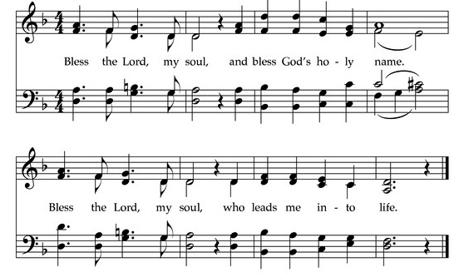
Call to Worship
The grace of our Lord Jesus Christ, the love of God,
and the communion of the Holy Spirit be with you all.
And also with you.
Welcome to our worship. Just as you are. Welcome.

