Hymn of Gathering: STJ 2 Hamba nathi (Come, walk with us)

Lighting the Peace Lamp and Prayer for Peace
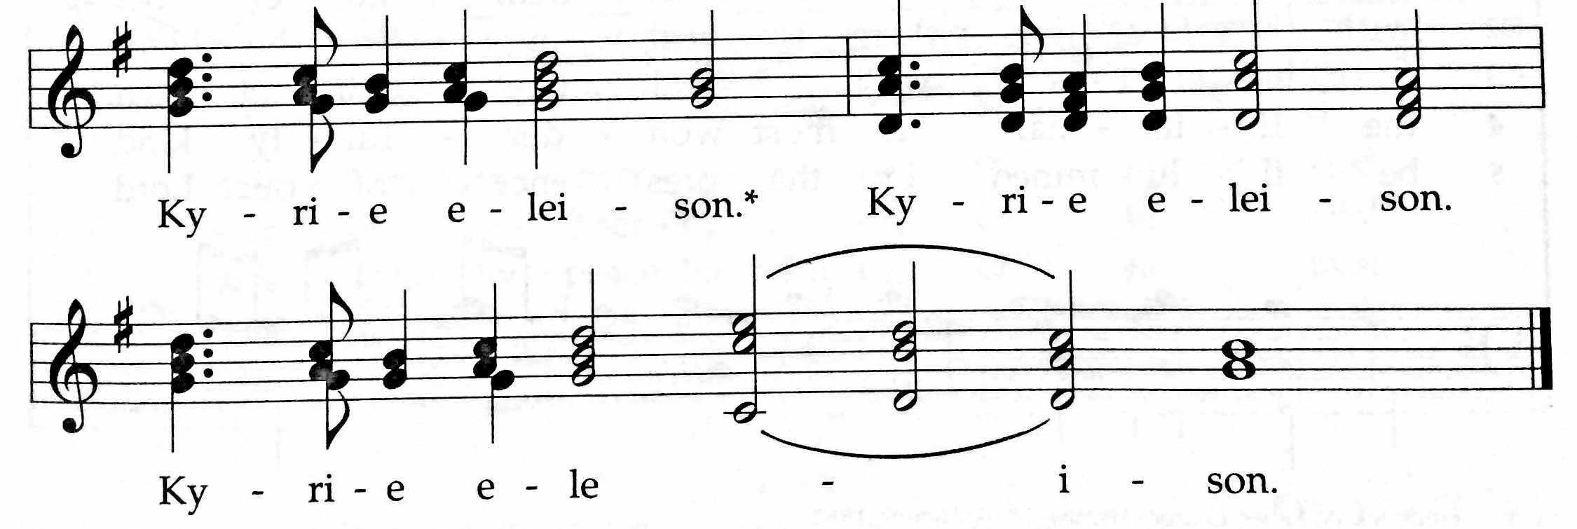
✢ Word ✢
Children’s Time
Let the children come to me; let the children come.
Never hinder them; never stop them. O let the children come.

Hymn: STJ 46 O breathe on me, o breath of God

First Reading: Genesis 17:1-7, 15-16

Psalm 22:23-31

Doxology (TUNE: Old Hundredth Doxology, HWB 119)
Praise God, the Source of life and birth.
Praise God, the Word, who came to earth.
Praise God, the Spirit, holy flame.
All glory, honor to God's name! Amen.

Gospel: Mark 8:31-38
For the word of God in scripture, for the word of God among us,
for the word of God within us, Thanks be to God.

Sermon

Silence (use this time to pray, reflect, or simply sit in silence)

Prayers of The People
Psalm 141, Let my prayer rise up like incense before you (insert)
Offering (guests may place Connect Cards from insert in the basket)
Generous God, through your Son, Christ Jesus,
You have shown us what it means to love.
And you’ve called us to follow your example—
to love our neighbors as we love ourselves,
to offer our lives and our resources in your service.
Accept the gifts we bring today.
May they help to spread the love we have received
to the world around us. Amen.
(Whether or not you have something physical to drop in the basket this morning, please take a moment to offer a prayer or blessing for this congregation, or pause to consider how you would like to offer yourself in service to God this week.)
For these offerings of money, of prayers, of intentions,
we give thanks, O God. Amen.

✢ Sending ✢
Closing Hymn: HWB 434 Thuma mine

Benediction and Extinguishing the Peace Lamp
Finally, whatever is true, whatever is honorable, whatever is just,
whatever is pure, whatever is lovely, whatever is gracious,
if there is any excellence, if there is anything worthy of praise,
think about these things. The God of peace be with you. Amen.
Now the light of Christ is in you.
Thanks be to God.

Worship Participants
Worship Leader: Jody Schmidt
Meditation: Megan Ramer
Song Leader: Philip Kendall
Pianist: Steve Warkentin
Altar: Brooke Hutchison

Announcements
Please turn in colorful inserts: We ask that you return your Psalm 141 (Let my prayer rise up) inserts. We will reuse them throughout Lent.
Membership Exploration Class, March 15, 12:00pm: All are welcome to attend this session focused on the story of CCMC. We will meet after Sunday School and wrap up by 2:00 p.m. A light lunch will be provided. Please RSVP with Pastor Megan (pastor@ccmcil.org) or contact her with questions.

President of EMU to be our guest at CCMC: We are excited that President Loren Swartzendruber of Eastern Mennonite University will be joining us on Sunday March 15. We have invited him to preach during worship and to lead our adult education hour.

Lost & Found: A pair of grey slippers was left at Menno Haven last weekend. Also, a grey and black stocking hat was found at the church. Please claim them in the CCMC library if they are yours.

Let’s Dance! Come dance to 80's music with us on March 20th at the Holiday Club (4000 N Sheridan, Chicago, 60613). Bar opens at 7pm and dancing starts at 10pm. For more info, talk to Sara Reschly, Liz Dyrst, Hannah Klassen, or Megan Ramer. www.holidayclubchicago.com

CDC Regional Gathering, Sat April 18: The leadership of Central District is excited to invite you to the 2015 gathering hosted by North Danvers Mennonite Church, 9:45am – 3:00pm. Please RSVP to Pastor Megan.

Christian Peacemaker Teams Prayer for Peacemakers: Pray for people of Hebron. February 25 marks the 21st anniversary of the Ibrahimi Mosque massacre, when a U.S.-born Israeli settler murdered twenty-nine Muslim men and boys while they prayed there. Dozens more Palestinians were injured in the demonstrations that followed. This week, there will be several nonviolent demonstrations protesting the closing of Shuhada Street. Pray for the safety of demonstrators and for all people in the Old City. Pray for the CPT Hebron Team who will be in the demonstrations.

Schedules
 | Today | Next Sunday
Greeter: | Anna Hershey | Kate Myers
Nursery: | Cecilia Goertzen  Luciano Lima | Chris Bohlander  Sara Reschly
Fellowship: | Anna Hershey  Hannah Klaassen | Kurt Frymire
Welcome Table: | Potluck | Jason Gerig  Anna Hersey

Chicago Community
Mennonite Church
425 S. Central Park Blvd., Chicago, IL 60624
773-343-4251 | pastor@ccmcil.org
www.ccmcil.org | facebook.com/ccmcil

Jason Gerig, Church Council Chair Megan Ramer, Pastor
773-949-4496, jgerig@gmail.com 773-343-4251, pastor@ccmcil.org

March 1, 2015 ✢ Lent: Let Our Prayers Rise Up

Announcements
✢ Gathering ✢
Hymn of Preparation
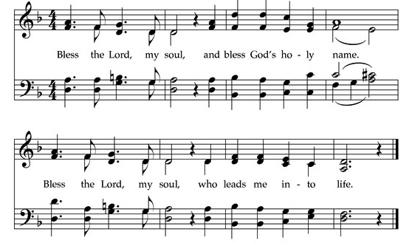
Call to Worship
The grace of our Lord Jesus Christ, the love of God,
and the communion of the Holy Spirit be with you all.
And also with you.
Welcome to our worship. Just as you are. Welcome.

