Hymn of Gathering: STJ 54 Longing for light

Lighting the Peace Lamp and Prayer for Peace
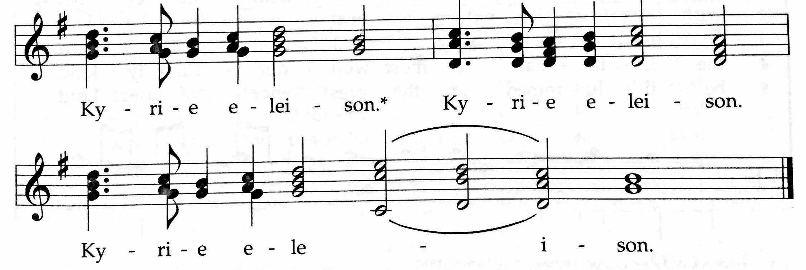
✢ Word ✢
Children’s Time
Let the children come to me; let the children come.
Never hinder them; never stop them. O let the children come.

Hymn: HWB 530 What wondrous love is this

Psalm 25

Doxology (TUNE: Old Hundredth Doxology, HWB 119)
Praise God, the Source of life and birth.
Praise God, the Word, who came to earth.
Praise God, the Spirit, holy flame.
All glory, honor to God's name! Amen.

Gospel: Mark 1.9-15
For the word of God in scripture, for the word of God among us,
for the word of God within us, Thanks be to God.

Sermon

Silence (use this time to pray, reflect, or simply sit in silence)

Prayers of The People
Psalm 141, Let my prayer rise up like incense before you (insert)
✢ Meal ✢
(Please turn to communion liturgy insert, “Coming To The Table.” During the offering, guests may place Connect Card from inserts in the basket.)
✢ Sending ✢
Closing Hymn: HWB 502 Spirit of God! Descend

Benediction and Extinguishing the Peace Lamp
Finally, whatever is true, whatever is honorable, whatever is just,
whatever is pure, whatever is lovely, whatever is gracious,
if there is any excellence, if there is anything worthy of praise,
think about these things. The God of peace be with you. Amen.
Now the light of Christ is in you.
Thanks be to God.

Worship Participants
Worship Leader: Maria Paff
Meditation: Megan Ramer
Song Leader: Mariell Waltner
Pianist: Steve Warkentin
Altar: Janet Friesen

Announcements
Please turn in colorful inserts: We ask that you return your communion liturgy and Psalm 141 (Let my prayer rise up) inserts to baskets in the sanctuary and fellowship hall. We will reuse them in the future.

On The Way: A Camino Sabbatical. Pastor Megan shares with us images and stories from her sabbatical time on the Camino de Santiago, a 500-mile ancient pilgrimage route through northern Spain.

Membership Exploration Class, March 15, 12:00pm: All are welcome to attend this session focused on the story of CCMC. We will plan to meet after Sunday School and wrap up by 2:00 p.m. A light lunch will be provided. Please RSVP with Pastor Megan (pastor@ccmcil.org) or contact her with questions.
Lost & Found: A pair of grey slippers was left at Menno Haven last weekend. Also, a grey and black stocking hat was found at the church. Please claim them in the CCMC library if they are yours.

Beer Group, Sat Feb 28, 6:00pm: Krista and Justin Riegsecker are hosting this month’s gathering. We’ll have a few light snacks and provide a selection of Trappist and Abbey beers to taste. Please add to the mix with a Belgian or Belgian-inspired beer. Or tasty snack. Or thrilling board game. Or just yourself. Everyone is welcome. 620 N East Ave, Oak Park

CDC Regional Gatherings: The leadership of Central District is excited to invite you to the 2015 CDC regional gatherings hosted at the following locations and dates, 9:45am – 3:00pm:
- INDIANA: Mar 7, Eighth Street Mennonite Church, Goshen
- ILLINOIS: Apr 18, North Danvers Mennonite Church
The gatherings are not a delegate or business session, but a way to build connections between congregations and open to anyone. For the gathering in Danvers IL, we especially invite delegates who will be attending Kansas City 2015. Childcare will be provided as needed. We will explore the theme of Transformed Through Text and Table together through worship, talking, song, and play. The North Danvers congregation has graciously agreed to provide lunch for us. Please bring a donation to help cover the costs.

Christian Peacemaker Teams Prayer for Peacemakers: Pray for Las Pavas community in Colombia. Pray for the land and crops of these campesinos (farmers) that are under the threat of Aportes San Isidro palm oil company. The company has installed fences within the campesinos land, creating physical obstacles that impede their access their own lands. Pray that the Collective Reparation Process that the Colombian government has offered this community as a way to compensate victims of the armed conflict becomes an immediate reality. Pray for the campesinos that work the land and allow us to have food on our tables.

Schedules
 | Today | Next Sunday
Greeter: | Justin Beeker | Anna Hershey
Nursery: | Kate Myers  Jane Baker | Cecilia Goertzen  Luciano Lima
Fellowship: | Jan Lugibihl | Anna Hershey  Hannah Klaassen
Welcome Table: | Jan Lugibihl  Justin Beeker | potluck

Chicago Community
Mennonite Church
425 S. Central Park Blvd., Chicago, IL 60624
773-343-4251 | pastor@ccmcil.org
www.ccmcil.org | facebook.com/ccmcil

Jason Gerig, Church Council Chair Megan Ramer, Pastor
773-949-4496, jgerig@gmail.com 773-343-4251, pastor@ccmcil.org

February 22, 2015 ✢ Lent: Let Our Prayers Rise Up

Announcements
✢ Gathering ✢
Hymn of Preparation
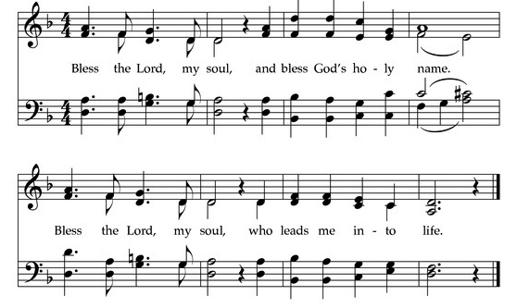
Call to Worship
The grace of our Lord Jesus Christ, the love of God,
and the communion of the Holy Spirit be with you all.
And also with you.
Welcome to our worship. Just as you are. Welcome.

