Chicago Community Mennonite Church

February 8, 2015 ✢ Faith on the Move: Yoga

Gathering

Prelude

Call to Worship

One: Come, Holy Spirit, Holy Breath,

comforter, disturber, inspirer, and advocate.

**All**: **Come, breathe into the church**

**the gifts earth can neither produce nor afford.**

One: Come, breathe into our lives

that rich mixture of peace and restlessness,

calm and enthusiasm,

which are hallmarks of holiness.

**All**: **Come, promised Spirit of God,**

**inspired Breath of God,**

**find your way and make your home among us. Amen.**

HWB 25 *Jesus, stand among us*

Welcome

Praising

Lighting the Peace Lamp

Prayer for Peace

HWB 57 *Come and give thanks to the Giver*

Children’s Time

*Let the children come to me; let the children come.*

*Never hinder them; never stop them. O let the children come.*

Presentation of worship bag to Aparecido

Receiving God’s Word

Ezekiel 37.1-14

John 20.19-23

One: For the word of God in Scripture, for the word of God among us, for the word of God within us,

**All: thanks be to God.**

HWB 290 *Spirit, come, dispel our sadness*

Meditation

Responding

HWB 498 *He comes to us as one unknown*

Sharing

Prayer

Offering

Archaeology of our Faith

Sending

Announcements

STS 121 *Nothing is lost on the breath of God*

Benediction

Extinguishing the Peace Lamp

One: Now the light of Christ is in you.

**All: Thanks be to God.**

|  |
| --- |
| Worship Participants  Worship Leader: Megan Ramer  Meditation: Julia Robling Griest  Song Leader: Glenn Martin Klaassen  Pianist: Beth Peachey  Altar: Antonia Kam |

Announcements

**CCMC will not meet for worship in Chicago next Sunday:**

Church service will be held at the Annual Church Retreat at Camp Menno Haven in Tiskilwa IL next weekend.

**Second Hour and Faith on the Move: Yoga:** Julia Robling Griest will lead participants in Chair Yoga. There will be a few standing poses, but we will use the chair for poses as well. There is also a discussion option for those that prefer.

**Membership Exploration Class, March 15, 12:00pm:** All are welcome to attend this session focused on the story of CCMC. We will plan to meet after Sunday School and wrap up by 2:00 p.m. A light lunch will be provided. Please RSVP with Pastor Megan (pastor@ccmcil.org) or contact her with questions.

**CDC Regional Gatherings:** The leadership of Central District is excited to invite you to the 2015 CDC regional gatherings hosted at the following locations and dates, 9:45am – 3:00pm:

* INDIANA: Mar 7, Eighth Street Mennonite Church, Goshen
* ILLINOIS: Apr 18, North Danvers Mennonite Church

The gatherings are not a delegate or business session, but a way to build connections between congregations and open to anyone. For the gathering in Danvers IL, we especially invite delegates who will be attending Kansas City 2015. Childcare will be provided as needed. We will explore the theme of Transformed Through Text and Table together through worship, talking, song, and play. The North Danvers congregation has graciously agreed to provide lunch for us. We ask that those eating lunch bring a donation to help cover the costs.

**Christian Peacemaker Teams Prayer for Peacemakers:** Pray for the people of Iraqi-Kurdistan and Palestine, this winter has been particularly hard and there are thousands of people living in refugee tents under extreme weather conditions. Pray for a more gentle weather for all of them. Pray also for the Palestinian children in Al-Khalil, who returned to school last week. During the month of December, the Israeli Army threw 172 tear gas bombs and 19 stun grenades to children while they were walking to school. The Israeli occupation and its violence are threatening Palestinian children’s right to education. Pray for these two nations.

Schedule

|  |  |  |
| --- | --- | --- |
|  | **Today** | **Next Sunday** |
| **Greeter:** | Jan Lugibihl | Church Retreat |
| **Nursery:** | Joel Peters-Fransen  Ross Bay | Church Retreat |
| **Fellowship:** |  | Church Retreat |
| **Welcome Table:** | Brian Paff  Brooke Hutchison | Church Retreat |

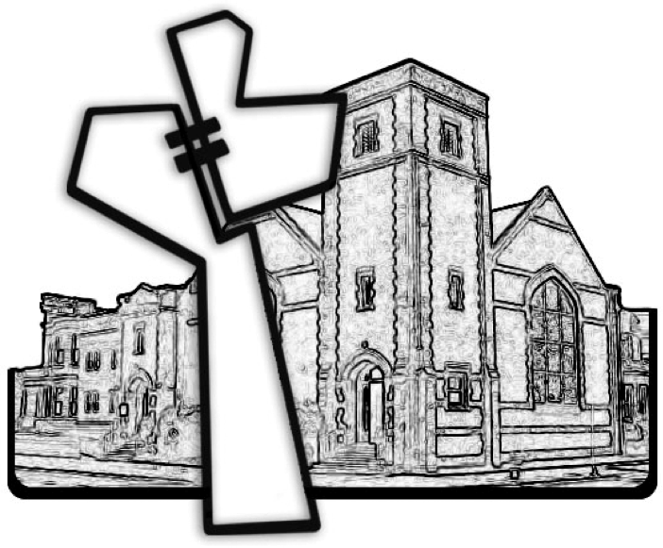

Chicago Community Mennonite Church



Chicago Community Mennonite Church

425 S. Central Park Blvd. (at Congress), Chicago, Illinois 60624-3224

www.ccmcil.org **|** facebook.com/ccmcil

**Church Council Chair:** Jason Gerig, 773-949-4496, jgerig@gmail.com

**Pastor:** Megan Ramer, 773-343-4251, pastor@ccmcil.org

February 8, 2015