Chicago Community Mennonite Church

February 1, 2015 ✢ Faith on the Move: Pilgrimage

Gathering

Prelude

Call to Worship – STJ 153

**All: All-powerful God,**

**You are never far away for those who seek you.**

Right: Be with your servants on this pilgrimage

*Left: and guide our way in accord with your will.*

Right: Bless this stone we carry on this pilgrimage.

*Left: Be a companion for us along our journey,*

Right: a guide at crossroads,

*Left: strength in our weariness,*

Right: a comforter in our discouragements,

*Left: and firmness in our intentions,*

**All**: **that we might arrive unscathed**

**at the end of our journey,**

**enriched with graces and virtues.**

**Through Jesus Christ your Son,**

**Amen.**

STJ 2 *Come walk with us*

Welcome

Lighting the Peace Lamp

Prayer for Peace

Praising

HWB 575 *Precious Lord, take my hand*

Psalm 131

Children’s Time

*Let the children come to me; let the children come.*

*Never hinder them; never stop them. O let the children come.*

Presentation of worship bag to Aparecido

Receiving God’s Word

STS 98 *On the journey to Emmaus*

Luke 24:13-35

One: For the word of God in scripture,   
for the word of God among us,   
for the word of God within us,

**All: thanks be to God.**

Meditation

Responding

HWB 226 *You are salt for the earth*

Sharing

Prayer

Offering

Sending

Announcements

STJ 78 *Sizohamba naye (We will walk with God)*

Benediction

Extinguishing the Peace Candle

One: Now the light of Christ is in you.

**All: Thanks be to God.**

|  |
| --- |
| Worship Participants  Worship Leader: Mark Frey  Meditation: Megan Ramer  Song Leader: Philip Kendall  Pianist: Spencer Foon  Altar: Brooke Hutchison |

Announcements

**Membership Exploration Class, March 15, 12:00pm:** All are welcome to attend this session focused on the story of CCMC. We will plan to meet after Sunday School and wrap up by 2:00 p.m. A light lunch will be provided. Please RSVP with Pastor Megan (pastor@ccmcil.org) or contact her with questions.

**CDC Regional Gatherings:** The leadership of Central District is excited to invite you to the 2015 CDC regional gatherings hosted at the following locations and dates, 9:45am – 3:00pm:

* OHIO: Feb 7, Lima Mennonite Church
* INDIANA: Mar 7, Eighth Street Mennonite Church, Goshen
* ILLINOIS: Apr 18, North Danvers Mennonite Church

The gatherings are not a delegate or business session, but a way to build connections between congregations and open to anyone. For the gathering in Danvers IL, we especially invite delegates who will be attending Kansas City 2015. Childcare will be provided as needed. We will explore the theme of Transformed Through Text and Table together through worship, talking, song, and play. The North Danvers congregation has graciously agreed to provide lunch for us. We ask that those eating lunch bring a donation to help cover the costs.

**Annual Church Retreat, Feb 14-15:** Join the fun at Camp Menno Haven in Tiskilwa IL. Church will not meet in Chicago that weekend.

Schedule

|  |  |  |
| --- | --- | --- |
|  | **Today** | **Next Sunday** |
| **Greeter:** | Hannah Klaassen | Jan Lugibihl |
| **Nursery:** | Bob Hostetter  Jan Lugibihl | Joel Peters Fransen  Ross Bay |
| **Fellowship:** | Ross Bay  Josiah Groff |  |
| **Welcome Table:** | Potluck | Brian Paff  Brooke Hutchison |

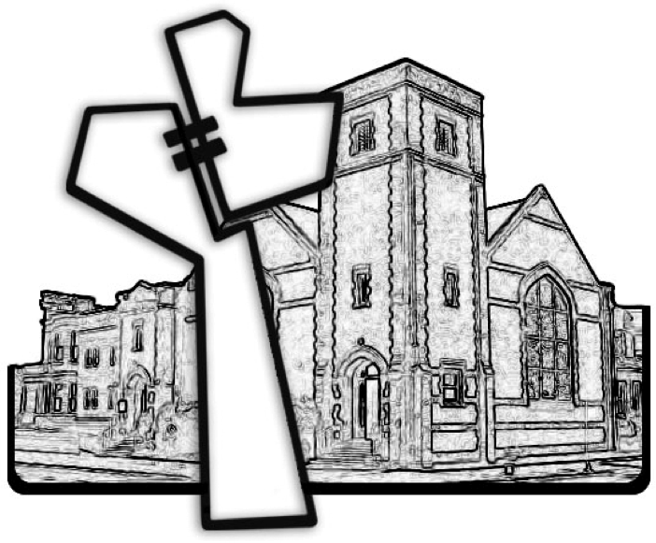

Chicago Community Mennonite Church



Chicago Community Mennonite Church

425 S. Central Park Blvd. (at Congress), Chicago, Illinois 60624-3224

www.ccmcil.org **|** facebook.com/ccmcil

**Church Council Chair:** Jason Gerig, 773-949-4496, jgerig@gmail.com

**Pastor:** Megan Ramer, 773-343-4251, pastor@ccmcil.org

February 1, 2015