Chicago Community Mennonite Church

December 7, 2014 ✢ Advent 2 ✢ Dwelling in Mystery: Peace

Gathering

Prelude

Call to Worship

One: Come, let us worship in faith the God who is here and desires our worship. Wondrous, redeeming God, work in our hearts so that we would share in your peace.

**All: Oh, that you would reveal your peace to us,**

**O Lord.**

One: The paths of our world are not straight; division remains between our families, our cities, our countries.

**People: Still, we listen for the voice in the wilderness, “Prepare a way for the Lord.”**

One: Behold, our God is coming.

**People: God speaks peace into our noisy world.**

**All: Comfort, comfort, my people,” says our God.**

HWB 176 *Comfort, comfort, o my people*

Welcome

Lighting the Peace Lamp

Prayer for Peace

Praising

STS 10 *Come! Walk in the light*

Isaiah 40:1-11

Children’s Time

*Let the children come to me; let the children come.*

*Never hinder them; never stop them. O let the children come.*

HWB 172 *O come, O come, Immanuel*

HWB 177 *Creator of the stars of night*

Receiving God’s Word

Psalm 85:1-2,8-13

Mark 1:1-8

One: For the word of God in Scripture,

for the word of God among us,

for the word of God within us,

**All: thanks be to God.**

Meditation

Responding

STS 8 *Wild and lone the prophet’s voice*

Sharing

Offering

Sending

Announcements

STS 16 *Peace before us*

Benediction

Extinguishing the Peace Lamp

One: Now the light of Christ is in you.

**All: Thanks be to God.**

|  |
| --- |
| Worship Participants  Worship Leader: Brooke Hutchison  Meditation: Megan Ramer  Song Leader: Philip Kendall  Pianist: Spencer Foon  Altar: Brooke Hutchison  Bulletin Artwork: Brooke Hutchison |

Announcements

**Annual Meeting Today:** This year's Annual Meeting will take place today following our potluck.

**CCMC 101, Sun Dec 14:** What’s this 606 people keep talking about? How do CCMCers have fun together? Who's responsible for what at CCMC? For the answers to these and other questions about the life of CCMC join the Prayer and Care Team for CCMC 101, a Second Hour on December 14th. If there's something about CCMC you've wondered about submit your question to Jan Lugibihl at jlugibihl@sbcglobal.net by December 7.

**Longest Night Service, Sun Dec 21, 6:00 PM:** Come for a contemplative service of worship marking the coming of winter and honoring some of the loss and grief associated with the Christmas season.

**Turning of the Year Retreat, Thur Jan 1, 1-4:00 PM** **(Chicago)**: Reflect, share, create, rest in God’s love, start the year off in joy and peace. $10-$40 contribution. Contact Carol Rose by Christmas to reserve a spot: 312-933-8986, carolarose77@gmail.com.

**A Charlie Brown Christmas:** Liz Dyrst is part of the after school theatre program at Avondale Logandale School where she teaches. All are invited to come see their production of A Charlie Brown Christmas December 18 and 19th at 7pm. Tickets are $5 or $12 for a family pack (2 adults/2 kids). Contact Liz to purchase tickets.

**Pre-service Christmas caroling, Advent Sundays, 8:45 a.m.:** The Advent team has planned for congregational Christmas caroling Sunday Dec 14 and Sunday Dec 21. We will focus on Advent hymns during worship, so plan to arrive early if you want to sing Christmas songs together. Then plan to join us for our annual Christmas Lessons & Carols service during worship Dec 28.

**Celeste Groff’s Ordination Ceremony, Sat Dec 13, 2:00 PM:** Please plan to attend this service of worship and celebration!

**Ordination Potluck Feast, Sat Dec 13:** We will host a meal following Celeste Groff's ordination for the church, family, friends, and colleagues. Please bring a generously sized dish to contribute! If you’d like to help that day please contact Leigh Peters-Fransen.

Schedule

|  |  |  |
| --- | --- | --- |
|  | **Today** | **Next Sunday** |
| **Greeter:** | Derek & Linda Becker | Kate Myers |
| **Nursery:** | Derek Becker  Joanne Zimmerly | Hannah Klassenn |
| **Fellowship:** | Joane Zimmerly  Katie VanderHeidi | Russell Johnson |
| **Welcome Table:** | Potluck | Megan Ramer |

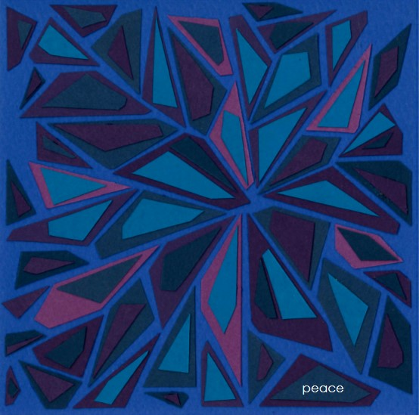



Chicago Community Mennonite Church

425 S. Central Park Blvd. (at Congress), Chicago, Illinois 60624-3224

www.ccmcil.org **|** facebook.com/ccmcil

**Church Council Chair:** Jason Gerig, 773-949-4496, jgerig@gmail.com

**Pastor:** Megan Ramer, 773-343-4251, pastor@ccmcil.org

Chicago Community Mennonite Church

December 7, 2014