Chicago Community Mennonite Church

December 21, 2014 ✢ Advent 4 ✢ Dwelling in Mystery: Love

Gathering

Prelude

Call to Worship

One: Host of Hosts, from sunrise to sunrise,  
and generation to generation, we are your people.

**All: You have been with us wherever we have gone.  
You will be with us wherever we may go.**

One: You planted us in a land flowing with milk and honey,  
then you planted our salvation in Mary’s womb.

**All: Jesus, who is the Christ, is planted firmly in each one of us.**

One: Our souls magnify the Holy One.

**All: Our spirits rejoice in God, our Savior.**

Welcome

HWB 211 *Lo, how a Rose e’er blooming*

Lighting the Peace Lamp

Prayer for Peace

Praising

HWB 71 *Joyful, joyful, we adore thee*

Psalm 89:1-4, 19-26

Children’s Time

*Let the children come to me; let the children come.   
Never hinder them; never stop them. O let the children come.* (STS 47)

Receiving God’s Word

2 Samuel 7:1-11, 16

HWB 180 *The angel Gabriel*

Luke 1:26-38

One: For the word of God in scripture,   
for the word of God among us,   
for the word of God within us,

**All: thanks be to God.**

Meditation

Responding

HWB 318 *Joy to the world*

Sharing

Prayer

Offering

Sending

Announcements

STS 121 *Nothing is lost on the breath of God*

Benediction

Extinguishing the Peace Candle

**One: Now the light of Christ is in you.**

All: Thanks be to God.

|  |
| --- |
| Worship Participants  Worship Leader: Ross Bay  Meditation: Glenn Martin Klaassen  Song Leader: Rachael Weasley  Pianist: Beth Peachey  Altar: Jody Schmidt  Bulletin Artwork: Brooke Hutchison, Rachael Weasley |

Announcements

***Christmas is for Sharing*, Today:** You are warmly invited to participate in a special Second Hour, for a time of sharing and reflection on meaningful holiday memories. Responding to the theme *Christmas is For Sharing,*we invite you to share your stories, poems, images, volunteer to lead (or request) a song or share how you are experiencing Advent this year.

**Longest Night Service, Today, 6:00 PM:** Come for a contemplative service of worship marking the coming of winter and honoring some of the loss and grief associated with the Christmas season.

**Pastor Megan’s Travel Schedule:** Jon and I are visiting his family in Germany and spending the holidays there. I return to the States on Jan 1. I’ll be in worship Jan 4 and then return fully to the office Monday Jan 5.

**Save the Date: Annual Church Retreat, Feb 14-15:** Mark your calendars and plan to join the fun at Camp Menno Haven in Tiskilwa, IL. Church will not be meeting in Chicago that weekend. All are welcome!

**Pledges for 2014 and 2015:** Please check with me if you want to know what the remaining amount of your 2014 pledge is. Because of the deficit budget for 2014, we can use all contributions. We encourage those of you who intend to pledge for 2015 to do so, including those of you who are new to the congregation.

—Paul Myers, Treasurer, paulmyerschicago@gmail.com

**Turning of the Year Retreat, Thur Jan 1, 1-4:00 PM** **(Chicago)**: Reflect, share, create, rest in God’s love, start the year off in joy and peace. $10-$40 contribution. Contact Carol Rose by Christmas to reserve a spot: 312-933-8986, carolarose77@gmail.com.

**Christian Peacemaker Teams Prayer for Peacemakers:** Pray that the citizens of Winnipeg, Mantoba repent of their injustice to the Shoal Lake 40 First Nation.  Winnipeg’s access to clean water comes at the expense of the residents of Shoal Lake, who have been under a boiled water advisory for eighteen years.

Schedule

|  |  |  |
| --- | --- | --- |
|  | **Today** | **Next Sunday** |
| **Greeter:** | Katie VanderHeide | Merle Baker |
| **Nursery:** | Steve Jost  Cecilia Goertzen | Liz Finch |
| **Fellowship:** | Joanne Zimmerly | Paul Myers |
| **Welcome Table:** | Jan Lugibihl | Derek Becker  Mark Liechty |

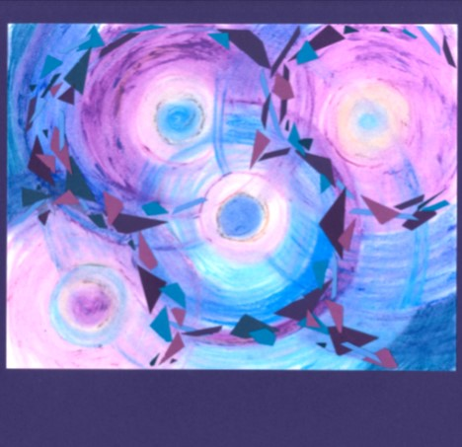

"Overlapping Ripples of Love"

Chicago Community Mennonite Church



Chicago Community Mennonite Church

425 S. Central Park Blvd. (at Congress), Chicago, Illinois 60624-3224

www.ccmcil.org **|** facebook.com/ccmcil

**Church Council Chair:** Jason Gerig, 773-949-4496, jgerig@gmail.com

**Pastor:** Megan Ramer, 773-343-4251, pastor@ccmcil.org

December 21, 2014