Chicago Community Mennonite Church

December 14, 2014 ✢ Advent 3 ✢ Dwelling in Mystery: Joy

Gathering

Prelude

Call to Worship

One: Our souls proclaim your greatness, O God.

**Many: And our spirits rejoice in you.**

One: We will praise you as long as we live.

**Many: We will sing praises to you our whole lives long.**

One: We will not trust in the powerful of this world,

**Many: But will trust in you – Creator of heaven and earth.**

One: the One who gives food to the hungry,

**Many: the One who enacts justice for the oppressed.**

One: Our souls proclaim your greatness, O God.

**Many: As we worship you in this place,**

**as we light these candles in hope, peace, and joy.**

STS 1 *Praise the One who breaks the darkness*

Welcome

Praising

Psalm 126

STS 13 *Sing we a song of high revolt*

Lighting the Peace Lamp

Prayer for Peace: Kyrie for the city (written by Celeste Groff)

**Refrain: God, have mercy.**

“Mary’s Song” *William Ortman*

Children’s Time

*Let the children come to me; let the children come.*

*Never hinder them; never stop them. O let the children come.*

HWB 172 *O come, O come, Immanuel*

STS 12 *Magnificat*

Receiving God’s Word

Isaiah 61:1-4,8-11

Luke 1:46b-55

One: For the word of God in Scripture, for the word of God among us, for the word of God within us,

**All: thanks be to God.**

Meditation

Responding

HWB 233 *Joyful is the dark*

Sharing

Prayer

Offering

HWB 181 *My soul proclaims with wonder*

Archaeology of our Faith

Sending

Announcements

STJ 13 *My soul is filled with joy*

Benediction

Extinguishing the Peace Lamp

One: Now the light of Christ is in you.

**All: Thanks be to God.**

|  |
| --- |
| Worship Participants  Worship Leader: Benjamin Anderson  Meditation: Megan Ramer  Song Leader: Glenn Martin Klaassen  Pianist: Beth Peachey  Altar: Antonia Kam  Bulletin Artwork: Rachael Weasley |

Announcements

**CCMC 101, Today:** What’s this 606 people keep talking about? How do CCMCers have fun together? Who's responsible for what at CCMC? For the answers to these and other questions about the life of CCMC join the Prayer and Care Team during Second Hour for CCMC 101.

**Pledges for 2014 and 2015:** Please check with me if you want to know what the remaining amount of your 2014 pledge is. Because of the deficit budget for 2014, we can use all contributions. We encourage those of you who intend to pledge for 2015 to do so, including those of you who are new to the congregation.

—Paul Myers, Treasurer, paulmyerschicago@gmail.com

**Longest Night Service, Sun Dec 21, 6:00 PM:** Come for a contemplative service of worship marking the coming of winter and honoring some of the loss and grief associated with the Christmas season.

**Save the Date: Annual Church Retreat, Feb 14-15:** Mark your calendars and plan to join the fun at Camp Menno Haven in Tiskilwa, IL. Church will not be meeting in Chicago that weekend. All are welcome!

**Turning of the Year Retreat, Thur Jan 1, 1-4:00 PM** **(Chicago)**: Reflect, share, create, rest in God’s love, start the year off in joy and peace. $10-$40 contribution. Contact Carol Rose by Christmas to reserve a spot: 312-933-8986, carolarose77@gmail.com.

**A Charlie Brown Christmas:** Liz Dyrst is part of the after school theatre program at Avondale Logandale School where she teaches. All are invited to come see their production of A Charlie Brown Christmas December 18 and 19th at 7pm. Tickets are $5 or $12 for a family pack (2 adults/2 kids). Contact Liz to purchase tickets.

**Pre-service Christmas caroling, Advent Sundays, 8:45 a.m.:** We will focus on Advent hymns during worship, so plan to arrive early if you want to sing Christmas songs together. Then plan to join us for our annual Christmas Lessons & Carols service during worship Dec 28.

Schedule

|  |  |  |
| --- | --- | --- |
|  | **Today** | **Next Sunday** |
| **Greeter:** | Kate Myers | Katie VanderHeide |
| **Nursery:** | Hannah Klaassen | Steve Jost  Cecilia Goertzen |
| **Fellowship:** | Russell Johnson | Joanne Zimmerly |
| **Welcome Table:** | Megan Ramer | Brian Paff  Derek Becker |

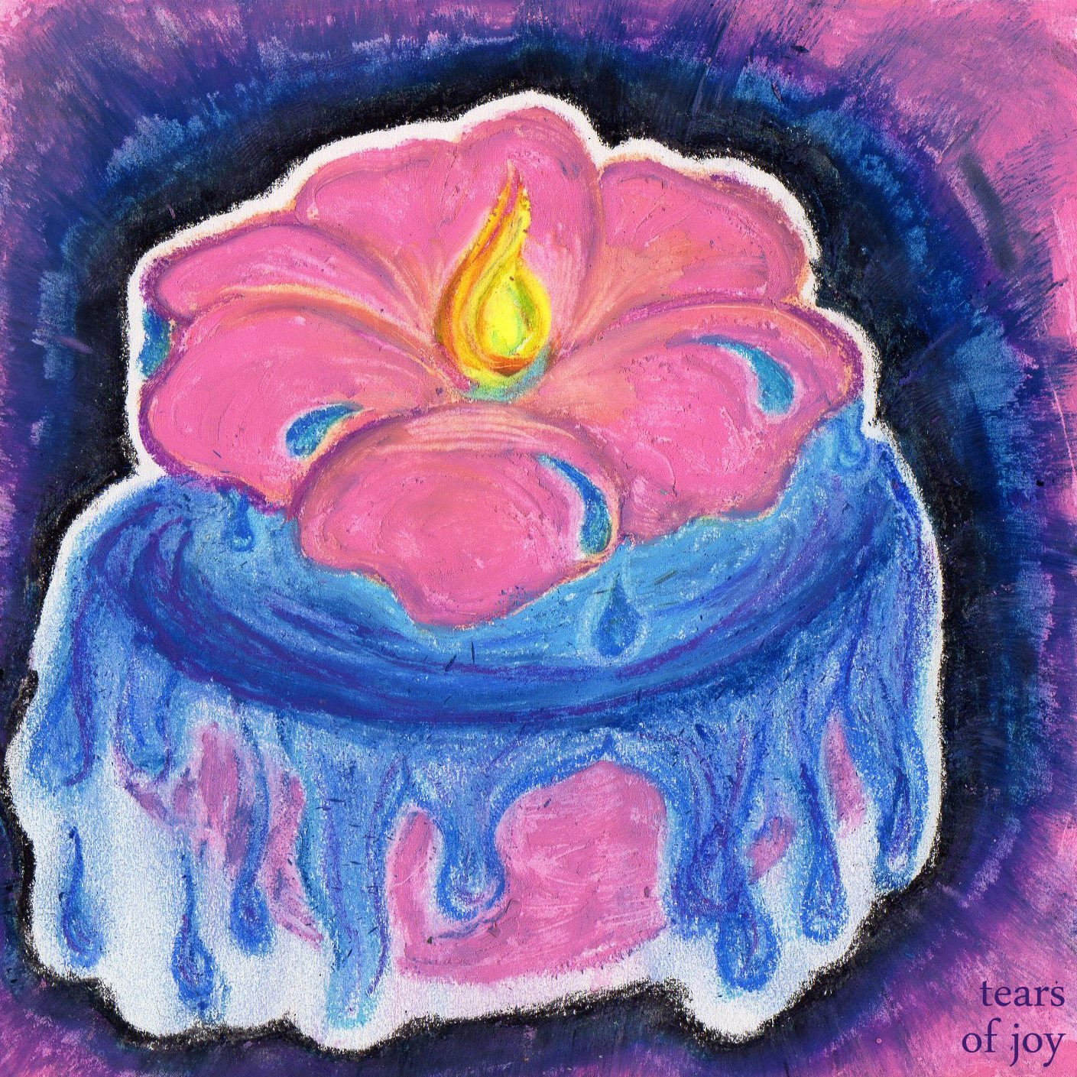



Chicago Community Mennonite Church

425 S. Central Park Blvd. (at Congress), Chicago, Illinois 60624-3224

www.ccmcil.org **|** facebook.com/ccmcil

**Church Council Chair:** Jason Gerig, 773-949-4496, jgerig@gmail.com

**Pastor:** Megan Ramer, 773-343-4251, pastor@ccmcil.org

Chicago Community Mennonite Church

December 14, 2014