Chicago Community Mennonite Church

November 9, 2014 ✢ Difficult Scriptures Series

Gathering

Prelude

Call to Worship

One: Come again, my friends, to worship and to pray.

**Many: Where we meet, God is there, today and yesterday.**

One: Come thirsting, and find a well.

**Many: A well unknown to the mighty but close to the many**

One: in the silence, in our thirsting, in the voices of our companions,

**Many: God calls us each by name.**

One: God, fill us now, fill us with your Holy Spirit.

**Many**: **Here before you now, see, our hands are empty.  God, fill us now with you.**

STS 63 *God, fill me now*

Welcome

Lighting the Peace Lamp

Prayer for Peace

Praising

STS 49 *I will come to you in the silence*

Children’s Time

*Let the children come to me; let the children come.*

*Never hinder them; never stop them. O let the children come.*

Archeology of Our Faith

Receiving God’s Word

STS 112 *My Lord, he is a-comin’ soon*

I Corinthians 7:8-9, 17-20, 25-35

One: For the word of God in Scripture, for the word of God among us, for the word of God within us,

**All: thanks be to God.**

Meditation

Responding

STJ 72 *One is the body*

Sharing

Prayer

STS 64 *There is a well*

Offering

Sending

Announcements

STS 57 *Go, my friends, in grace*

Benediction

Extinguishing the Peace Lamp

One: Now the light of Christ is in you.

**All: Thanks be to God.**

|  |
| --- |
| Worship Participants  Worship Leader: Rachael Weasley  Meditation: Ross Bay  Song Leader: Mariell Waltner  Pianist: Steve Warkentin  Altar: Antonia Kam |

Announcements

**Pastor Megan’s Travel Schedule:** I am enjoying a quarterly weekend off and have traveled to Cape Cod to visit my dear seminary friend and peer accountability partner who serves as a UCC pastor there. I am looking forward to worshiping with her church and witnessing her ministry – a rare opportunity for pastor friends! I’ll be back in the office Tue Nov 11.

**Second Hour Fall Series: Bringing Peace Home:** Please join us for a lively discussion exploring how Christians committed to nonviolence might approach ​the battle scenes ​found in the Book of Revelation​, especially chapters 7–9, 14, and 19.​

**Annual Meeting: Save the Date:** This year's Annual Meeting will take place on Sunday, December 7th following our potluck.

**Sunday Lunch at Inspiration Kitchens:** Beginning today, CCMCers will gather for lunch at Inspiration Kitchens (3504 W Lake St) after Second Hour on non-potluck Sundays. All are welcome. If you want to make arrangements ahead of time with a particular week’s lunch “host” – or if you’d like to host – contact Derek Becker: [derekkeithbecker@gmail.com](mailto:derekkeithbecker@gmail.com).

**Karena Mendoza Memorial Gift:** Prayer & Care Team and Council have decided to purchase the David Orth designed Lotus Urn to symbolize our church's holding of each other in times of greatest life stress and grief. Checks can be made out to CCMC with "Karena memorial gift" in the memo line. Thank you!

**Annual Bake Sale Fundraiser on November 16:** Not only is it a chance to show off your fancy baking skills, all proceeds will go towards our goal to fundraise $1000 for the ministry of William and Marina Valencia in Columbia. If you can't make the fundraiser, you can make a donation to CCMC and write "Colombia Mission Fund" in the memo line!

**Fabulous, Fierce & Sacred: an Anabaptist LGBTQA Gathering:**  We need your help to make this gathering a success. One way that CCMCers can provide support is by assisting with childcare on Saturday, November 22. Contact Hannah Klaassen if you can help: hannah.klaassen@gmail.com, 316-772-3671.

Schedule

|  |  |  |
| --- | --- | --- |
|  | **Today** | **Next Sunday** |
| **Greeter:** | Hannah Klaassen | Russell Johnson |
| **Nursery:** | Zamir Magalhaes  Sara Reschly | Cecilia Goertzen  Justin Riegsecker |
| **Fellowship:** | Jan Lugibuhl | Josiah Groff |
| **Welcome Table:** | Mariell Waltner  Mark Frey | Merle Baker  Rosalynn Gingerich |

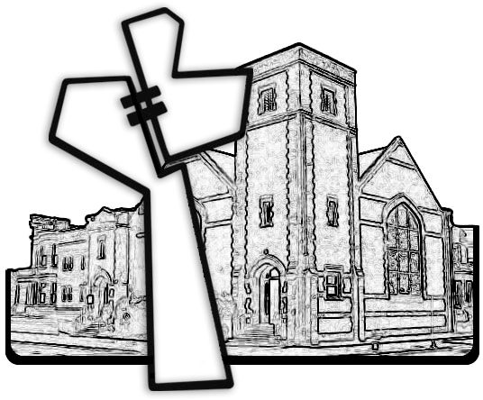



Chicago Community Mennonite Church

425 S. Central Park Blvd. (at Congress), Chicago, Illinois 60624-3224

www.ccmcil.org **|** facebook.com/ccmcil

**Church Council Chair:** Jason Gerig, 773-949-4496, jgerig@gmail.com

**Pastor:** Megan Ramer, 773-343-4251, pastor@ccmcil.org

Chicago Community Mennonite Church

November 9, 2014