Chicago Community Mennonite Church

November 30, 2014 ✢ Advent 1 ✢ Dwelling in Mystery: Hope

Gathering

Prelude

Call to Worship

One: Come, let us worship God who is here,

dwelling among us.

Redeeming God, show your face, so that we,

your people, may share your hope.

**All: Reveal your hope to us, O Great Mystery.**

One: Let your truth shine, so we may know your peace.

**All: Speak to us, for your word is our everlasting light.**

One: Walk with us, so we may dwell in your mystery.

**All: Inspire us, so we may remember we are whole.**

One: Guide us, so we may align our will with yours.

**All: Awaken us, now, to your presence here on Earth,**

**O God of hope.**

STS 7 *Come, come Emmanuel*

Welcome

Lighting the Peace Lamp

Prayer for Peace

Praising

HWB 498 *Christ comes to us as one unknown*

Psalm 80:1-7, 17-19

Children’s Time

*Let the children come to me; let the children come.*

*Never hinder them; never stop them. O let the children come.*

HWB 175 *O Savior, rend the heavens*

HWB 104 *Of your perfect love begotten*

Receiving God’s Word

Isaiah 64:1-9

Mark 13:24-37

One: For the word of God in Scripture,

for the word of God among us,

for the word of God within us,

**All: thanks be to God.**

Meditation

Responding

STS 6 *Save us, O Lord*

Sharing

Prayer

Offering

Communion

Sending

Announcements

STS 124 *My soul cries out*

Benediction

Extinguishing the Peace Lamp

One: Now the light of Christ is in you.

**All: Thanks be to God.**

|  |
| --- |
| Worship Participants  Worship Leader: Philip Kendall  Meditation: Megan Ramer  Song Leader: Nancy Hostetter  Pianist: Joanne Zimmerly  Altar: Antonia Kam |

Announcements

**Longest Night Service, Sun Dec 4, 6:00 PM:** Come for a contemplative service of worship marking the coming of winter and honoring some of the loss and grief associated with the Christmas season.

**Inter-congregational Green Team Forming, Thurs Dec 4, 6:00 PM:** Members of CCMC and First Church will meet in the sanctuary to officially launch our partnership with Faith in Place, an Illinois-based non-profit which "inspires religious people of diverse faiths to care for the Earth through connection, education, and advocacy." We aim to establish an inter-congregational Green Team to address environmental justice and sustainability at our facilities and beyond.

**Annual Meeting, Sun Dec 7:** This year's Annual Meeting will take place on Sunday, December 7 following our potluck.

**Pre-service Christmas caroling, Advent Sundays, 8:45 a.m.:** The Advent team has planned for congregational Christmas caroling the four Sundays of Advent: 11/30, 12/7, 12/14, 12/21. We will focus on Advent hymns during worship, so plan to arrive early if you want to sing Christmas songs together. Then plan to join us for our annual Christmas Lessons & Carols service during worship Dec 28.

**Celeste Groff’s Ordination Ceremony, Sat Dec 13, 2:00 PM:** Please plan to attend this service of worship and celebration!

**Ordination Potluck Feast, Sat Dec 13:** We will host a meal following Celeste Groff's ordination for the church, family, friends, and colleagues. Please bring a generously sized dish to contribute! If you’d like to help that day please contact Leigh Peters-Fransen.

**Advent Cookie Party, Sat Dec 6, 4:00 PM:** The Peters-Fransens will host the annual CCMC cookie party at 115 Elgin Ave in Forest Park. The cookie ceremonies will be followed by a pizza dinner at 6:00 p.m. and then the classic Grinch and a second holiday movie. Please RSVP to Joel and Leigh, [petersfransen@gmail.com](mailto:petersfransen@gmail.com).

Schedule

|  |  |  |
| --- | --- | --- |
|  | **Today** | **Next Sunday** |
| **Greeter:** | Rochelle Martin Klaassen | Derek & Linda Becker |
| **Nursery:** | Liz Dyrst  Mark Liechty | Derek Becker  Joanne Zimmerly |
| **Fellowship:** | Rosalynn Gingerich | Joane Zimmerly  Katie VanderHeidi |
| **Welcome Table:** | Sara Reschly  Josiah Groff | Potluck |

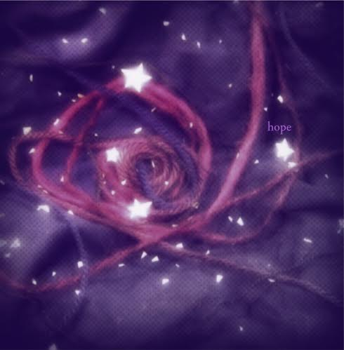



Chicago Community Mennonite Church

425 S. Central Park Blvd. (at Congress), Chicago, Illinois 60624-3224

www.ccmcil.org **|** facebook.com/ccmcil

**Church Council Chair:** Jason Gerig, 773-949-4496, jgerig@gmail.com

**Pastor:** Megan Ramer, 773-343-4251, pastor@ccmcil.org

Chicago Community Mennonite Church

November 30, 2014