Chicago Community Mennonite Church

November 2, 2014 ✢ All Souls Day

Gathering

Prelude

Call to Worship

One: This morning we remember our loved ones who have died,

**Many: And we remember God’s promise of eternal life.**

One: This morning we mourn the absence of many,

**Many: And we celebrate God’s continuing presence.**

One: We listen for the Divine voice in ancient words of scripture,

**Many: And we hear of miracles,**

**we hear that death will be swallowed up forever.**

One: Through sorrow and through joy, let us worship our Holy God.

**All**: **Let us be glad and rejoice in our salvation.**

Welcome

Lighting the Peace Lamp

Prayer for Peace

Praising

HWB 48 *All creatures of our God and King*

Psalm 34:1-10, 22

Children’s Time

*Let the children come to me; let the children come.*

*Never hinder them; never stop them. O let the children come.*

HWB 636 *For all the saints*

Receiving God’s Word

Revelation 7:9-17

HWB 526 *In the rifted rock I’m resting*

Matthew 5:1-12

One: For the word of God in Scripture, for the word of God among us, for the word of God within us,

**All: thanks be to God.**

Meditation

Responding

All Souls Day Liturgy

STS 121 *Nothing is lost on the breath of God*

Sharing

Prayer

HWB 580 *My life flows on*

Offering

Sending

Announcements

HWB 653 *Abide with me*

Benediction

Extinguishing the Peace Lamp

One: Now the light of Christ is in you.

**All: Thanks be to God.**

|  |
| --- |
| Worship Participants  Worship Leader: Jason Gerig  Meditation: Megan Ramer  Song Leader: Philip Kendall  Pianist: Hannah Klaassen  Altar: Brooke Hutchison |

Announcements

**Annual Meeting: Save the Date:** This year's Annual Meeting will take place on Sunday, December 7th following our potluck.

**Karena Mendoza Memorial Gift:** Prayer & Care Team and Council have decided to purchase the David Orth designed Lotus Urn to symbolize our church's holding of each other in times of greatest life stress and grief. Checks can be made out to CCMC with "Karena memorial gift" in the memo line. Thank you!

**Beer Group Tonight at 6:00 PM!** Meet at Chris and Zemir's place in Oak Park, 5 Pleasant St. Apt 2C, (708) 613-5568. Bring a beer to share that you would enjoy on a chilly fall day. We will make soup – something Brazilian. Feel free to bring something to eat with it.

**Sunday Lunch at Inspiration Kitchens:** Beginning November 9, CCMCers will gather for lunch at Inspiration Kitchens (3504 W Lake St) after Second Hour on non-potluck Sundays. All are welcome. If you want to make arrangements ahead of time with a particular week’s lunch “host” – or if you’d like to host – contact Derek Becker: [derekkeithbecker@gmail.com](mailto:derekkeithbecker@gmail.com).

**Annual Bake Sale Fundraiser on November 16:** Not only is it a chance to show off your fancy baking skills, all proceeds will go towards our goal to raise $1000 for the ministry of William and Marina Valencia in Columbia. If you can't make the fundraiser, you can make a donation to CCMC and write "Colombia Mission Fund" in the memo line!

**Fabulous, Fierce & Sacred: an Anabaptist LGBTQA Gathering:**  We need your help to make this gathering a success. One way that CCMCers can provide support is by assisting with childcare on Saturday, November 22. Contact Hannah Klaassen if you can help: hannah.klaassen@gmail.com, 316-772-3671.

**Jewel’s Cuisinart cookware:** If you shop at Jewel, you may collect stamps and put them in the envelope in Bill Luginbuhl’s mailbox. If you are replacing your own cookware, you may leave it in the mailbox room. All donations will benefit Bill’s clients with HIV who are moving out of homelessness or moving into their first apartment.

Schedule

|  |  |  |
| --- | --- | --- |
|  | **Today** | **Next Sunday** |
| **Greeter:** | Mariell Waltner | Hannah Klaassen |
| **Nursery:** | Chris Bohlander  Sherry Jost | Zamir Magalhaes  Sara Reschly |
| **Fellowship:** | Kate Myers  Jason Gerig | Jan Lugibuhl |
| **Welcome Table:** | Potluck | Mariell Waltner  Mark Frey |

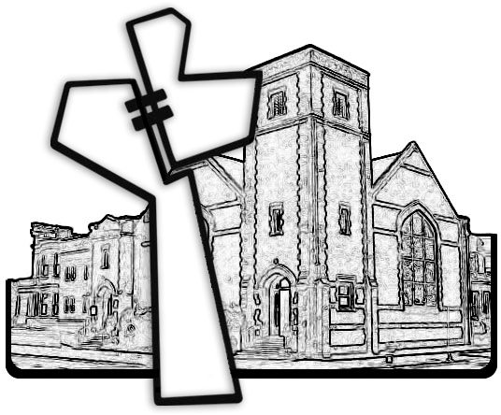



Chicago Community Mennonite Church

425 S. Central Park Blvd. (at Congress), Chicago, Illinois 60624-3224

www.ccmcil.org **|** facebook.com/ccmcil

**Church Council Chair:** Jason Gerig, 773-949-4496, jgerig@gmail.com

**Pastor:** Megan Ramer, 773-343-4251, pastor@ccmcil.org

Chicago Community Mennonite Church

November 2, 2014