Chicago Community Mennonite Church

November 23, 2014 ✢ Difficult Scriptures Series

Gathering

Prelude

Call to Worship (Psalm 95:1-7)

One: O come, let us sing to the Lord;

let us make a joyful noise to the rock of our salvation!

**All: Let us come into God’s presence with thanksgiving;**

**let us make a joyful noise to the Lord with songs of praise!**

One: For the Lord is a great God,

and a great King above all gods.

**All: In God’s hand are the depths of the earth;**

**the heights of the mountains are also.**

**The sea is Lord’s and the dry land.**

One: O come, let us worship and bow down,

let us kneel before the Lord, our Maker!

**All: For the Lord is our God,**

**and we are the people of God’s pasture,**

**and the sheep of God’s hand.**

HWB 26 *Holy Spirit, come with power*

Welcome

Lighting the Peace Lamp

Praising

HWB 559 *O thou, in whose presence*

Children’s Time

*Let the children come to me; let the children come.*

*Never hinder them; never stop them. O let the children come.*

Nursery Graduation for Max Franklin

Receiving God’s Word

Excerpts from Joshua chapters 1, 2 and 6

One: For the word of God in Scripture,

for the word of God among us,

for the word of God within us,

**All: thanks be to God.**

Meditation

Responding

HWB 582 *Guide me, O thou great Jehovah*

Offering

Sharing

HWB 353 *Lord, listen to your children*

Sending

Announcements

HWB 429 *Go now in peace*

Benediction

Extinguishing the Peace Lamp

One: Now the light of Christ is in you.

**All: Thanks be to God.**

|  |
| --- |
| Worship Participants  Worship Leader: Celeste Groff  Meditation: Megan Ramer  Song Leader: Dan Bertsche  Pianist: Maria Paff  Altar: Janet Friesen |

Announcements

**Second Hour Fall Series—Bringing Peace Home:** Today Lauren Friesen presents "Mennonite Peace Legacy: From Nonresistance to Nonviolent Action." Join us for a journey through historical highlights of Anabaptist views on peace and activism from the early days until now.

**Inter-congregational Green Team Forming, Thurs Dec 4, 6:00 p.m.:** Members of CCMC and First Church will meet in the sanctuary to officially launch our partnership with Faith in Place, an Illinois-based non-profit which "inspires religious people of diverse faiths to care for the Earth through connection, education, and advocacy." We aim to establish an inter-congregational Green Team to address environmental justice and sustainability at our facilities and beyond.

**Annual Meeting, Sun Dec 7:** This year's Annual Meeting will take place on Sunday, December 7 following our potluck.

**Pregnant with Gratitude, Fri Nov 28:** Carol Rose will lead a day retreat from 10:30 a.m. – 3:00 p.m.. Site to be confirmed. Requested contribution of $10-$40. Please RSVP by Nov 22 to Carol, [carolarose77@gmail.com](mailto:carolarose77@gmail.com).

**Pre-service Christmas caroling, Advent Sundays, 8:45 a.m.:** The Advent team has planned for congregational Christmas caroling the four Sundays of Advent: 11/30, 12/7, 12/14, 12/21. We will focus on Advent hymns during worship, so plan to arrive early if you want to sing Christmas songs together. Then plan to join us for our annual Christmas Lessons & Carols service during worship Dec 28.

**Celeste Groff’s Ordination Ceremony, Sat Dec 13, 2:00 p.m.:** Please plan to attend this service of worship and celebration!

**Ordination Potluck Feast, Sat Dec 13:** We will host a meal following Celeste Groff's ordination for the church, family, friends, and colleagues. Please bring a generously sized dish to contribute! If you’d like to help that day please contact Leigh Peters-Fransen.

**Advent Cookie Party, Sat Dec 6, 4:00 p.m.:** The Peters-Fransens will host the annual CCMC cookie party at 115 Elgin Ave in Forest Park. The cookie ceremonies will be followed by a pizza dinner at 6:00 p.m. and then the classic Grinch and a second holiday movie. Please RSVP to Joel and Leigh, [petersfransen@gmail.com](mailto:petersfransen@gmail.com).

Schedule

|  |  |  |
| --- | --- | --- |
|  | **Today** | **Next Sunday** |
| **Greeter:** | Ross Bay | Rochelle Martin Klaassen |
| **Nursery:** | Justin Hoschtetter  Laura Hostettler | Liz Dyrst  Mark Liechty |
| **Fellowship:** | Spencer Foon  Geoff Martin | Rosalynn Gingerich |
| **Welcome Table:** | Ruby Yoder Campos  Spencer Foon | Sara Reschly  Josiah Groff |

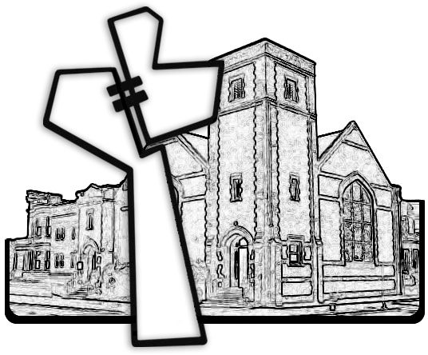



Chicago Community Mennonite Church

425 S. Central Park Blvd. (at Congress), Chicago, Illinois 60624-3224

www.ccmcil.org **|** facebook.com/ccmcil

**Church Council Chair:** Jason Gerig, 773-949-4496, jgerig@gmail.com

**Pastor:** Megan Ramer, 773-343-4251, pastor@ccmcil.org

Chicago Community Mennonite Church

November 23, 2014